MODELING ECOLOGICAL DETERMINANTS OF THE SYMBIOTIC

PERFORMANCE OF INTRODUCED RHIZOBIA IN TROPICAL SOILS

A DISSERTATION SUBMITTED TO THE GRADUATE DIVISION OF THE
UNIVERSITY OF HAWAII IN PARTIAL FULFILLMENT OF THE
REQUIREMENTS FOR THE DEGREE OF

DOCTOR OF PHILOSOPHY

IN

MICROBIOLOGY

AUGUST 1990

by

Janice E. Thies

Dissertation Committee:

B. Ben Bohlool, Chairman
Francoise M. Robert
John B. Hall
Paul W. Singleton
Goro Uehara

We certify that we have read this dissertation and that, in our opinion, it is satisfactory in scope and quality as a dissertation for the degree of Doctor of Philosophy in Microbiology.

ABSTRACT
Despite selection of inoculant strains for improved nitrogen fixation capacity and competitive ability, rhizobial inoculation frequently fails to improve crop yield. The natural diversity in rhizobial population size, soils, and climates present at five sites on Maui, Hawaii, was used to examine, under field conditions, the role that indigenous rhizobia and other environmental factors play in determining the symbiotic performance of inoculant strains. Eight inoculation trials were conducted using 2-4 legumes from among 9 species which yielded 29 legume/site observations. Uninoculated, inoculated, and fertilizer N treatments evaluated the impact of indigenous rhizobial populations and soil N availability on inoculation response and yield potential. Inoculation increased yield by 62% on average. A significant inoculation response was obtained in 38% of the trials and varied by both legume species and site. Significant responses to N application, significant increases in nodule parameters, and greater than 50% nodule occupancy by inoculant rhizobia did not necessarily coincide with significant inoculation responses. Size of indigenous rhizobial populations and soil N status had the greatest influence on inoculation response. As few as 54 rhizobia g⁻¹ soil prevented a significant response to inoculation. Inoculation response and competitive success of inoculant rhizobia were inversely related to numbers of indigenous rhizobia. Hyperbolic and log-linear equations, respectively, were most useful in quantifying these relationships. Combining indices of soil N with hyperbolic response models yielded useful equations for determining the need to inoculate and predicting success of inoculant strains introduced into new environments. Rhizobial interstrain competition studies identified both highly and poorly competitive inoculant strains across diverse environments. Symbiotic crops attained, on average, only 88% of maximum yield as defined by the fertilizer N treatment. Nitrogen source also significantly affected crop development. Crops supplied with urea had higher rates of vegetative growth, but, delayed reproductive maturity compared with crops relying on soil N and nitrogen fixation. Results of 4 soybean trials were compared with output from an existing soybean crop model. Difficulty in accurately simulating field results was encountered, indicating the need to address both source and supply of N when predicting legume yield and inoculation success.

TABLE OF CONTENTS

ABSTRACT..................................................3

LIST OF TABLES............................................6

CHAPTER 1. DISSERTATION INTRODUCTION......................8

CHAPTER 2. ENVIRONMENTAL FACTORS DETERMINING THE
INOCULATION RESPONSE OF FIELD-GROWN
LEGUMES........................................14

CHAPTER 3. PREDICTING LEGUME RESPONSE TO RHIZOBIAL
INOCULATION....................................44

CHAPTER 4. ENVIRONMENTAL EFFECTS ON RHIZOBIAL
INTERSTRAIN COMPETITION FOR NODULE
OCCUPANCY......................................64

CHAPTER 5. EFFECT OF NITROGEN SOURCE ON THE GROWTH
AND PHENOLOGY OF SOYBEAN AND BUSH BEAN.........105

SUMMARY AND CONCLUSIONS...................................133

APPENDIX..................................................141

LITERATURE CITED..........................................163
LIST OF TABLES

Table Page

2.1 Location, characteristics, and planting dates
of 8 inoculation trials conducted at 5 field
sites on Maui, HI.......................................19

2.2 Most-Probable-Number counts of indigenous,
homologous rhizobia for legumes grown in 8
inoculation trials at 5 sites on Maui, HI...............20

2.3 List of strain designations and source for
inoculant rhizobia used in the Maui inoculation
trials..................................................22

2.4 Incidence of significant (p < 0.10) of biomass
increases due to inoculation at early harvest and
observed economic yield increase due to inoculation
and N accumulation at late harvest......................30

2.5 Summary of nodulation responses to inoculation in
relation to the most probable number (MPN) of
indigenous rhizobia.....................................33

2.6 Proportion of nodules formed by inoculant rhizobial
strains on legumes grown in 8 inoculation trials at
5 sites on Maui, HI.....................................34

2.7 Summary of yield responses to inoculation and N
application in relation to the most probable
number (MPN) of indigenous rhizobia.....................40

3.1 Summary of measures of soil N availability in the
Maui inoculation trials.................................47

3.2 Regression analysis of the relationship between
indigenous rhizobia and legume inoculation
response................................................50

3.3 Measures of soil N availability in the Maui
inoculation trials and their relationship to the
slope coefficient (b0) in the hyperbolic-response
model...................................................56

3.4 Soil N deficit factors in the Maui inoculation
trials and their relationship to the slope
coefficient (b0) in the hyperbolic-response
model...................................................62

LIST OF TABLES (continued)

Table Page

4.1 Kendall tau b correlation coefficients for
environmental factors influencing nodule
occupancy by inoculant rhizobia and size of
indigenous rhizobial populations........................73

4.2 Summary of equations to describe the
relationship between total nodule occupancy by
inoculant rhizobia in all trials, number of
indigenous rhizobia, and inoculant application
rate....................................................77

4.3 Competitive success of inoculant strains in
relation to indices of the size and competitive
strength of indigenous rhizobial populations............81

4.4 Relative effectiveness of cowpea nodules crushates
obtained from 3 Maui field soils on 4 legumes that
nodulate with Bradyrhizobium sp.........................85

4.5 Effectiveness of 38 cowpea nodule crushates from
site 1 soil on cowpea and their corresponding
effectiveness on lima bean, peanut, and siratro.........88

4.6 Effectiveness of 37 cowpea nodule crushates from
site 3 soil on cowpea and their corresponding
effectiveness on lima bean, peanut, and siratro.........89

4.7 Effectiveness of 35 cowpea nodule crushates from
site 4 soil on cowpea and their corresponding
effectiveness on lima bean, peanut, and siratro.........90

5.1 Elevation, planting date, days to first flower (R1),
growing degree days, and daylength at (R1), and
average soil and air temperature during crop growth
of soybean and bush bean at 4 field sites on
Maui, HI................................................111

5.2 Effect of N source on crop growth rate during
vegetative and reproductive growth of soybean
and bush bean at 3 sites on Maui, HI....................124

5.3 Effect of N source on N assimilation rate during
vegetative and reproductive growth of soybean
and bush bean at 3 sites on Maui, HI....................125

CHAPTER 1
Dissertation Introduction
Rhizobia are symbiotic N₂ fixing soil bacteria that form nodules on the roots of leguminous plants. The association between rhizobia and legumes results in the biological transformation of atmospheric N₂ to plant protein. The ability of legumes to obtain the N required for their growth and reproduction from both soil and symbiosis sets them apart from other economically valuable crops, such as cereals, that rely solely on soil N assimilation to satisfy their N requirements.
Nitrogen is the most common nutrient limiting plant growth, particularly in the tropics (Atkins, 1986). Increasing yield through application of nitrogenous fertilizers is costly, may have adverse environmental consequences, and is often not a viable option for farmers in developing countries. The legume-Rhizobium symbiosis has been exploited for many years to reduce dependence on N fertilizers without compromising crop yield (Fred et al., 1932).
Rhizobia are commonly inoculated onto legume seeds prior to planting in the hope of increasing plant protein content and seed yield. Despite improvements in inoculation methods (Boonkerd et al., 1978: Sparrow and Ham, 1983: Jensen, 1987; Torres et al., 1987) and selection of rhizobial strains for increased nitrogen fixation capacity (Kishinevsky et al., 1984), competitive ability (Berg et al., 1988), and ability to withstand environmental stress (Munns et al., 1979; Keyser et al., 1979; Lowendorf, 1980), inoculation frequently fails to increase crop yield.
Several inoculation trials have been conducted to identify the factors that contribute to the success or failure of rhizobial inoculants to improve legume yield (Weaver and Frederick, 1974b; Elkins et al., 1976; Harris, 1979). However, failure to correctly identify or quantify the primary independent variables determining inoculation response has hampered use of these results to generate predictions regarding performance of inoculants under varying environmental conditions.
Symbiotic performance of rhizobia introduced into different environments can be evaluated in several ways: by their ability to increase yield above that of uninoculated crops (inoculation response); their ability to compete successfully both among themselves and with indigenous rhizobia for nodule occupancy; and their ability to promote a yield similar to that of N fertilized legumes. All of these aspects of symbiotic performance are mediated by environmental influences. The objective of this study was to identify quantifiable environmental factors that determine and can be used to predict the symbiotic performance of introduced rhizobia in tropical soils.
Determining need to inoculate is an important consideration in the cultivation of leguminous crops. Often the decision of whether or not to use inoculants is not predicated on any measurable factors of the environment, but divined through analysis of legume cropping history or from previous success in improving yields using inoculants. While these methods may provide a good basis for decision in individual instances, they do little to elucidate the underlying mechanisms that determine inoculation response. Without an understanding of the environmental factors that contribute to achieving a response to rhizobial inoculation, successful use of inoculants will remain a site-specific phenomenon. The ability to predict locations and legume species that will most likely respond to inoculation will enable decision-makers to make broader recommendations and direct resources where they are needed most.
Cropping history (Elkins et al., 1976): magnitude and effectiveness of indigenous rhizobial populations (Singleton and Tavares, 1986); soil N availability in relation to legume N requirement (Gibson and Harper, 1985); and environmental constraints, which interact with management inputs to determine legume yield potential and N requirement (Singleton et al., 1985), all significantly influence inoculation response. Therefore, the interaction between these factors should ultimately determine the likelihood and magnitude of an inoculation response (Singleton et al., 1985).
Competition between strains of rhizobia for nodule occupancy is influenced by environmental variables, intrinsic characteristics of the rhizobia themselves, and genetic determinants of the host. Environmental factors reported to affect competition for nodule occupancy include presence of indigenous rhizobia (Ireland and Vincent, 1968; Bohlool and Schmidt, 1973; Weaver and Frederick, 1974a,b), soil type (Damirgi et al., 1967; Ham et al., 1971), temperature (Caldwell and Weber, 1970; Weber and Miller, 1972; Kvien and Ham, 1985; Kluson et al., 1986), moisture (Boonkerd and Weaver, 1982), pH (Damirgi et al., 1967; Dughri and Bottomley, 1983,84), nitrogen availability (McNiel, 1982), and microbial antagonism (Schwinghamer and Brockwell, 1978; Triplett and Barta, 1987). Characteristics of rhizobia that may influence the outcome of competition are host genotype compatibility (Johnson et al., 1965; Caldwell and Vest, 1968; Diatloff and Brockwell, 1976; Materon and Vincent, 1980; Kvien et al., 1981; Keyser and Cregan, 1987), motility and chemotactic responses (Hunter and Fahring, 1980; Wadisirisuk et al., 1989), and ability to attach to host roots and initiate nodule formation (Dart, 1977).
Much attention has been paid to factors that affect the ability to establish inoculant strains in a significant proportion of nodules formed on plants in the presence of indigenous rhizobia. This is due to the concept that successful establishment of strains superior in N₂ fixing ability should lead to yield improvement through inoculation. This perspective presupposes that indigenous rhizobia are symbiotically less effective than inoculant strains. While this has been shown to be true in some cases (Ireland and Vincent, 1968), the average effectiveness of populations of indigenous rhizobia may be comparable to that of inoculant strains (Bergersen, 1970; Singleton and Tavares, 1986). While researchers agree that indigenous rhizobia have a tremendous impact on competition for nodule occupancy by inoculant rhizobia, considerable disparity exists in the literature concerning the influence of other environmental variables.
Several mathematical models have been proposed in the literature to describe and quantify competition for nodule occupancy (Ireland and Vincent, 1968; Weaver and Frederick, 1974a; Amarger and Lobreau, 1982; and Beattie et al., 1989). In all of these models, nodule occupancy by inoculant strains is some function of numbers of indigenous rhizobia and application rate of inoculant strains. None of these models has integrated other environmental factors that may influence the outcome of competition.
Numerous legume crop models have been developed in recent years to try to predict phenology (timing of developmental stages) and yield under varying environmental conditions (Major et al., 1975; Wann and Raper, 1979; Hadley et al., 1984; Hodges and French, 1985; Salado-Navarro et al., 1986a,b; Sinclair et al., 1987; Jones et al., 1989). Few of these have considered N dynamics. Because N is present in numerous essential compounds, effects of N deficiency on crops are dramatic. Most legume crop models assume that plants have sufficient N for maximum growth. This assumption is not problematic if growth and yield predictions are to be made for crops grown under high management conditions. However, for these models to be of broader applicability and address problems common to crop production in the developing world, the effects of nutrient insufficiencies, particularly N, on crop growth need to be addressed. Developing models that can simulate crop growth under varying sources and supplies of N requires an understanding of the effects of different sources of N on plant development and yield.
The natural diversity in rhizobial population size, soils, and climates present at five sites on the island of Maui, Hawaii was used to examine, under field conditions, the impact of environmental factors on the symbiotic success of inoculant rhizobia in tropical soils. Sites in the University of Hawaii's Maui Soil, Climate, and Land Use Network (MauiNet) (Soil Conservation Service, 1984) provided a unique opportunity to study these relationships as sites lacked indigenous rhizobia for some legumes, but provided a range from less than 1 to more than 3.5 x 10⁴ g⁻¹ soil for others. The diversity of soils and climates at the MauiNet sites allowed measurement of the impact of varying crop yield potential and soil N availability on the interaction between indigenous rhizobia, legume inoculation response, and competition for nodule occupancy. Effect of N source on growth and development of two legumes was also examined at 4 of the sites. Collection of minimum data sets required to run the crop model, SOYGRO (Jones, et al. 1989), in these trials allowed comparison of field results to model simulations.
The goal of this study was to identify and quantify the primary environmental determinants of legume inoculation response and rhizobial competition for nodule occupancy. And, to use these variables to develop mathematical models that can be used to predict the symbiotic performance of rhizobia introduced into different environments.

CHAPTER 2
Environmental Factors Determining the Inoculation Response of Field-grown Legumes
Introduction
Inoculation of legumes with exotic strains of rhizobia is a common agricultural practice intended to promote nitrogen fixation and increase crop yield. Despite improvements in inoculation methods (Boonkerd et al., 1978; Sparrow and Ham, 1983; Jensen, 1987; Torres et al., 1987) and selection of rhizobial strains for increased nitrogen fixation capacity (Harris, 1979; Kishinevsky et al., 1984), competitive ability (Berg et al., 1988), and ability to withstand environmental stress (Munns et al., 1979; Keyser et al., 1979; Lowendorf, 1980), inoculation often does not increase plant growth and crop yield.
Plant response to inoculation is determined by a variety of factors. The presence and quality of indigenous rhizobial populations (Ham et al., 1971; Diatloff and Langford, 1975; Boonkerd et al., 1978; Singleton and Tavares, 1986), soil N availability (Sutton, 1983; Gibson and Harper, 1985), soil physicochemical constraints (Holding and Lowe, 1971; Singleton et al., 1985), and climatic conditions (Caldwell and Weber, 1970) all significantly influence our ability to achieve increased crop yield through inoculation.
Population density, effectiveness, and competitive ability are the primary characteristics of indigenous rhizobial populations that affect inoculation response. In greenhouse studies, Singleton and Tavares (1986) demonstrated that statistically significant inoculation responses can be eliminated when there are as few as 20 indigenous rhizobia g⁻¹ of soil as long as the population contains some effective strains. Strains within populations of rhizobia differ significantly in their ability to supply the host plant with fixed N (effectiveness) under greenhouse conditions (Singleton and Stockinger, 1983; Singleton et al., 1985; Singleton and Tavares, 1986). Differences in the effectiveness of inoculant strains can also be demonstrated under field conditions as long as the soil is free of indigenous rhizobia (Ham, 1980). In the presence of an indigenous population, however, improved crop yield through inoculation with more effective inoculant strains is difficult to demonstrate (Ham et al., 1971; Diatloff and Langford, 1975; Meade et al., 1985).
Successful competition for nodule sites from indigenous rhizobia has been suggested as one reason for failure to achieve a response to inoculation with elite rhizobial strains (Johnson et al., 1965; Meade et al., 1985; Weaver and Frederick, 1974a,b). Both pot experiments (Bohlool and Schmidt, 1973) and field trials (Weaver and Frederick, 1974b) demonstrated that to achieve nodule occupancy greater than 50%, the inoculant must be applied at a rate per seed at least one thousand times greater than the estimated number of indigenous rhizobia g-1 soil. However, even when a highly effective inoculum strain forms the majority of nodules, failure to improve yield through inoculation is common (Weaver and Frederick, 1974b: Diatloff and Langford, 1975).
High concentrations of soil N affect response to inoculation by inhibiting nodulation thereby decreasing the proportion of plant N that is derived from N₂ fixation (Gibson and Harper, 1985). Available soil N, therefore, must be less than the legume crop N requirement for an inoculation response to be measured.
Environmental stresses that limit yield potential and hence, the crop N requirement, also affect the nitrogen fixation potential of the symbiotic association (Singleton et al., 1985). Environmental constraints include soil physicochemical factors such as acidity, toxicity, salinity, and low fertility (Holding and Lowe, 1971; Singleton and Bohlool, 1983; Singleton et al., 1985); climatic stresses such as low rainfall, inadequate soil and air temperatures, and insufficient solar radiation (Caldwell and Weber, 1970); insect predation; and disease. Consequently, the ability to improve crop yield through inoculation involves an interaction between soil N availability and other environmental conditions affecting crop yield.
The natural diversity in rhizobial population size and composition present at five sites on the island of Maui, Hawaii (Woomer et al., 1988) was used to examine the role indigenous rhizobia play in obtaining a legume yield increase from rhizobial inoculation. The hypothesis that inoculation response is a function of the size of the indigenous rhizobial population and soil N availability in relation to crop N demand was tested. Sites in the University of Hawaii's Maui Soil, Climate, and Land Use Network (MauiNet) (Soil Conservation Service, 1984) provided a unique opportunity to study this relationship as sites lacked indigenous rhizobia for some legumes, but provided a range from less than 1 to more than 3.5 x 10⁴ g⁻¹ soil for other legumes. MauiNet sites also have a diversity of soils and climates which allowed measurement of the impact of varying crop yield potential and soil N availability on the interaction between indigenous rhizobial population size and legume inoculation response. Understanding the role of indigenous rhizobial populations in determining host response to inoculation should help to identify locations where inoculation will succeed in improving crop yield. Such knowledge can help determine where and when to use inoculants, appropriate locations for inoculum production facilities, and their production requirements.

Materials and Methods
General experimental approach. A series of field inoculation trials was installed at five ecologically diverse sites on the island of Maui, HI (Table 2.1), using legume species for which the number of soil rhizobia varied between sites (Table 2.2). Each legume species received three N-source treatments: (i) uninoculated, no N applied: (ii) inoculated at 1(16-107 rhizobia per seed; and (iii) fertilizer N applied as urea at a rate of 100 kg N ha⁻¹ wk⁻¹ beginning at planting for sites 1, 2, 3, and 3a and at week 2 for sites 4, 5 and 5a for a total of 800-2000 kg N ha⁻¹ over the cropping cycle. Yield of the fertilizer N treatment estimated the maximum yield potential of each legume species at each site. The uninoculated treatment measured both soil N available for crop growth and, where present, the effect of native rhizobial populations. Rates of inoculation used ranged from 11 to 68 times recommended farmer rates (FAO, 1984) and represented maximum rhizobial numbers that could be successfully applied to the seed. A non-nodulating isoline of soybean was also planted at each site to provide a biological measurement of soil N available for plant growth during the cropping cycle. Each site was equipped with a Campbell Scientific CR-21 micrologger (Campbell Scientific, Inc., Logan, UT) to record climate and soil data.

Table 2.1 Location, characteristics, and planting dates of 8 inoculation trials conducted at 5 field sites on Maui, HI.
No. | b  Site Planting Elevation Soil a MAR  Name Date (m) Classification (mm/yr) | Mean  Temp. (C)  Soil Air | c Irradiance  (w/m^2/d) | Legumes present  at site
 | e
1  1a | Hashimoto 3/24/87 37 Torroxic 322  Farm 3/10/88 Haplustoll | 30.2 23.5  34.1 24.9 | 274  291 | Leucaena, Prosopis
2 | Kuiaha 8/15/86 320 Humoxic 1875  Tropohumult | 25.1 23.4 | 230 | Desmodium, Indigofera,  Crotalaria, Acacia,  Cassia
3  3a | Kula Agric. 9/12/86 366 Torroxic 375  Park 5/14/87 Haplustoll | 25.8 22.5  28.7 23.5 | 210  258 | Leucaena, Indigofera,  Macroptilium, Prosopis
4 | Haleakala 6/08/87 660 Humoxic 1800  Station Tropohumult | 22.9 21.5 | 233 | Desmodium, Trifolium,  Acacia, Crotalaria
 | f | d d | d
5  5a | Tengan 10/20/87 670 Torroxic 523  Farm 1/07/88 Haplustoll | 22.1 18.9  22.5 18.6 | 187  206 | Medicago, Vicia,  Leucaena, Acacia
a  b  c  d  e  f | USDA Soil Conservation Service (1972).  State Department of Land and Natural Resources (1982).  Averaged across duration of the longest crop for each planting at a site.  Hawaii's Maui Soil, Climate, and Land Use Network (MauiNet).  From MauiNet Pulehu Farm Site weather station located at the same elevation  Soybean was replanted on 4/8/87 due to poor emergence.  Lima bean and bush bean were replanted on 10/28/87 and cowpea was replanted | From weather stations  0.78 km north.  on 11/18/87 due to | on location operated  poor emergence. | by University of

Table 2.2 Most-Probable-Number countsª of indigenous, homologous rhizobia for legumes grown in 8 inoculation trials conducted at 5 sites on Maui, HI.
No. | Legume Species  Site G. P. V. P. A. L. M. T. L.  Name max lunatus unguiculata vulgaris hypogaea leucocephala sativa repens tingeatus
 | Rhizobial/g soil^{b}
1  1a | Hashimoto 0 <1 54 7 - - - - -  Farm  - - - - 5^{c} >1650 - - -
2 | Kuiaha 0 61e 2306e 93e - - - - -
3  3a | Kula 0 <1^{d} 18^{c} 2^{d} - - - - -  Agric.  Park  0 - - 211^{d} 5^{c} >5938^{d} - - -
4 | Haleakala 0 311^{d} 35900e 437^{d} - - - - -  Station
5  5a | Tengan 0 23 283 31 - - - - -  Farm  - - - - - - 1038 <1 15
a  b  c  d  e | Calculated y the Most Probable Number Estimation System , oomer et al., 1990)  Upper and lower fiducial limits are determined by dividing or multiplying by 2.7, unless otherwise noted  Upper and lower fiducial limits are determined by dividing or multiplying by 2.0  Upper and lower fiducial limits are determined by dividing or multiplying by 2.9  Upper and lower fiducial limits are determined by dividing or multiplying by 3.8

Soil amendments. Soils were limed at sites 2 and 4 (Table 2.1) with Ca (OH)₂ one week prior to planting to achieve a pH of between 5.5 and 5.9. Nutrients were applied in non-limiting amounts based on soil test values. Range of application rates and compounds used were (kg ha⁻¹): 300-610 P as treble superphosphate; 285-352 K as K₂SO₄; 60-77 Mg as MgSO₄·7H₂0; 5-15 Zn as ZnSO4·7H2O; 5 B as H₃BO₃; and 2 Mo as Na₂MoO₄·2H₂O.
Legume cultivars. Legume species and cultivars used were: Glycine max cv Clark, nodulating and non-nodulating isolines (P. Cregan, USDA Nitrogen Fixation Laboratory, Beltsville, MD); Phaseolus lunatus cv Henderson's Baby; Phaseolus vulgaris cv Bush Bountiful; Vigna unguiculata cv Big Boy at sites 2 and 3 and cv Knuckle Purplehull at the remaining sites; Arachis hypogaea cv McRan Valencia at site 3a and cv Burpee Spanish at site 1a; Leucaena leucocephala cv K-8; Lathyrus tingeatus cv Tinga pea; Medicago sativa cv Florida 77; and Trifolium repens cv Regal Ladino.
Inoculum strains and inoculation procedure. Three serologically distinct rhizobial strains were used to inoculate each legume species. Strains used and their sources are listed in Table 2.3. All strains were grown separately in yeast-extract mannitol broth culture (Vincent, 1970) to a concentration of 10⁹ cells mL⁻¹. For all trials except those at sites 2 and 3 (Table 2.1), fifty mL of each broth culture was injected into 100 g of gamma-irradiated peat in separate polyethylene bags (Agricultural Laboratories Pty. Ltd., Sefton, New South Wales, Australia).
Table 2.3 List of strain designations and source for inoculant rhizobia used in the Maui inoculation trials.
Legume NifTAL (2)  Host Designation | Original Designation  and Other Names | Source
G. max TAL 102  TAL 377  TAL 379 | USDA 110  USDA 138  USDA 136b, CB 1809 | (1)  (1)  (1)
P. lunatus TAL 22  TAL 169  TAL 644 | NifTAL original  Nit 176A22  CIAT 257 | (2)  (3)  (4)
P. vulgaris TAL 182.  TAL 1383  TAL 1797 | NifTAL original  CIAT 632  CIAT 899 | (2)  (4)  (4)
V. unguiculata TAL 173  TAL 209  TAL 658 | Nit176A30  NifTAL original  CIAT 71 | (3)  (2)  (4)
A. hypogaea TAL 169  TAL 173  TAL 658 | Nit 176A22  Nit 176A30  CIAT 71 | (3)  (3)  (4)
L. leucocephala TAL 82  TAL 582  TAL 114.5 | NifTAL original  CB 81  CIAT 1967 | (2)  (5)  (4)
L. tingeatus TAL 634.  TAL 1236  TAL 1402 | Nit 92A3  Allen 344  Nit 128C75 | (3)  (6)  (3)
T. repens TAL 1826  TAL 1827  TAL 1828 | S11-6  S11-16  AR 21 | (7)  (7)  (7)
M. sativa TAL 380  TAL 1372  TAL 1373 | SU 47  POA 116  POA 135 | (8)  (9)  (9)
(1) U.S. Dept. of Agric., Beltsville, MD; (2) NIfTAL Project, Paia, HI; (3) Nitragin Co., Madison, WI; (4) Centro Internacional Agricultural Tropical, Call, Columbia; (5) Commonwealth
Scientific Industrialization Research Organization, Brisbane, Australia; (6) O.N. Allen,
Univ. of Wisconsin, Madison, WI; (7) P.J. Bottomley, Oregon St. Univ., Covallis, OR; (8) Univ. of Sydney, NSW, Australia; (9) Universidade Federal Rio Grande do Sul, Porto Alegre, Brazil.

Peat inoculants were: incubated for 14 days at 26 C, counted, then held at 4 C until used. Rhizobial numbers in each inoculant were determined using the drop plate method (Somasegaran and Hoben, 1985). The three peat inoculants for each legume species were combined to provide equal numbers of each strain in a mixed inoculant. For trials conducted at sites 2 and 3, broth cultures of the 3 strains for each legume species were combined in equal volumes. Fifty mL of these combined broth cultures was injected into 100 g of gamma-irradiated peat. These inoculants were incubated, counted, and stored as described above. Rhizobial number g⁻¹ peat averaged 3.16 x 10⁹ with a minimum of 4.03 x 10⁸. I mmediately before planting, seeds were coated with 0.4 to 2.8 mL per 100 g seed (based on seed size) of a 40% gum arabic solution. Inoculant was applied to the coated seeds in amounts sufficient to provide 10⁷ rhizobia seed⁻¹ for large-seeded legumes and 10⁵ rhizobia seed⁻¹ for small-seeded legumes. A final coating of CaCO₃ was applied to all seeds to facilitate handling. Viable counts of rhizobia on pelleted seeds averaged 2.47 x 10⁷ seed⁻¹ for large-seeded legumes and 1.13 x 10⁵ seed⁻¹ for small-seeded legumes.
Enumeration of native soil rhizobial populations.
Immediately prior to planting, field soils were sampled to determine the Most-Probable-Number (MPN) of indigenous soil rhizobia capable of nodulating the selected host legumes (Table 2.2). Thirty 2.54 cm diam. soil cores to a depth of 25 cm were taken in a grid pattern across each experimental area. Soil cores were pooled, mixed, subsampled for determination of moisture content, and stored at 4 C overnight. Serial 1:2, 1:4, 1:5, or 1:10 soil dilutions were prepared as described in Somasegaran and Hoben (1985) using no less than 50 g (oven-dried basis, 100 C) of soil for the first dilution step. Prior estimations of soil rhizobial populations performed by Woomer et al. (1988) were used as a guideline for the appropriate dilution ratio to use for each legume species at each site. Test plants were inoculated as described in Somasegaran and Hoben (1985) and kept supplied with an adequate volume of an N-free nutrient solution (Singleton, 1983). Plants were scored for nodulation 21 to 28 days after inoculation and the MPN of indigenous rhizobia determined by computer using the Most-Probable-Number Estimation System, MPNES (bloomer et al., 1990).
Plant culture. Seeds of all cultivars except the forage legumes were sown in rows 60 cm apart. Seeds were spaced to provide a planting density (plants ha⁻¹) of 416,667 for G. max, 333,333 for P. lunatus, P. vulgaris, and V. unguiculata, 166,667 for A. hypogaea, 125,000 for L. leucocephala at site 3, and 333,333 at site 1. Seeds of M. sativa and T. repens were sown in rows 30 cm apart. Seeds were broadcast along the rows at a rate of 22 kg seed ha⁻¹ for M. sativa and 10 kg seed ha⁻¹ for T. repens. L. tingeatus was sown in rows 40 cm apart. Seeds were spaced to provide a planting density of 500,000 plants ha⁻¹. All fields were irrigated to 0.03 MPa (field capacity) at planting and maintained near that tension for the duration of each trial with the aid of tensiometers. Planting dates for each site are given in Table 2.1.
Early harvest. Pulse crops were harvested at or near full-bloom. Forage crops were harvested 71-74 days after planting (DAP). Plants were cut at the soil surface from 3.0 to 6.0 linear m of row (1.8 to 3.6 m²). Outside rows were used for plot borders with a minimum of 50 cm border at the end of each plot. Fresh weight of the sample was determined immediately. A subsample of 10-20 plants was taken and their fresh weight recorded in the field. Subsamples were dried at 70 C to a constant weight, weighed, and ground to pass through a 2 mm sieve. Ground samples (0.25 g) were digested in 6 mL H₂SO₄ containing 0.25 g L⁻¹ salicylic acid after pretreatment with 3 mL H₂O₂ (30%) (Parkinson and Allen, 1975). Ammonium in the digests was determined using the indophenol blue method (Keeney and Nelson, 1982).
Ten randomly selected rootstocks were excavated from each plot. Nodules were removed, counted, dried at 70 C, and weighed. Plant density was determined in each plot. Nodule number plant⁻¹ and mass (g⁻¹ plant) in the sample were multiplied by the plant stand ha⁻¹ to determine number and kg of nodules ha⁻¹. Nodule occupancy by inoculum strains was determined on 24 to 36 randomly selected nodules from each plot using strain-specific fluorescent antibodies as described in Somasegaran and Hoben (1985). The indirect immunofluorescence method was used for L. tingeatus and T. repens and the direct method for the remaining legume species.
Late harvest. G. max, P. vulgaris, and A. hypogaea were harvested at harvest maturity (R8) (Fehr et al., 1971). P. lunatus and V. unguiculata were harvested when the majority of the first flush of pods were dry. L. leucocephala was harvested 118 DAP at Kula Ag Park and 166 DAP at Hashimoto Farm. The forage legumes were harvested 112-117 DAP. Plants were harvested from 6.0 to 10.0 linear m of interior row (3.6 to 6.0 m²). Subsamples of 10-15 plants were taken, dried, and analyzed for N content as described above.
Experimental design and analysis. Inoculation trials were planted in a split-plot design with four replications (Appendix 1). Legume species were assigned to mainplots and N source treatments confined to subplots. All plant growth and nodulation data were analyzed by site (Appendix 2) except the yield data from L. leucocephala at sites 1a and 3a and P. vulgaris at site 1, and the nodulation data from V. unguiculata at site 1 which were analyzed as separate randomized complete block experiments due to non-homogeneity of variance with the other legume species. Nodulation data from G. max were also excluded from the analyses because the uninoculated (non-modulated) plants lacked any variance. Means of nodule mass and number on inoculated soybean were considered to be significantly different from zero as long as their 95% confidence intervals did not include zero. PC-SAS analysis of variance procedure (Statistical Analysis System for personal computers, SAS Institute, 1986) was used for all other analyses.
Results
Yield of nine legumes grown under uninoculated, inoculated, and fertilizer N conditions in eight field inoculation trials is presented in Figure 2.1 (and Appendix 2). Seed yield for the grain legumes and above ground biomass for the forage legumes is the reported economic yield. For the grain legumes, economic yield was highly significantly correlated with above ground biomass (r=0.91) and N accumulation (r=0.90) (data not shown). Economic yield for the forage legumes was also highly significantly correlated with N accumulation (r=0.97). Inoculation increased economic yield in 22 of the 29 (76%) legume species by site combinations. While the yield increase was greater than 100 kg ha⁻¹ in all cases, in only 11 (38%) of the species-site combinations was the increase statistically significant (p=0.05). Response to inoculation varied between both sites and legume species tested. Inoculation response was most frequent at sites 1 and 3. No response to inoculation was obtained at site 5(a). Soybean (G. max) responded to inoculation in 5 of 6 trials (83%): with yield of inoculated crops being at least double that of uninoculated crops. While lima bean (P. lunatus), peanut (A. hypogaea), and cowpea (V. unguiculata) all nodulate with Bradyrhizobium spp., lima bean and peanut responded to inoculation at sites la and 3a, whereas, cowpea failed to respond in all trials. Bush bean (P. vulgaris) responded to inoculation 50% of the time. No significant inoculation response was obtained with the forage legumes.
N application improved yield over the uninoculated condition 90% of the time, however, only 52% of the observations were significant (p=0.05) (Figure 2.1). A significant increase in yield due to N fertilization was accompanied by a significant inoculation response only of the time. Eight of the 29 observations had a significant increase in yield due to N application above that attained by inoculation. Of these, only half also had a significant inoculation response.

Biomass at early harvest was highly significantly correlated (r=0.97) with total N accumulation at early harvest (data not shown). However, there was no significant correlation between biomass and N accumulation measured at early harvest and any of the yield parameters measured at late harvest. Consequently, significant responses to inoculation or N application at final harvest could not be reliably predicted from yield measurements made at early harvest (Table 2.4).
Inoculation enhanced nodulation in 25 of 28 (89%) species-site combinations (Figure 2.2 and Appendix 2). Increases were significant (p < 0.05) in only 14 of the observations for nodule number and 17 of the observations for nodule mass. Significantly enhanced nodule number and mass led to a significant inoculation response 71% and 65% of the time, respectively. There were no indigenous Bradyrhizobium japonicum present at any of the sites (Table 2.2), consequently, inoculation enhanced nodulation of soybean at all sites. Nodule number on soybean was relatively consistent between sites 1-4, however, at site 5 nodule number was less than half that obtained on average at the other sites. Nodule mass of soybean was inversely correlated (r = -0.60) to the economic yield of uninoculated (non-nodulated) soybean which depended solely on soil N for growth (Figure 2.1). In general, sites where the yield of non-nodulated soybean was low (sites 2, 3(a)), nodule mass of the inoculated crop was high. Conversely, sites where the yield of non-nodulated soybean was high (sites 4 and 5), nodule mass of the inoculated crop was low. Nodule mass for the other species grown at these sites follows the same relative pattern, indicating that environmental factors,

Table 2.4 Incidence of significant (p< 0.10) biomass increases
due to inoculation at early harvest and observed economic yield
increase due to inoculation and N application at late harvest.
Significant increase (p < 0.10)
Early Response to in economic yield due to:
Inoculation
in Biomass Yield Inoculation N application
----------------no. of observations --------------
Yes 7 4 4
No 22 8 12
Total 29 12 16

primarily soil N availability, were controlling nodulation.
Indigenous rhizobia capable of nodulating legume species other than soybean were present in varying numbers at each of the sites (Table 2.2). Nodulation of uninoculated plants was closely related to the size of the indigenous homologous rhizobial population (Table 2.5). On average, when less than 10 rhizobia g⁻¹ soil were present, inoculation increased nodule number and mass many fold. When the number of indigenous rhizobia was between 10 and 100 g⁻¹ soil, inoculation roughly doubled nodule mass and tripled nodule number. Whereas, nodule number and mass in the inoculated and uninoculated treatments were not significantly different when the number of soil rhizobia was greater than 100 g⁻¹ soil. Notable exceptions are bush bean at sites 2 and 4, peanut at sites la and 3a, and clover at site 5a.
Nodule occupancy by inoculant strains ranged from 7 to 100 (Table 2.6) and was inversely related to numbers of indigenous rhizobia (Table 2.5). Inoculant strains were, in general, very successful in competing with indigenous rhizobia for nodule occupancy. Nodule occupancy by inoculant strains of no less than 66% was required for a significant increase in economic yield to be realized. However, lack of an inoculation response was common even when inoculant rhizobia occupied the majority of nodules.

Table 2.5 Summary of nodulation responses to inoculation in relation to the most probable number (MPN) of indigenous rhizobia.
MPN  of soil  rhizobia Observations | Significant increase due  to inoculation in nodule  parameters:  mass number |  | Ratio of Inoculated to  Uninoculated yield of  nodule parameters:  mass number |  | Average nodule  occupancy by  inoculant strains
 |  | ----no. of trials---- |  | ----fold increase---- |  | ---- % ----
0 - 10 13 |  | 11 9 |  | 17.6ª 36.2ª |  | 89
10 - 100 7 |  | 4 3 |  | 2.1^{b} 2.7^{b} |  | 86
>100 9 |  | 2 2 |  | 1.1^{c} 1.3^{c} |  | 53
Total 29 |  | 17 14
a Excludes soybean data.
b Excludes bush bean at site 2.
c Excludes bush bean at site 4.

Table 2.6 Proportion of nodules formed by inoculant rhizobial strains on legumes grown in 8 inoculation trials at 5 sites on Maui, HI.
 | Legume Species
No. | Site G. P. V. P. A. L. M. T. L.  Name max lunatus unguiculata vulgaris hypogaea leucocephala sativa repens tingeatus
 | --------- --------- ----------- % of total nodulesª ----------------- -------- -------- --------
1  1 a | Hashimoto 100 92 67 94 - - - - -  Farm - - - - 31 7 - - -
2 | Kuiaha 100 80 54 89 - - - - -
3  3a | Kula Agr. 100 94 96 83 - - - - -  Park 100 - - 96 66 8 - - -
4 | Haleakala 100 49 48 96 - - - - -  Station
5  5a | Tengan 100 85 67 95 - - - - -  Farm - - - - - - nd 96 88
a | Determined by immunofluorescence microscopy.

Discussion
The response of legumes to rhizobial inoculation is measured as the increase in yield of inoculated over uninoculated crops. The goal of many inoculation programs is to maximize this increase. In these inoculation trials, the effect of indigenous rhizobial population size, in relation to crop yield potential and available soil N, on the ability to improve legume yield through inoculation was examined.
In order for inoculation to improve crop yield there must be a demand for fixed N₂ in the cropping system not met by soil N or N₂ fixed by indigenous rhizobia. In the absence of indigenous rhizobia, demand for fixed N₂ is the difference between quantity of soil N available for crop uptake and amount of N required by the crop to meet its yield potential. Yield potential can be defined as the maximum yield attainable under a given set of growth conditions. If yield potential of the crop is limited by a nutrient deficiency other than N, or environmental stress, N demand will be reduced accordingly (Odum, 1971). If the quantity of N₂ fixed by indigenous rhizobia is adequate to meet crop N demand, inoculation with more elite inoculant strains will not result in increased yield regardless of their effectiveness or competitive ability.
Ability of the indigenous rhizobial population to meet crop N demand is determined by the number of invasive rhizobia present in the soil and their effectiveness. Soil rhizobia incapable of fixing N₂ in symbiosis with the host will do little to meet crop N demand. However, Singleton and Tavares (1986) have shown that indigenous rhizobial populations, with a range of effectiveness from ineffective to highly effective, are capable of meeting crop N demand as long as they are present in sufficient number to adequately nodulate the host. This might be due to a mechanism whereby photosynthates are selectively partitioned to effective nodules (Singleton and Stockinger, 1983). Results of these trials support the findings of Singleton and Tavares (1986) and indicate that relatively small indigenous populations of rhizobia are required to meet host N demand as long as there are some effective strains in the population.
Since B. japonicum was absent at all sites and soybean mainplots were randomized over each field, measurement of crop available soil N at each of site was possible. Yield of N fertilized soybean estimated the maximum yield potential of the crop at each site under non-N-limiting conditions. The difference between yield of non-nodulated and N fertilized soybean defined the crop symbiotic N demand. Demand for fixed N was highest at site 3 and lowest at site 5 where 18 and 68%, respectively, of the maximum yield potential was met by soil N (Figure 2.1). While soil N contributed most toward realizing the maximum yield potential of soybean at site 5, maximum yield was lowest at this site. Impacts of low soil and air temperatures and solar radiation (Table 2.1) were most likely responsible for decreased yield potential at this site and consequent failure to achieve a significant response to either inoculation or N application. At the remaining sites where there was a demand for fixed N; both soybean inoculation and N application resulted in significant increases in economic yield.
Results from these soybean trials indicate that failure to respond to applied N in the remaining crops grown at site 5(a) can be primarily attributed to an adequate soil N supply to meet crop demand. This condition would preclude obtaining an inoculation response on any of the species grown at this site regardless of the presence of indigenous rhizobia. Reduced nodulation in both inoculated and uninoculated clover and the grain legumes grown at site 5(a), compared with other sites, supports this interpretation.
Crops grown at the remaining sites, where there was an N limitation to maximum yield, required either fixed or applied N to meet their yield potential. For crops other than soybean, a portion of this N demand was satisfied by symbiotic association with indigenous rhizobia. The size of the indigenous rhizobial population was the major determinant of whether the crop symbiotic N demand was met by indigneous rhizobia. Significant responses to both inoculation and N application indicated that the indigenous rhizobial population was unable to meet crop N demand. These occurred when counts of indigenous rhizobia were below 7 cells g⁻¹ soil. A significant inoculation response was observed in only one species-site combination where indigenous rhizobia were present in excess of 54 cells g⁻¹ soil (Figure 2.1, Table 2.2). This result was with bush bean at site 4. Low nodulation of uninoculated plants at this site, a highly significant increase in both nodule number and mass due to inoculation, and 96% nodule occupancy by inoculant strains indicate that either the population size was overestimated (Singleton and Tavares, 1986) or indigenous rhizobia were highly non-competitive. Dramatic increases in yield were observed when less than 10 rhizobia were present g⁻¹ soil (Table 2.7). When indigenous rhizobia numbered greater than 10 cells g⁻¹ soil yield was increased only 7-9% on average.
Five species-site combinations had significant increases in economic yield due to N application yet failed to respond to inoculation. Three of these had significant increases in economic yield due to applied N above that obtained through inoculation. These were cowpea at sites 1 and 3 and bush bean at site 2. In these cases, symbiosis between our best available inoculant strains and their legume hosts did not fix enough N₂ to meet maximum yield potential. In all 3 cases, nodulation was significantly increased by inoculation, soil rhizobial numbers were below 100 g⁻¹ soil, and soil N was insufficient to meet maximum yield potential, yet, all failed to respond to inoculation. In the remaining 2 cases, available soil N plus the N₂ fixed by indigenous rhizobia was adequate to achieve an economic yield that did not differ significantly from that of inoculated crops. The indigenous rhizobial population was in excess of 10³ cells g⁻¹ soil in both cases.
Results obtained with peanut were atypical. Economic yield was significantly increased by inoculation at both site 3a (p=0.05) and site 1a (p=0.10), where numbers of indigenous rhizobia were approximately 5 cells g⁻¹ soil at both sites. However, economic yield of peanut was not increased by N application at either site. Nitrogen fertilization did significantly increase above ground biomass in both cases, however. Failure to enhance seed yield through large applications of fertilizer N while above ground biomass is greatly

Table 2.7 Summary of yield responses to inoculation and N application in relation to the most probable number (MPN) of indigenous rhizobia.
Frequency of significant  MPN increases (p < 0.10) in  of soil economic yield due to:  rhizobia Observations Inoculation N application | Yield of inoculated and  uninoculated treatments Average yield^{b}  relative to N fertilizer treatmentª increase due  Uninoculated Inoculated to inoculation
--------------- number --------------- | -----% of maximum----- --% increase--
0-10 13 11 9 | 46 82 128
10 - 100 7 0 4 | 85 92 9
>100 9 1 3 | 88 92 7
Total 29 12 16
a Arithmetic average of: mean yield of uninoculated crops/mean yield of N fertilized crops * 100 for all observations within an MPN group.
b Arithmetic average of: (mean yield of inoculated crop - mean yield of uninoculated crop) / mean yield of uninoculated crop for all observations within an MPN group.

greatly increased has also been consistently observed with groundnuts in India (C. Johanson, 1989, personal communication).
Crops relying on soil N alone or a combination of soil and fixed N for their N requirement were not able to achieve their maximum yield potential in these trials. On average, economic yield of inoculated crops was only 88% of that of N supplied crops (Table 2.7). This percentage was fairly consistent regardless of the size of the indigenous rhizobial population. Failure of crops relying on fixed N to achieve their maximum yield potential in these trials may reflect the energy cost involved and/or basic inefficiencies in the N₂ fixation process. The proportion of maximum yield potential attained by uninoculated crops depended upon indigenous rhizobial population size. On average, when indigenous rhizobia were below 10 cells g⁻¹ soil, uninoculated crops produced only 46% of their maximum yield potential. Non-nodulated soybean, which depended solely upon soil N to meet its N needs, met only 34% of its maximum yield potential in these trials. Indigenous rhizobial populations in excess of 10 cells g⁻¹ soil were, on average, able to supply nearly as much fixed N for economic yield as that of inoculated crops. The gap between yield of N fertilized and inoculated crops indicates potential for improving inoculation technology, the N₂ fixation capacity of rhizobial strains, and the efficiency of the symbiosis.
In summary, the relationship between inoculation response and size of the indigenous rhizobial population was consistent regardless of whether inoculation response was measured in terms of enhanced economic yield, above ground biomass, or total N accumulation. Inoculation response in these trials was first dependent upon there being a demand for fixed N by the legume crop. Where soil N was insufficient to meet crop N demand, inoculation response was dependent upon whether the sum of available soil N plus N₂ fixed by the indigenous rhizobial population was sufficient to meet demand. In these trials an indigenous rhizobial population in excess of 7 cells g⁻¹ soil was sufficient to achieve yields not significantly different from those of inoculated crops, except where populations were mostly ineffective. Inoculation succeeded in significantly increasing economic yield in 38% of the trials. When soil rhizobia numbered less than 10 cells g⁻¹ soil, yield was improved 85% of the time. Inoculation significantly increased yield only 6% of the time when indigenous rhizobial populations numbered greater than 10 cells g⁻¹ soil. Yield of inoculated crops was, on average, only 88% of yield potential which was defined by yield of the fertilizer N control. Significantly increased nodulation due to inoculation did not guarantee a significant increase in economic yield. No less than a doubling of nodule mass was required to obtain a significant response to inoculation. However, in 7 of the 17 (41%) species-site combinations where nodule mass was at least doubled a significant inoculation response was still not obtained. Nodule occupancy by inoculant strains of greater than 50% did not insure a significant inoculation response. No less than 66% nodule occupancy by inoculant strains was required to achieve a significant response to inoculation. Competition from indigenous rhizobia for nodule occupancy was not necessarily the major determining factor for failure to obtain a significant response to inoculation. These results suggest that presence of an adequate soil rhizobial population to meet the N₂ fixation requirements of the host was the primary reason for failure of crops to respond to inoculation.
CHAPTER 3
Predicting Legume Response to Rhizobial Inoculation
Introduction
Determining the need to inoculate is an important consideration in the cultivation of leguminous crops. Often the decision of whether or not to use inoculants is not predicated on any measurable factors of the environment, but divined through analysis of legume cropping history or from previous success in improving yields using inoculants. While these methods may provide a good basis for decision in individual instances, they do little to elucidate the underlying mechanisms that determine inoculation response. Without an understanding of the environmental factors that contribute to achieving a response to rhizobial inoculation, successful use of inoculants will remain a site-specific phenomenon. The ability to predict locations and legume species that will most likely respond to inoculation will enable decision-makers to make broader recommendations and direct resources where they are needed most.
Many inoculation trials have been conducted to identify the factors that contribute to the success or failure of rhizobial inoculants to improve legume yield (Weaver and Frederick, 1974b; Elkins et al., 1976; Harris, 1979). However, failure to correctly identify or quantify the primary independent variables determining inoculation response has hampered use of these results to generate predictions regarding performance of inoculants under varying environmental conditions. Cropping history (Elkins et al., 1976): magnitude and effectiveness of indigenous rhizobial populations (Singleton and Tavares, 1986; Chapter 2): soil N availability in relation to legume N requirement (Gibson and Harper, 1985: Chapter 2); and environmental constraints, which interact with management inputs to determine legume yield potential and N requirement (Singleton et al., 1985), all significantly influence inoculation response. Therefore, it is the interaction between these factors that will ultimately determine the likelihood and magnitude of an inoculation response (Singleton et al., 1985; Chapter 2).
From results of inoculation trials conducted at several sites on the island of Maui, HI, that varied greatly in soil N availability and soil rhizobial populations, the relationship between inoculation response and size of the indigenous rhizobial population was mathematically described and quantified. The resulting single variable response regression was subsequently combined with measures of soil N availability to generate predictive models for determining the magnitude of the increase in a legume's yield resulting from rhizobial inoculation. These models provide predictive capability needed to determine the inoculation requirements of legumes grown in diverse environments and are based on measures of independent soil and microbial properties.
Material and Methods
Field inoculation trials. Eight field inoculation trials, using 2-4 legume species in each trial, were conducted at five diverse sites on the island of Maui, HI. Design, installation, harvest, and analysis of these trials, site characteristics, and enumeration of indigenous rhizobial populations have been described previously (Chapter 2).
Soil N availability. Soil mineral N available for plant growth was assessed using both laboratory methods and appropriate controls in the field inoculation trials. Soil analysis yielded measures of soil N mineralization potential and total soil N (Table 3.1). Twenty-five 2.54 cm diam. cores to a depth of 25 cm of uncultivated field soil were taken from each field site. Soil cores from each site were combined, mixed thoroughly, sieved through a 2.8 mm mesh screen and air-dried for 4 days prior to analysis. Soil N mineralization potential was determined in an incubation assay conducted at 40 C for 7 days under waterlogged conditions (Keeney, 1982). Total soil N was determined by micro-Kjeldahl digestion (Bremner and Mulvaney, 1982). Crop measures of soil N availability included N accumulation and seed yield of non-nodulating soybean and N derived from N₂ fixation in inoculated soybean (Table 3.1). Nitrogen accumulation by non-nodulating soybean was determined by dividing total N uptake of the crop (seed N + stover N) at harvest maturity (R8) (Fehr et al., 1971) by the crop duration in days to give N accumulated ha-1 d-1. Seed yield of non-nodulating soybean was determined as previously described (Chapter 2). Percent N derived from N₂ fixation was determined in soybean using the N-difference method (Peoples et al., 1989). Percent N derived from fixation was assumed to be the same for the other crops grown at each site.
Model development. Economic yield increase due to inoculation was converted to percent increase in order to eliminate yield potential of the nine legume species as a variable. Relative inoculation response was therefore expressed as: the percent increase in mean economic
Table 3.1 Summary of measures of soil N availability in the Maui inoculation trials.
Site  No. Name | Soil Variables  N Mineralization Total N  (ug N/g soil/wk) (%) |  | Crop Variables  Non-nodulating Soybean  N Accumulation Seed Yield  (kg N/ha/da) (kg/ha) | N Derived from  N2 fixation  (%)
1 Hashimoto Farm | 7.0 (0.4)ª | 0.0753 (.0004)ª | 0.415 (0.156)ª 627 (282)ª | 82.0 (7.9)ª
2 Kuiaha | 27.4 (0.9) | 0.2527 (.0052) | 0.583 (0.044) 840 (53) | 76.3 (3.5)
3 Kula Agric. Park  3a | 17.5 (0.5)  24.3 (1.2) | 0.1512 (.0022)  0.1448 (.0033) | 0.382 (0.118) 485 (127)  0.523 (0.082) 935 (236) | 80.3 (5.6)  75.6 (6.6)
4 Haleakala  Station | 44.1 (2.0) | 0.3163 (.0074) | 1.100 (0.051) 1711 (98) | 58.2 (3.5)
5 Tengan Farm | 20.9 (1.2) | 0.1906 (.0008) | 0.951 (0.225) 1356 (269) | 15.5 (21.4)
a Standard error of the mean.

yield of inoculated (I) over uninoculated (U) crops [(I-U)/U * 100].
Relative response was regressed against 1 + the number of indigenous soil rhizobia as counted in the Most-Probable Number (MPN) plant infection assay (Somasegaran and Hoben, 1985) to find the best mathematical description (BMD) of their relationship. Regression analysis using the BMD was performed on an individual site basis to generate a table of slope coefficients. These coefficients were regressed against measures of soil N availability to determine their mathematical relationships. Mathematical expressions incorporating measures of soil N availability were then substituted for the slope coefficient in the BMD to produce predictive models for legume response to rhizobial inoculation. All analyses were performed using the non-linear regression and correlation analysis modules of SYSTAT
version 4.0 (Wilkinson, 1988).
Results and Discussion
Legume response to rhizobial inoculation was found to be inversely related to the number of indigenous rhizobia. Results of regression analyses of the relationship between inoculation response and numbers of indigenous rhizobia are presented in Table 3.2. The best mathematical description (BMD) of this relationship was selected by comparing residual mean square values and the correlation between observed inoculation response and values predicted by the various equations. While power, first order exponential, and hyperbolic functions yielded similar results, the hyperbolic equation was selected as the BMD because the slope of the regression line was not as steep as the others (estimating slightly greater inoculation responses over a wider range of indigenous rhizobial numbers) and the residual mean square was lower (indicating a higher sum of squares for the regression). This equation takes the form:
Relative response = b0 * (1/(1 + indigenous rhizobia))
where relative response is the increase in yield due to inoculation (%); indigenous rhizobia is the number of infective rhizobia g⁻¹ soil as counted in the MPN plant infection assay: and b0, the slope coefficient, is the y intercept and represents the maximum inoculation response predicted in the absence of indigenous rhizobia. A comparison of responses observed in the inoculation trials and those estimated by this equation is presented in Figure 3.1. Comparison between observed and predicted values for all other equations and analysis of their residuals can be found in Appendix 3.
The hyperbolic regression yields an r²=0.59 indicating that 59% of the variation observed in inoculation response can be accounted for by its inverse relationship with numbers of indigenous rhizobia. The greatest responses were observed when indigenous rhizobia numbered between 0 and 10 cells g⁻¹ soil (Figure 3.1). In this range there is a high probability that an inoculation response will be obtained as long as N is limiting crop yield potential. Little or no response is expected when numbers of indigenous rhizobia are greater than 100 cells g⁻¹ soil. Large variation in the magnitude of inoculation response was observed in the absence of indigenous rhizobia. These points represent soybean grown at 5 different sites. The observed variation was related to differences in site characteristics, particularly, the quantity of soil N available for crop growth (Table
Table 3.2 Regression analysis of the relationship between indigenous rhizobia and legume inoculation response. (x =1 + the most probable number of indigenous rhizobia. y = percent increase in mean economic yield of inoculated over uninoculated crops.)
Equation  Type Form | Coefficients  a b c | Residual  Mean Square | Correlation of Observed  vs Predicted Values  r r^2
Linear y = a + b(x) | 65.6 -0.002 | 10029.7 | 0.15 0.02
Logarithmic y = a + b(logx) | 123.2 -43.6 | 7014.3 | 0.56 0.32
Quadratic y = a + b(x) + c(x^ 2)  y = a + b(logx) + c(logx^2) | 71.6 -0.02 0.0  162.9 -134.6 24.6 | 10069.0  5520.5 | 0.23 0.05  0.69 0.48
Power y = a(x^b)  y = a(b^x) | 207.2 -1.2  497.6 0.4 | 4162.1  4442.2 | 0.77 0.60  0.76 0.58
Exponential y = a(exp^b(logx)) | 207.2 -2.8 | 4162.1 | 0.77 0.60
Hyperbolic y = a + b(1/x)  y = b(1/x) | 3.0 198.1  201.9 | 4187.5  4053.6 | 0.77 0.59  0.77 0.59
3.1).
A conceptual model for predicting legume inoculation response is presented in Figure 3.2. This model emphasizes the key roles played by plant symbiotic N demand and ability of the indigenous rhizobial population to meet that demand. This model assumes that in order to realize benefit from rhizobial inoculation, there must be a demand for symbiotic N in the cropping system. In the absence of indigenous rhizobia, the magnitude of any inoculation response will be directly proportional to symbiotic N demand. The greater the demand, the greater the potential response. If indigenous rhizobia are present and effective, they will satisfy a portion of this demand. The greater the proportion of symbiotic N demand met by indigenous rhizobia, the smaller will be the magnitude of any inoculation response. The hyperbolic equation can be used to describe these two effects and estimate inoculation response by redefining the slope coefficient (b0) in terms of available soil N supply such that:
B0 = function (soil N availability).

It is assumed that the quantity of soil N available will dictate symbiotic N demand. This relationship will not hold if yield is limited at a site by environmental factors other than N (Figure 3.2).
A summary of the measures of soil N availability in the Maui inoculation trials can be found in Table 3.1. Significant relationships between slope coefficients generated by hyperbolic regressions performed by site and both N mineralization potential and N derived from N₂ fixation are illustrated in Figure 3.3. While linear, hyperbolic, and logarithmic functions may all be used to
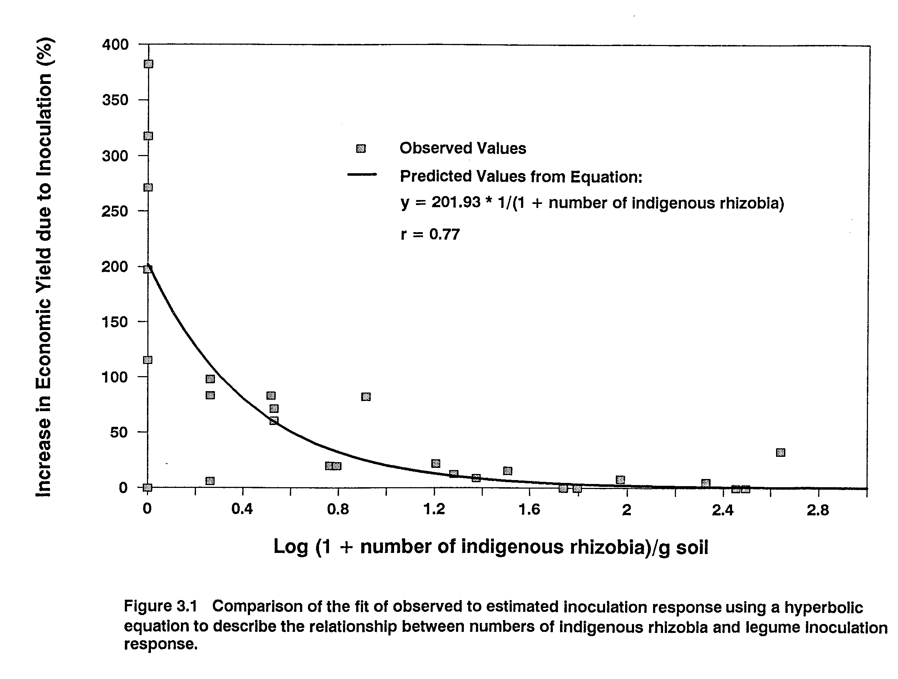

describe the relationship between N mineralization potential and the slope coefficients, the relationship is most nearly linear. The single point deviating from a linear relationship (Figure 3.3 A) was from a site where factors other than N were the major limitations to yield (see Chapter 2). The relationship between N derived from N₂ fixation and the slope coefficients is best described by an exponential equation, although both linear and parabolic relationships were highly significant. Significant linear relationships were found between the slope coefficients, N accumulation and seed yield of non-nodulating soybean, and total soil N (r=0.85, r=0.82, r=0.46, respectively) (Appendix 4). Substitution of these equations for the slope coefficient (b0) in the hyperbolic response regression yielded useful predictive models (Table 3.3).
The models can be evaluated by comparing the residual mean square values and the correlation between observed inoculation responses and those estimated by each function (Table 3.3) (for analysis of residuals see Appendix 5.1). Incorporating expressions of N availability into the hyperbolic model improves agreement between observed and predicted values compared to the initial response regression (r=0.77) (Table 3.2 and Figure 3.1). Of these, the exponential equation involving N derived from N₂ fixation in soybean and the linear expression incorporating soil N mineralization potential show the most promise when used to estimate b0. A comparison between observed inoculation responses and regression lines generated by these two equations is shown in Figure 3.4. Substitution of expressions involving measures of available N for the slope

Table 3.3 Measures of soil N availability in the Maui inoculation trials and their relationship to the slope coefficient (b0) in the hyperbolic-response model: Response = b0 * 1/(1 + number of indigenous rhizobia).
Relationship  to b0 | Measure of Soil N  Availability (MSA) | Units | Coefficients  b1 b2 | Residual  Mean  Square | Correlation of  Observed vs  Predicted Values  r
Linear:  b0 = b1 + b2(MSA) | N Mineralization | ug N/g soil/wk | 314.7 -5.1 | 3680.1 | 0.83
 | Total Soil N | % | 335.6 -742.3 | 3658.5 | 0.83
 | Seed Yield of  Non-nod Soybean | kg/ha | 422.4 -0.2 | 2329.3 | 0.91
 | N Accumulated by  Non-nod Soybean | kg N/ha/da | 440.0 -364.3 | 2048.7 | 0.92
 | N derived from  N fixation | % | -87.5 4.5 | 1510.0 | 0.94
Logarithmic:  b0 = b1 + b2(log(MSA)) | N Mineralization | ug N/g soil/wk | 535.2 -259.4 | 3680.1 | 0.84
Exponential:  b0 = b1(exp^b2(MSA)) | N derived from  N fixation | % | 7.3 0.05 | 1211.9 | 0.96

coefficient proportionally decreased estimated inoculation response as N availability increased (and symbiotic N demand decreased). This yielded better inoculation response estimates which improved the agreement between observed responses and those estimated by the hyperbolic response regression (Figure 3.5).
Nitrogen derived from N₂ fixation in soybean is the best estimator of available soil N because it is a direct expression of symbiotic N demand. Therefore, it reflects not only soil N availability, but integrates the effects of all other environmental variables on yield potential. Incorporating the exponential equation involving N derived from N₂ fixation in soybean into the hyperbolic response regression provided the best fit of observed to predicted values (r=0.96) (Figures 3.4 B and 3.5). Ability to predict inoculation response using this equation is limited, however, by the need to grow non-nodulating and nodulating soybean at a site in order to obtain an inoculation response estimate.
Another approach to estimating symbiotic N demand involved the use of soil N deficit factors (Table 3.4). Expressions involving these factors use the difference between crop N demand and soil N supply to fractionally decrease the maximum predicted inoculation response such that:
b0 = b1 ((N demand - N supply)/N demand)
where b0 is the slope coefficient in the hyperbolic response regression; b1 is the maximum predicted inoculation response (% increase in economic yield); N demand is either the N accumulation (kg N ha⁻¹ d⁻¹) (Appendix 6) or seed yield (kg ha⁻¹) (Appendix 2) of crops

grown with no N limitation to yield (fertilizer N treatment as described in Chapter 2); and N supply is either N accumulation (kg N ha⁻¹ d⁻¹) or seed yield (kg ha⁻¹) of non-nodulating soybean (Table 3.1). Nitrogen supply can also be estimated using N mineralization potential or total soil N. However, if either of these variables is used, the general equation is modified as follows:
b0 = b1 * ((N demand - (b2 * N supply))/N demand)
where b2 is a coefficient that adjusts for the change in units between N demand and N supply.
The lowest residual mean square and best correlation between observed inoculation responses and predicted values were achieved with the equation that uses yield variables to express both crop N demand and soil N supply (r=0.90) (Table 3.4) (for analysis of residuals see Appendix 5.2). Although all of these expressions provide reasonable inoculation response estimates, their usefulness can be increased by using actual yield data from farms in regions of interest to provide input values.
In summary, inoculation response was inversely related to numbers of indigenous rhizobia. This relationship was best described by a hyperbolic equation. The fact that 59% of the observed variation in inoculation response could be accounted for by numbers of indigenous rhizobia illustrates the profound influence that soil rhizobial populations have on the success of rhizobial inoculants. Slope coefficients generated from the use of the hyperbolic equation were significantly related to various measures of soil N availability. Significant relationships were quantified and resulting expressions
Table 3.4 Soil N deficit factors in the Maui inoculation trials and their relationship to the slope coefficient (b0) in the hyperbolic-response model: Response = b0 * 1/(1 + number of indigenous rhizobia).
Relationship to b0 | Measures of crop N  demand and soil N  supply (NDEM;NSUP) | Units | Coefficients  b1 b2 | Residual  Mean  Square | Correlation of  Observed vs  Predicted Values  r
Fractional decline:  b0 = b1 + [NDEM - b2(NSUP)  NDEM] | N Accumulated by N  fertilized plants;  N Mineralization | kg N/ha/da  ug N/g soil/wk | 397.6 0.05 | 2865.2 | 0.86
 | N Accumulated by N  fertilized plants;  Total Soil N | kg N/ha/da  % | 360.5 4.9 | 3267.7 | 0.83
 | Yield of N fertilized  plants;  N Mineralization | kg/ha  ug N/g soil/wk | 388.3 67.1 | 3016.2 | 0.89
 | Yield of N fertilized  plants;  Total Soil N | kg/ha  % | 369.0 7640.7 | 3255.3 | 0.87
Fractional decline:  b0 = b1 * [(NDEM - NSUP)  NDEM] | N Accumulation of N  fertilized plants;  N Accumulation of  Non-nod Soybean | kg N/ha/da  kg N/ha/da | 317.3 | 2830.9 | 0.88
 | Yield of N fertilized  plants; Yield of  Non-nod Soybean | kg/ha  kg/ha | 326.5 | 2425.1 | 0.90

substituted for the slope coefficient in the hyperbolic equation to generate models for predicting legume response to rhizobial inoculation. While predicted values from the model incorporating N derived from N₂ fixation, a post-harvest variable, was most highly correlated with observed inoculation responses, its use in a predictive capacity is limited. On the other hand, the model that combines soil N mineralization potential with numbers of indigenous rhizobia, while providing less precise estimates of inoculation response, is more useful because all input variables can be obtained through soil analysis prior to planting. These models reduce the need to conduct multiple field inoculation trials to estimate responses to inoculation that can be expected by farmers. They also provide the predictive capability needed by regional planners to determine the inoculation requirements of legumes introduced into new areas and, in turn, the need for and capacity of inoculant production facilities in their area.
Chapter 4
Environmental Effects on Rhizobial Interstrain Competition for Nodule Occupancy

Introduction
Competition between strains of rhizobia for nodule occupancy is a complex and controversial area in the study of the legume-Rhizobium symbiosis. Many environmental variables, intrinsic characteristics of the rhizobia themselves, and genetic determinants of the host contribute to the success or failure of rhizobial strains to occupy a significant proportion of nodules formed under a given set of conditions (for review see bowling and Broughton, 1986).
Environmental factors reported to affect competition for nodule occupancy include presence of indigenous rhizobia (Ireland and Vincent, 1968; Bohlool and Schmidt, 1973; Weaver and Frederick, 1974a,b), soil type (Damirgi et al., 1967; Ham et al., 1971), temperature (Caldwell and Weber, 1970; Weber and Miller, 1972; Kvien and Ham, 1985; Kluson et al., 1986), moisture (Boonkerd and Weaver, 1982), pH (Damirgi et al., 1967; Dughri and Bottomley, 1983,84), nitrogen availability (McNiel, 1982), and microbial antagonism (Schwinghamer and Brockwell, 1978; Triplett and Barta, 1987). Characteristics of rhizobia that may influence the outcome of competition are host genotype compatibility (Johnson et al., 1965: Caldwell and Vest, 1968; Diatloff and Brockwell, 1976; Materon and Vincent, 1980; Kvien et al., 1981; Keyser and Cregan, 1987), motility and chemotactic responses (Hunter and Fahring, 1980; Wadisirisuk et al., 1989), and ability to attach to host roots and initiate nodule formation (Dart, 1977). While researchers agree that indigenous rhizobia have a tremendous impact on competition for nodule occupancy by inoculant rhizobia, considerable disparity exists in the literature concerning the influence of other environmental variables.
Interstrain competition for nodule occupancy has been studied in both the greenhouse and the field from a variety of perspectives: among strains comprising the indigenous population (Caldwell and Weber, 1970; Weber and Miller, 1972; Klubek et al., 1988); between one or several introduced strains and the indigenous population (Read, 1953; Johnson et al., 1965; Ireland and Vincent, 1968; Bohlool and Schmidt, 1973; Weaver and Frederick, 1974a,b; Roughley et al., 1976; Brockwell et al., 1982; Berg et al., 1988; Klubek et al., 1988), and among introduced strains in the absence of an indigenous population (Caldwell, 1969; Kosslak and Bohlool, 1985; Brockwell et al., 1987; George et al., 1987: Abaidoo et al., 1990). Much attention has been paid to factors that affect the ability to establish inoculant strains in a significant proportion of nodules formed on plants growing in soil with indigenous rhizobia. This emphasis on competitive ability of inoculant strains is due to the expectation that successful establishment of strains superior in N₂ fixing ability will lead to yield improvement. This perspective presupposes that indigenous rhizobia are symbiotically less effective than inoculant strains. While this has been shown to be true in some cases (Ireland and Vincent, 1968), the average effectiveness of populations of indigenous rhizobia may be comparable to that of inoculant strains (Bergersen, 1970; Singleton and Tavares, 1986).
Some evidence indicates that, in the absence of indigenous rhizobia, competitive ability is a stable characteristic of rhizobial strains as long as plant growth conditions are agriculturally favorable (Brockwell et al., 1982; George et al., 1987; Beattie et al., 1989; Abaidoo et al., 1990). In other words, that the competition pattern exhibited among several introduced rhizobial strains remains constant as long as the environmental conditions remain within the ecological amplitude (range of tolerance) of the strains in question. Implicit in this concept is that competitive competence may indeed be influenced by more extreme environments, some of which may be within the ecological amplitude of the crop. It is generally thought that crops are more sensitive to environmental adversity than are rhizobia (Lowendorf, 1980), however, certain aspects of competition such as bacterial motility, attachment, and nodule initiation may be more sensitive to changes in the environment than either crops or rhizobia living saprophytically.
Several mathematical models have been proposed in the literature to describe and quantify competition for nodule occupancy. Ireland and Vincent (1968) found that nodule occupancy by inoculant rhizobia (log₁₀) was related to inoculant application rate (log₁₀) and number of indigenous rhizobia (log₁₀) by a multiple linear equation. Weaver and Frederick (1974a) reported a similar relationship between these variables. Amarger and Lobreau (1982) studied the effect of varying ratios of inoculant rhizobia applied to soils containing indigenous rhizobia on nodulation competitiveness of strains of Rhizobium leguminosarum. They found that the ratio of nodules formed by the inoculant strain to nodules formed by indigenous rhizobia was related to the ratio of cells in the inoculum to those in the soil by a power function (y = ax^{n}). This relationship was used to quantitatively compare the relative competitiveness of inoculant strains in different soils (Amarger, 1984). Beattie et al. (1989) studied the relative nodulation competitiveness of two strains of R. leguminosarum biovar phaseoli by varying the ratio of their application rates. They found that the ratio of the proportion of nodules occupied by each strain (log₁₀) was linearly related to the ratio of the cells of each strain in the inoculum (log₁₀). They evaluated the competitiveness of strains by comparing the value of the y intercept from each regression equation which they defined as a competitiveness index. They found a modification of the equation was useful for comparing competitiveness of inoculum strains against an indigenous rhizobial population.
In this study, environmental effects on competition for nodule occupancy between several introduced rhizobial strains and indigenous rhizobia and among the introduced strains both in the presence and absence of indigenous rhizobia were investigated. Outcome of competition between indigenous and inoculant rhizobia was described and quantified and the ability of several competition models to predict results was evaluated.
I took advantage of the diverse environments present at
5 well-characterized sites in the Maui Soil, Climate and
Land Use Network (MauiNet) (Soil Conservation Service, 1984) which provided a suitable database to correlate environmental factors with competition for nodule occupancy in different legumes. Many studies have been done and conclusions drawn regarding competition from sites with relatively narrow ecological amplitudes. The diversity of soils and climates in the MauiNet allowed evaluation of the influence of many environmental variables on rhizobial interstrain competition. Identification of factors that strongly influence the outcome of competition can be used to help match rhizobial strains to particular environments and identify environmental variables that may be manipulated to give the balance of the advantage to inoculant strains.
Materials and Methods
Field inoculation trials. Eight field inoculation trials, using 2-4 legumes in each trial chosen from among 9 legume species, were conducted at five diverse sites in the MauiNet (Soil Conservation Service, 1984) on the island of Maui, HI. Design, installation, harvest, and analysis of these trials inoculum strains used, inoculation procedure, and determination of nodule occupancy enumeration of indigenous rhizobia; site characteristics: and collection of climatic data have been described previously (Chapter 2).
Assay for the effectiveness of indigenous Bradyrhizobium sp.. Soil was collected from unplanted areas adjacent to the field trials at sites 1, 3, and 4 (Table 2.1). Most-Probable-Number of indigenous rhizobia (MPN) was determined on 4 test hosts: Vigna unguiculata, Phaseolus lunatus, Arachis hypogaea, and Macroptilium atropurpureum. Method of soil sampling and MPN determination have been described previously (Chapter 2). A representative sample of nodules was taken from the MPN assays performed on V. unguiculata. Nodules were selected from all dilutions where present. Nodules formed by inoculant strains TAL 644 and TAL 658 (Table 2.3) were used as positive controls. Nodules were surface-sterilized by immersion in 70% ethanol for 1 minute followed by several rinses in sterile water. Individual nodules were crushed in 0.1 ml of yeast-extract mannitol broth (YMB) (Vincent, 1970), nodule remnants removed, and 4 ml of YMB added. After 2 days incubation at room temperature, 1 ml of each nodule crushate was inoculated onto each of the 4 test hosts growing in plastic growth pouches (Somasegaran and Hoben, 1985). No less than
7 uninoculated control plants were maintained for each test host. Observations on abundance, size, and interior color of nodules and plant vigor were recorded and leaf chlorophyll content (chl a + chl b) determined 32 days after inoculation (DAI) for V. unguiculata and P. lunatus and 41 DAI for A. hypogaea and M. atropurpureum. Relative effectiveness of the crushates was determined by comparing the chlorophyll content of 6 leaf discs (dia. = 0.635 cm) taken from the most recently fully expanded trifoliate leaf on each of the test hosts (Mirza et al., 1990). Crushates forming nodules on the test hosts were divided into 4 effectiveness groupings: highly effective, effective, moderately effective, and ineffective. Crushates were considered to be ineffective if the chlorophyll content of host plant leaf discs was within the 95% confidence interval for the chlorophyll content of uninoculated control plants. Crushates were deemed moderately effective if leaf disc chlorophyll content was higher than the upper confidence limit for uninoculated control plants, but less than the lower confidence limit for chlorophyll content of plants nodulated by known effective strains. Crushates were termed effective if leaf disc chlorophyll content was within the 95% confidence interval and highly effective if higher than the upper confidence limit for chlorophyll content of plants inoculated with known effective strains.
Data analysis. Kendall tau b rank correlation and multiple linear and stepwise regression analyses were used to evaluate the relationship between nodule occupancy by inoculant strains and details of the environment. Soil variables used in the analyses were: most probable number of indigenous rhizobia; organic C and N content (%); C:N ratio; N mineralization potential (as described in Chapter 3, Table 3.1); sum of the base nutrient ions (meq 100 g⁻¹ soil) in the CEC (Ca²⁺, Mg²⁺, K⁺, and Na⁺) ; clay, silt, and sand content (%); P retention (%); bulk density; water holding capacity; and pH. Climate variables used were: mean annual rainfall; maximum, minimum, and average soil temperature at 10 cm for the first 10 days following planting and for the interval between planting and nodule harvest; maximum and minimum air temperature for the first 10 days after planting; average soil temperature at 50 cm during the interval between planting and nodule harvest; and the Julian date of planting.
Significance of differences in interstrain competition for nodule occupancy by inoculant rhizobia was determined by a Chi-square test for deviation from a 1:1:1 ratio. Significance of differences in nodule occupancy by the two more similar of the three inoculant strains was determined using a paired t-test. In these analyses, double occupancy by inoculant strains was scored as positive for each strain, therefore, total nodule occupancy exceeded 100 in some cases. However, nodule occupancy by inoculant strains for each legume species was adjusted to total 100 prior to correlation analysis.
Multiple linear regression analysis was performed using the MGLH module of SYSTAT v 4.0 (Wilkinson, 1988). All other analyses were performed using PC-SAS procedures (Statistical Analysis System for personal computers, SAS Institute, 1986).
Results and Discussion
The influence of environmental factors on competition for nodule occupancy by rhizobia was investigated from 2 perspectives in this study: (i) competition between inoculant and indigenous rhizobia for up to 8 legume hosts grown in 5 environments: and (ii) competition among three select inoculant strains for each legume host grown in the different environments. These aspects of competition for nodule occupancy were differentially affected by factors of the environment.
Competition for nodule occupancy between inoculant and indigenous rhizobia. The influence of environmental factors on total nodule occupancy by inoculant rhizobia could be investigated in detail only for the legumes; lima bean (P. lunatus), bush bean (P. vulgaris), and cowpea (V. unguiculata), because only these species had enough data points across sites that had indigenous homologous rhizobia. For each of these species, maximum soil temperature at 10 cm depth during the first 10 days following planting was most strongly related to nodule occupancy by inoculant strains (Table 4.1). Following maximum soil temperature, the relationship between nodule occupancy by inoculant strains and log₁₀ 1 + number of indigenous rhizobia (LOGR) was the most significant. These variables were inversely correlated for lima bean and cowpea and positively correlated for bush bean. Decreasing nodule occupancy by inoculant strains with increasing number of indigenous rhizobia observed for lima bean and cowpea is consistent with other reports (Ireland and Vincent, 1968; Weaver and Frederick, 1974a). Positive correlation between these variables observed for bush bean may have resulted from presence of highly non-competitive indigenous populations of R. leguminosarum biovar phaseoli or difficulty in estimating size of the effective population (Singleton and Tavares, 1986).
In agreement with the results of bloomer et al. (1988), LOGR for all three species was significantly inversely related to average and maximum soil temperature at 10 cm depth and positively correlated with mean annual rainfall. In this study, LOGR was also significantly correlated with soil organic C and N content and soil N mineralization potential (Table 4.1). Significance of these correlations most likely reflects the impact of these environmental variables on the ability of indigenous rhizobia to persist at these sites.
Correlation coefficients between environmental variables and nodule occupancy by inoculant strains for lima bean and cowpea were the converse of those observed for LOGR. In agreement with the positive correlation observed between nodule occupancy by inoculant bush bean rhizobia and LOGR, correlation coefficients between environmental variables and bush bean nodule occupancy were similar to those observed for LOGR. In a stepwise regression procedure performed for the dependent variable percent nodule occupancy by inoculant
Table 4.1 Kendall tau b correlation coefficients for environmental factors influencing nodule occupancy by inoculant rhizobia and size of indigenous rhizobial populations.
Organic  Species Variable C  (%) | Total Soil N  Soil N Mineralization  (%) (ug/g/wk) | pH | Temperature C  Soil (10 cm)  Maximum Average | MAR  (mm/yr) | LOGR^{b}
P.lunatus Occupancyª -0.80  0.050  LOGR^{b} 0.95  0.023 | -0.80 -0.80  0.050 0.050  0.95 0.95  0.023 0.023 | na  -0.74  0.077 | 1.00 0.80  0.014 0.050  -0.95 -0.95  0.023 0.023 | -0.60  0.142  0.74  0.077 | -0.95  0.023
P. vulgaris Occupancy 0.40  0.327  LOGR 0.80  0.050 | 0.40 0.40  0.327 0.327  0.80 0.80  0.050 0.050 | na  -0.80  0.050 | -0.60 -0.40  0.142 0.327  -1.00 -0.80  0.014 0.050 | 0.20  0.624  0.60  0.142 | 0.60  0.142
V. unguiculata Occupancy -0.74  0.077  LOGR 1.00  0.014 | -0.74 -0.74  0.077 0.077  1.00 1.00  0.014 0.014 | na  -0.60  0.142 | 0.95 0.74  0.023 0.077  -0.80 -1.00  0.050 0.014 | -0.53  0.207  0.80  0.050 | -0.74  0.077
LOG R for all 3 species 0.71  (n = 15) >0.001 | 0.71 0.71  >0.001 >0.001 | 0.61  0.003 | -0.73 -0.71  >0.001 >0.001 | 0.61  0.003
a Total nodule occupancy by 3 inoculant rhizobial strains as determined by immunofluorescence microscopy.
b Log (1 + most probable number of indigenous rhizobia) per g soil.

bush bean rhizobia and LOGR, correlation coefficients between environmental variables and bush bean nodule occupancy were similar to those observed for LOGR. In a stepwise regression procedure performed for the dependent variable percent nodule occupancy by inoculant strains and all environmental variables measured, LOGR was the only variable that met the 0.15 significance level for entry into the model. The data indicate that environmental factors exert their influence on nodule occupancy by inoculant strains indirectly through their effect on the size of the indigenous rhizobial population. And, that the number of indigenous rhizobia present at a site is the primary environmental factor affecting total nodule occupancy by inoculant strains.
The best mathematical relationship between nodule occupancy by introduced strains against an increasing background of indigenous rhizobia was found to be a derivative of the equation first proposed by Ireland and Vincent (1968), as modified by Weaver and Frederick (1974a) (Table 4.2). Weaver and Frederick (1974a) found that percent nodule occupancy by inoculant rhizobia was dependent upon the log₁₀ number of inoculant rhizobia applied per 2.5 cm of row and the log₁₀ number of indigenous rhizobia g⁻¹ soil. In these trials, the significance of this relationship was no different from that obtained using the single independent variable LOGR because rates of inoculant application were at consistently high levels across sites. The fit of observed to predicted values using the equation:
y = a + b log (x + 1)
where y is the percent of nodules occupied by inoculant rhizobia and x is the number of indigenous rhizobia g⁻¹ soil is presented in Figure 4.1. This equation was used to develop individual predicted values for lima bean and cowpea which agreed closely with those obtained from regression analysis across all sites and species (Figure 4.1). Predicted values developed using the bush bean data reflect the positive correlation observed for this species between LOGR and nodule occupancy by inoculant strains. This result may indicate that indigenous R. leguminosarum bv phaseoli populations were highly non-competitive or that numbers of these bacteria were overestimated (Chapter 2). A significant relationship between nodule occupancy by inoculant rhizobia and indigenous rhizobial population size was not obtained for the legume systems used in this study using the equation proposed by Beattie et al. (1989) for R. leguminosarum biovar phaseoli (Table 4.2).
While nodule occupancy by inoculant strains declined as numbers of indigenous rhizobia increased, inoculant strains were, in general, quite competitive. Weaver and Frederick (1974b) reported that in order for inoculant rhizobia to occupy greater than 50% of the nodules formed in the presence of indigenous rhizobia, they must be applied at a rate 1000 times that of the indigenous population g⁻¹ soil. Across all 8 legume species used in these trials, greater than 50% occupancy by inoculant strains was achieved in 75% of the observations where inoculant rhizobia were applied at a rate less than 1000 times the size of the indigenous rhizobial population (Table 4.3). This result demonstrates the tremendous inoculation success, as measured by nodule

Table 4.2 Summary of equations to describe the relationship between total nodule occupancy by inoculant rhizobia in all trials, number of indigenous rhizobia, and inoculant application rate.
Value (and significance)  Form of the equation of coefficients  a b c | Regression  r^2 | Citation
log y = a + b log x1 + c log x2 2.46 -0.061 -0.133  (>0.001) (ns) (0.001) | 0.38  (.003) | Ireland and  Vincent, 1968
y = a + b log x3 + c log x2 131.78 -4.77 -14.12  (.007) (ns) (>0.001) | 0.48  (>0.001) | Weaver and  Frederick, 1974a
log (y/1-y) = a + b log (x1/x2) -0.70 0.235  (ns) (0.059) | 0.17  (0.059) | Beattie et al.,  1989
y = a + b log x2 98.07 -14.35  (>0.001) (>0.001) | 0.47  (>0.001) | This study
where: y = percent of nodules occupied by inoculant rhizobia.
x1 = number of inoculant rhizobia applied per seed and x3 = number of inoculant rhizobia applied per
2.5 cm of row.
x2 = most probable number of indigenous rhizobia per g soil.

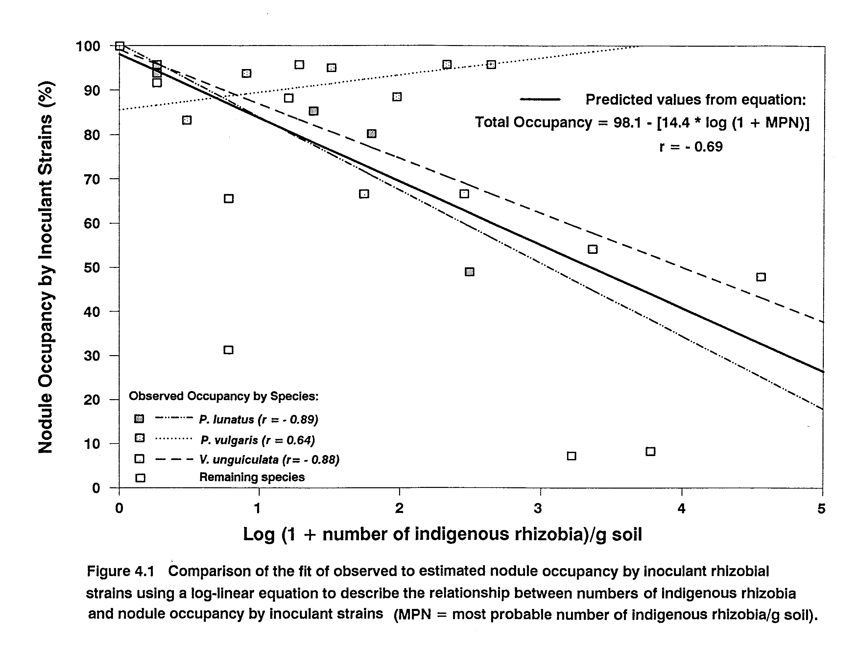
occupancy by inoculant rhizobia, achieved in these trials across a wide range of environments. Inoculants were applied at realistic economic rates, which, indicates that existing inoculation technology may be adequate for successful nodule establishment of inoculant rhizobia. However, while nodule occupancy by inoculant rhizobia was significantly correlated with percent increase in yield due to inoculation (r = 0.43, p < 0.02), greater than 50% nodule occupancy by inoculant strains did not guarantee a significant yield response to inoculation (Figure 4.2, Table 4.3). This was perhaps due to the high effectiveness of indigenous rhizobial populations. A significant inoculation response was achieved in all trials where the ratio of applied to indigenous rhizobia exceeded 1000 to 1, and in only 2 trials, both with bush bean, where this ratio was less. These results support conclusions reached previously (Chapter 2) that where yield is limited by insufficient soil N, size of the indigenous rhizobial population is the primary environmental factor determining the ability of inoculation to increase yield.
Competitive success of inoculant strains was inversely and significantly correlated (r = -0.59, p = 0.001) with the competitive ability of indigenous rhizobial populations as well as their size. Competitiveness of indigenous rhizobial populations can be expressed as the ratio of nodule occupancy by indigenous rhizobia to their number in the soil (percent occupancy by indigenous rhizobia/LOGR). This ratio provides both a measure of the strength of the competition barrier presented by the indigenous population and a means to compare the relative competitiveness of rhizobial populations across sites
Table 4.3 Competitive success of inoculant strains in relation to indices of the size and competitive strength of indigenous rhizobial populations.
Site  No. | Legume  Species | Log (1+MPN  Indigenous  Rhizobia) | Indigenousª  Competition  Barrier | Nodule  Occupancy  by Inoculant  Rhizobia (%) | Ratio of^{b}  Applied to  Indigenous | Inoculation  Response  (p < 0.10)
1 | P.lunatus | 0.26 | 31.6 | 91.7 | 6002 | *
2 |  | 1.79 | 11.0 | 80.2 | 137
3 |  | 0.26 | 23.6 | 93.8 | 10016 | *
4 |  | 2.49 | 20.4 | 49.0 | 18
5 |  | 1.38 | 10.6 | 85.4 | 132
1 | V. | 1.74 | 19.1 | 66.7 | 94
2 | unguiculata | 3.36 | 13.6 | 54.2 | 2
3 |  | 1.28 | 3.3 | 95.8 | 227
4 |  | 4.56 | 11.4 | 47.9 | <1
5 |  | 2.45 | 13.6 | 66.7 | 3
1a | A. hypogaea | 0.78 | 88.3 | 31.3 | 2479 | *
3a |  | 0.78 | 44.2 | 65.6 | 1892 | *
1a | L. | 3.22 | 28.8 | 7.3 | 2
3a | leucocephala | 3.77 | 24.3 | 8.3 | 1
5a | L. tingeatus | 1.20 | 9.7 | 88.3 | 130
5a | T. repens | 0.26 | 16.0 | 95.8 | 294
1 | P. vulgaris | 0.90 | 6.9 | 93.8 | 456 | *
2 |  | 1.97 | 5.8 | 88.5 | 17
3 |  | 0.48 | 35.0 | 83.3 | 1009 | *
4 |  | 2.64 | 1.6 | 95.8 | 24 | *
5 |  | 1.51 | 3.3 | 95.1 | 44
1 | G. max | 0 | 0 | 100 | na | *
2 |  | 0 | 0 | 100 | na | *
3 |  | 0 | 0 | 100 | na | *
3a |  | 0 | 0 | 100 | na | *
4 |  | 0 | 0 | 100 | na | *
5 |  | 0 | 0 | 100 | na
a  b | Percent nodule occupancy by indigenous rhizobia/log (1 + MPN of indigenous rhizobia).  Number of inoculant rhizobia applied/MPN of indigenous rhizobia per g soil.

(Table 4.3). For example, at the two sites where peanut was grown (sites la and 3a), numbers of indigenous rhizobia were equal, yet, inoculant strains occupied less than half the number of nodules at site 1a as they did at site 3a. Using the ratio defined above, it can be seen that indigenous rhizobia at site 1a were twice as competitive as those at site 3a and presented a much stronger competitive barrier to nodule occupancy by inoculant strains. Indeed, the Bradyrhizobium sp. population present at site 1 was also more competitive on cowpea and on lima bean than that at any other site (Table 4.3). With the exception of indigenous rhizobia nodulating cowpea, the next most competitive indigenous population was that present at site 3. Environmental conditions at sites 1 and 3 were harsher than at the remaining sites (higher soil temperatures and lower mean annual rainfall) (Table 2.1) indicating that better adaptation to prevailing environmental conditions by indigenous rhizobia may also contribute to their competitiveness. With the exception of site 3, populations of Rhizobium Leguminosarum bv phaseoli presented a comparatively weak competition barrier across sites. This may help to explain the consistently anomalous results obtained with bush bean at these sites (discussed above).
Sub-groups of the cowpea miscellany, Bradyrhizobium sp.
Considerable diversity exists in the relative effectiveness of populations of indigenous Bradyrhizobium sp. on different host legumes (Singleton and Tavares, 1986). This diversity is reflected in differences in the size of bradyrhizobial populations capable of nodulating homologous hosts and their competitiveness with the
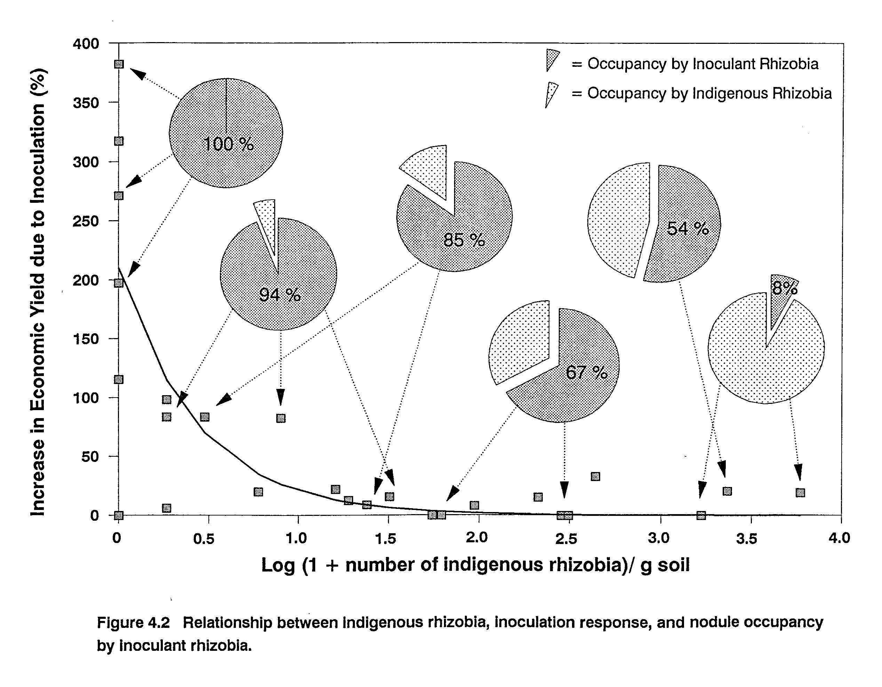
different hosts. Cowpea, lima bean, peanut, and siratro are all nodulated by rhizobia classified in the Bradyrhizobium sp. group. However, MPN counts of indigenous rhizobia capable of nodulating these legumes are substantially different within the same soil sample from a given site (Table 2.2). At all sites, MPN counts of indigenous Bradyrhizobium sp. were highest on cowpea and siratro (M. atropurpureum), the more promiscuous of these hosts. A smaller population of these rhizobia nodulated peanut, and, a considerably smaller proportion of the population was able to nodulate lima bean. Relative effectiveness of indigenous bradyrhizobia from 3 MauiNet sites was evaluated on these 4 hosts.
Effectiveness of nodule crushates on cowpea was roughly normally distributed with approximately two-thirds or more of the crushates forming moderately effective to effective symbioses and the remaining crushates divided between forming highly effective or ineffective symbioses (Table 4.4). A greater proportion of effective to highly effective crushates were observed on cowpea at site 1 compared to the other sites. Effectiveness profiles of the crushates were strikingly different on the other legumes (Table 4.4). Across sites, 56-84% of the crushates either failed to nodulate or formed ineffective nodules on lima bean resulting in a much lower proportion of the crushates forming moderately effective to effective symbioses. Thirty percent or more of the crushates failed to nodulate or formed ineffective nodules on peanut. However, at sites 1 and 4 a greater proportion of the crushates was moderately effective and, at site 4, close to half of the crushates were no different in effectiveness than inoculant

Table 4.4 Relative effectiveness of cowpea nodule crushates obtained from 3 Maui field soils on 4 legumes that nodulate with Bradyrhizobium sp.
Site 1 - Hashimoto Farm | Site 3 - Kula Agricultural Park | Site 4 - Haleakala Station
Nodulates  Legume Yesª No  Species HE E M I | Nodulates  Yes No  HE E M I | Nodulates  Yes No  HE E M I
__________% _________ | __________% _________ | __________% _________
V. unguicuiata 21^{b} 55 19 5 0 | 11^{c} 46 19 24 0 | 17^{d} 52 14 17 0
M. atropurpureum 0 3 77 20 0 | 0 20 58 22 0 | 0 47 44 9 0
P.lunatus 3 10 3 66 18 | 6 22 16 24 32 | 9 12 0 79 0
A.hypogaea 0 18 32 42 8 | 0 14 14 21 51 | 0 44 26 6 24
a HE _ highly effective; E = effective; M = moderately effective; and I = ineffective.
b Percentage of 38 crushates.
c Percentage of 37 crushates.
d Percentage of 35 crushates.

strains. All of the crushates were able to nodulate siratro, yet, a higher percentage of the crushates from all sites formed only moderately effective symbioses on this species. Site 1 yielded a higher percentage of ineffective crushates, while fewer ineffective and a roughly equivalent proportion of effective crushates were obtained at site 4. Clearly, the relative effectiveness of the indigenous bradyrhizobial population nodulating cowpea is patently different on the other host legumes. These observations agree with those of Singleton and Tavares (1986) who found that, within a soil, the range of effectiveness of indigenous rhizobial isolates obtained from nodules formed on cowpea, lima bean, and peanut and inoculated back onto the same hosts differed. These authors did not, however, characterize the effectiveness of isolates from any one of the hosts on the others. Hence, the nature of differences observed in the range of effectiveness of the isolates could not be determined. To examine the nature of these differences, effectiveness of crushates was determined on cowpea and performance of crushates in the resulting effectiveness groupings determined for the other species (Tables 4.5-4.7).
Population effectiveness profiles differed for the other hosts. The extent of differences in crushate effectiveness varied depending on site. At sites 1 and 4, only 17-18% of the crushates within the effectiveness groupings highly effective (HE), effective (E), and moderately effective (M) for cowpea, were also effective on lima bean (Tables 4.5 and 4.7). At site 3, this proportion was higher (46%) (Table 4.6). However, greater host/crushate incompatibility for infection was observed at sites 1 and 3, where 18 and 32%, respectively, of all crushates failed to modulate lima bean. In contrast, all crushates from site 4 modulated lima bean, yet, a higher proportion of crushates were incompatible for effectiveness (79%) (Table 4.4). These trends appear to be reversed for peanut where at site 3, fewer of the crushates effective on cowpea were also effective on peanut (21%) (Table 4.6), whereas, sites 1 and 4 yielded a higher proportion of crushates effective on both species (50 and 68%, respectively) (Tables 4.5 and 4.7). Unlike lima bean, one fourth of all crushates failed to modulate peanut at site 4, whereas, only a small percentage (6%) of those modulating this host were ineffective. Similar to lima bean, crushates incompatible for infection with peanut were observed at sites 1 and 3. More than half the crushates at site 3, but, only 8% at site 1, failed to modulate peanut. Effectiveness profiles of cowpea and siratro were quite similar at all sites, however, a few crushates were identified for each site that were effective on cowpea, but, not on siratro and visa versa.
The widest divergence in effectiveness profiles were those observed between lima bean and peanut. Profiles again varied according to site. Of the crushates effective on lima bean; 33%, 81%, and 100 were ineffective or failed to nodulate peanut at sites 1, 3, and 4, respectively (data not shown). Of all crushates that were ineffective or failed to nodulate lima bean; 47%, 19%, and 92% were effective on peanut at sites 1, 3, and 4, respectively. In general, these two legumes shared a larger proportion of crushates in common with cowpea and siratro than with each other.

Table 4.5 Effectiveness of 38 cowpea nodule crushates from site 1 soil on cowpea and their corresponding effectiveness on lima bean, peanut, and siratro.
Distribution of effectiveness of 38 crushates on V. unguiculata:
Highly Effective (HE) Effective (E) Moderate (M) | Ineffective (I)
8 21 7 | 2
Nodulates Nodulates Nodulates  Yesª No Yes No Yes No  HE E M I HE E M I HE E M I | Nodulates  Yes No  HE E M I
M. atropurpureum^{b}  0 0 7 1 0 0 1 11 3 0 0 0 4 1 0 | 0 0 1 1 0
P. lunatus  1 0 0 5 2 0 3 1 14 3 0 1 0 5 1 | 0 0 0 1 1
A.hypogaea  0 1 3 4 0 0 3 7 11 0 0 3 1 1 2 | 0 0 1 0 1
a HE = highly effective; E = effective; M = moderately effective; and I = ineffective.
b Of the total number of crushates, 8 were not tested on this species.

Table 4.6 Effectiveness of 37 cowpea nodule crushates from site 3 soil on cowpea and their corresponding effectivenesson lima bean, peanut, and siratro.
Distribution of effectiveness of 37 crushates on V. unguiculata:  Highly Effective (HE) Effective (E) Moderate (M)  4 17 7 | Ineffective (I)  9
Nodulates Nodulates Nodulates | Nodulates
Yesª No Yes No Yes No  HE E M I HE E M I HE E M I | Yes No  HE E M I
M. atropurpureum  0 2 2 0 0 0 3 11 3 0 0 2 5 0 0 | 0 0 3 5 0
P. lunatus  1 0 0 2 1 1 4 3 5 4 0 3 1 2 1 | 0 1 2 0 6
A.hypogaea  0 1 0 2 1 0 2 2 1 12 0 1 0 2 4 | 0 1 3 3 2
a HE = highly effective; E = effective; M = moderately effective; and I = ineffective.

Table 4.7 Effectiveness of 35 cowpea nodule crushates from site 4 soil on cowpea and their corresponding effectiveness on lima bean, peanut, and siratro.
Distribution of effectiveness of 35 crushates on V. unguiculata:
Highly Effective (HE) Effective (E) Moderate (M)  6 18 5 | Ineffective (I)  6
Nodulates Nodulates Nodulates | Nodulates
Yesª No Yes No Yes No  HE E M I HE E M I HE E M I | Yes No  HE E M I
M. atropurpureum^{b}  0 3 3 0 0 0 9 9 0 0 0 2 1 2 0 | 0 2 2 1 0
P. lunatus^{b}  0 0 0 6 0 3 1 0 13 0 0 1 0 4 0 | 0 2 0 4 0
A.hypogaea^{b}  0 3 0 1 2 0 6 6 1 4 0 3 1 0 1 | 0 3 2 0 1
a HE = highly effective; E =effective; M = moderately effective; and I = ineffective.
b Of the total number of crushates, 1 was not tested on this species.

Doku (1969) used mixtures of nodule crushates to examine the cross-infection patterns in lima bean, peanut, soybean, and cowpea. He found that a mixture of effective nodule crushates from either cowpea or lima bean failed to nodulate peanut. He also reported that lima bean nodulated freely with a mixture of effective nodule crushates from peanut, soybean, cowpea, and bambara groundnut. We used crushates of single nodules as inoculants in this study and found that lima bean was considerably more specific, and, peanut less exclusive than previously reported.
In summary, cowpea and siratro had similar profiles in terms of both invasiveness and effectiveness. Peanut appears to be more specific in terms of nodulation and shows greater specificity for effectiveness than either cowpea or siratro. Lima bean appears to be more specific in terms of effectiveness and shows greater specificity for infection than either cowpea or siratro.
Competition for nodule occupancy among inoculant rhizobia. To investigate the effects of environmental variation on interstrain competition, 4-8 legumes grown in as many as 5 environments were inoculated with an equal mixture of 3 serologically distinct strains of homologous rhizobia. For each legume species, except clover (T. repens), one of the 3 inoculant strains was shown to be a poor competitor across all environments (Figures 4.3-4.8). Competition for nodule occupancy between the remaining 2 strains for each species varied between sites and appeared to be related to climatic and soil variables. For a list of legume hosts and strains see Table 2.2 (Chapter 2).
Competition for nodule occupancy on soybean (G. max) was exclusively between inoculant strains as there were no indigenous Bradyrhizobium japonicum at any of the sites. USDA 110 and USDA 138 were the 2 most successful competitors on soybean, occupying on average across all sites 42% and 50% of nodules formed, respectively (Figure 4.3). USDA 136b failed to be recovered from nodules at site 3, was recovered in 5% or less of the nodules at sites 1 and 2, and occupied between 10% and 16% of the nodules from the remaining sites. Nodule occupancy by this strain was always significantly less than that of USDA 138 and only at site 5 was not significantly less than that of USDA 110 (Figure 4.3). Nodule occupancy by USDA 136b was significantly correlated with soil minimum temperature (at 10 cm for the first 10 days following planting) (r = -0.87, p = 0.015) and clay content (r = -0.69, p = 0.056), where this strain was more successful at the cooler sites and in soils with lower clay content.
Competition for nodule occupancy between USDA 110 and USDA 138 also varied according to site (Figure 4.3). Nodule occupancy between these two strains was not significantly different at sites 1 or 4. USDA 110 occupied a significantly greater proportion of nodules recovered at sites 2 and 3, whereas, USDA 138 occupied significantly more at sites 3a and 5. In general, USDA 110 had higher nodule occupancy at the warmer locations and in higher clay soils (r = 0.87, p = 0.015 and r = 0.69, p = 0.056, respectively). USDA 138 was the more successful competitor in the cooler environments (r = -0.60, p = 0.09).
These results differ from those of Weber and Miller (1972) who found nodule occupancy by serogroup 110 on soybean cultivar 'Lee' to decrease with increasing soil temperature. Kvien and Ham (1985), however, reported that USDA 138 and USDA 110 were equally successful competitors at both high (30 C) and low (15 C) soil temperatures on 4 soybean cultivars. Both of these experiments were conducted in controlled environment chambers which limited other environmental variability to which field trials are subject.
George et al. (1987) and Abaidoo et al. (1990) investigated interstrain competition between USDA 110, USDA 138, and USDA 136b at 3 and 2 field sites, respectively. In agreement with the results reported here, these authors found USDA 110 to be a good competitor for nodule occupancy across sites. However, in contrast with results reported here, George et al. (1987), found USDA 138 to be an extremely poor competitor, occupying less than 5% of nodules formed across sites. USDA 110 was found to consistently occupy greater than two-thirds of nodules formed while USDA 136b occupied the remainder. Abaidoo et al. (1990) found the competitive ability of USDA 138 to be equivalent to that of USDA 136b (33% and 37%, respectively) across sites. However, both strains occupied significantly fewer nodules than USDA 110 (68%) across sites. No significant relationship between competition for nodule occupancy and either soil temperature or type was reported in either of these experiments. Average soil temperatures in the experiment of George et al. (1987) ranged from 20.7 C to 25.3 C and were 22 C and 25 C at the two sites used by Abaidoo et al. (1990). Average soil temperatures in the first 10 days following planting in the trials reported here ranged from 20.5 C to 30.8 C, and, were not different from average soil temperatures
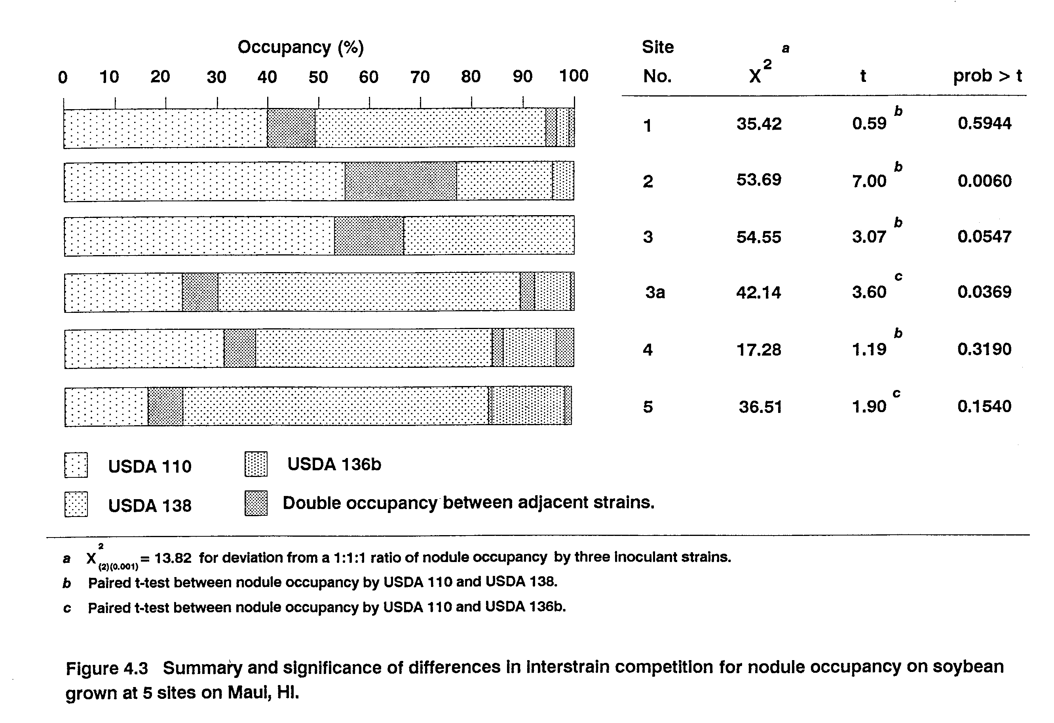

reported across the crop duration (Table 2.1). Perhaps the more extreme temperatures recorded in these experiments provided more environmentally challenging conditions for these organisms, which may have resulted in the observed temperature-related differences in nodule occupancy by these strains. While one effect of elevated temperature may be on differential survival of rhizobia in the rhizosphere, neither Abaidoo et al. (1990), nor Moawad et al. (1984) found a significant relationship between size of the rhizosphere population of different rhizobial strains and their nodule occupancy. In accord with results reported here, a positive correlation between increased nodule occupancy by USDA 110 and soil clay content has also been reported by Weaver and Frederick (1974a). Soil temperature and clay content may be influencing nodule occupancy by inoculant rhizobia through effects on bacterial motility, chemotaxis, or hormone production. All of these activities are intrinsic microbial characteristics that have been suggested as mechanisms that may enhance the ability of rhizobial strains to initiate root infections (Bauer, 1981).
In competition for nodule occupancy on lima bean, TAL 169 failed to occupy any of the nodules formed at the 5 sites. Nodule occupancy by the other strains used, TAL 22 and TAL 644, differed significantly at all sites (Figure 4.4). TAL 644 was the most competitive of the 2 strains at four of the five sites. However, TAL 22 was the more successful competitor at site 1. While site 1 had the highest average soil temperature, nodule occupancy by these two strains was not significantly correlated with temperature or any of the other environmental variables examined, including, indigenous bradyrhizobial population size.
For cowpea, TAL 658 was not detected in any of the nodules recovered at any of the sites. Nodule occupancy by TAL 173 and TAL 209 differed significantly at all sites (Figure 4.5). Two genotypes of cowpea were used in these trials, and, rather than being related to details of the environment, nodule occupancy by these strains was more closely related to cowpea genotype. TAL 173 was the more successful competitor on V. unguiculata cv Big Boy, whereas, TAL 209 occupied a significantly greater proportion of nodules on V. unguiculata cv Knuckle purplehull.
TAL 1797 was identified as a poor competitor in these trials as it was not detected in bush bean nodules from sites 2, 3, or 5 and occupied less than 6% of nodules tested from the other sites (Figure 4.6). While nodule occupancy by TAL 182 and TAL 1383 did not differ significantly at any of the sites, nodule occupancy by TAL 1383 was significantly correlated with soil sodium content (r = 0.89, p = 0.016) and inversely related to soil clay content (r = -0.69, p = 0.056).
For the legume species, soybean, lima bean, cowpea, and bush bean, nodule occupancy by individual inoculant strains was correlated (either positively or inversely) with minimum soil temperature and clay content at p = 0.14 or lower. Although correlation coefficients were not highly significant for most strain/species combinations, the trend was evident for all strain/species combinations. Other than the correlation between soil sodium content and bush bean nodule occupancy
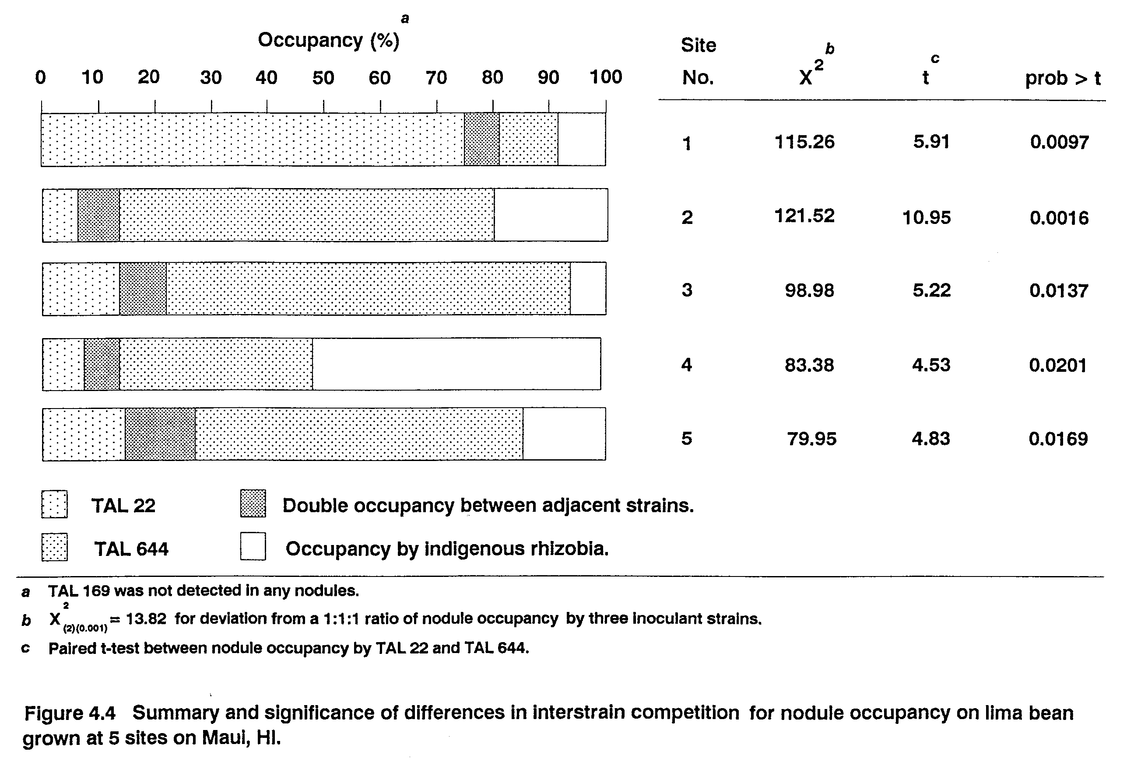

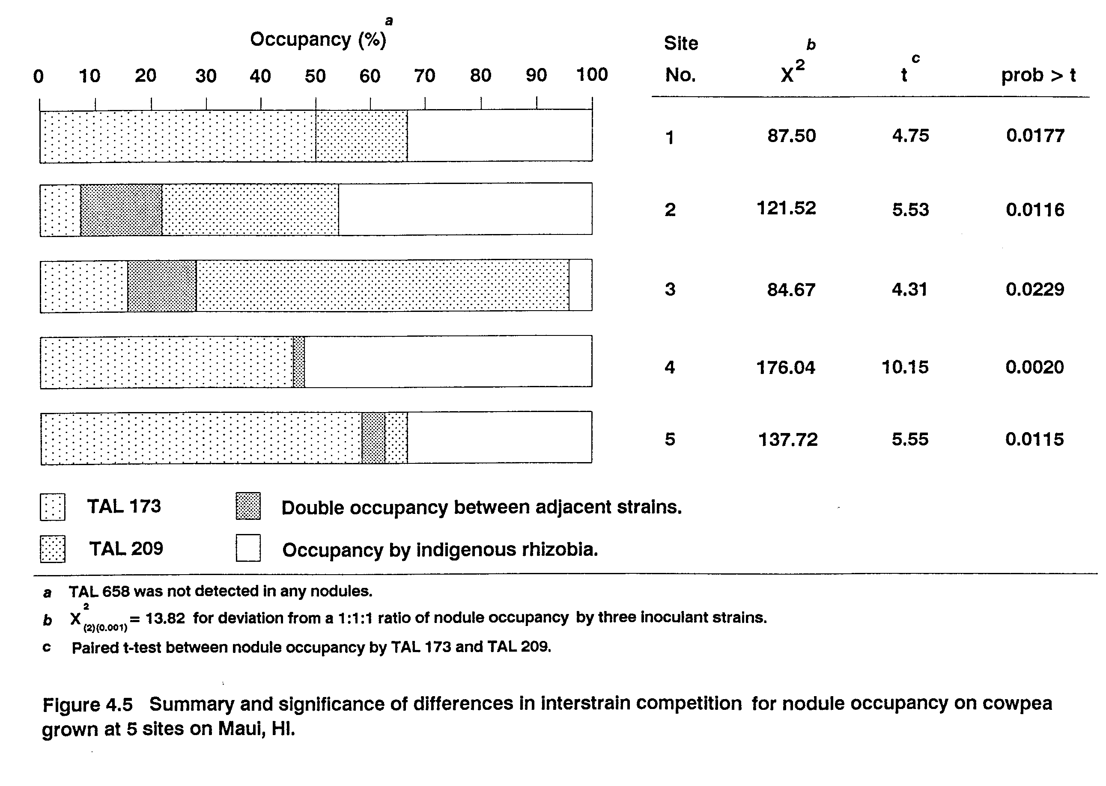

by TAL 1383 as mentioned above, none of the other environmental variables examined were significantly correlated with competition among inoculant strains for nodule occupancy. Soil acidity has been correlated with nodule occupancy in other studies (Damirgi et al., 1967). This relationship and effects of moisture stress could not be evaluated in this study as more acidic soils were limed and fields irrigated to remove these variables as limitations to maximum yield. Considering the extent of differences between the 5 environments, however, it is remarkable that so few variables were found to significantly influence competition for nodule occupancy between inoculant rhizobia. This result supports the suggestion of George et al. (1987) that highly competitive inoculant strains can be identified that will perform well across a range of environments. However, failure of at least one of the three inoculant strains to compete well (or at all) in these environments cautions against the use of single strain inoculants, particularly in more stressful environments.
Competition for nodule occupancy for the remaining legume species could not be correlated with the environmental database as there were not a sufficient number of observations across sites. However, significant differences in nodule occupancy were observed.
TAL 169 and TAL 173 were not detected in nodules sampled from peanuts grown at site 1 and were poorly competitive against both TAL 658 and indigenous bradyrhizobia at site 3a (Figure 4.7). Although TAL 658 was the most competitive of the inoculant strains, it did not prove to be highly competitive against the indigenous bradyrhizobia which numbered only 5 g⁻¹ soil at both sites.
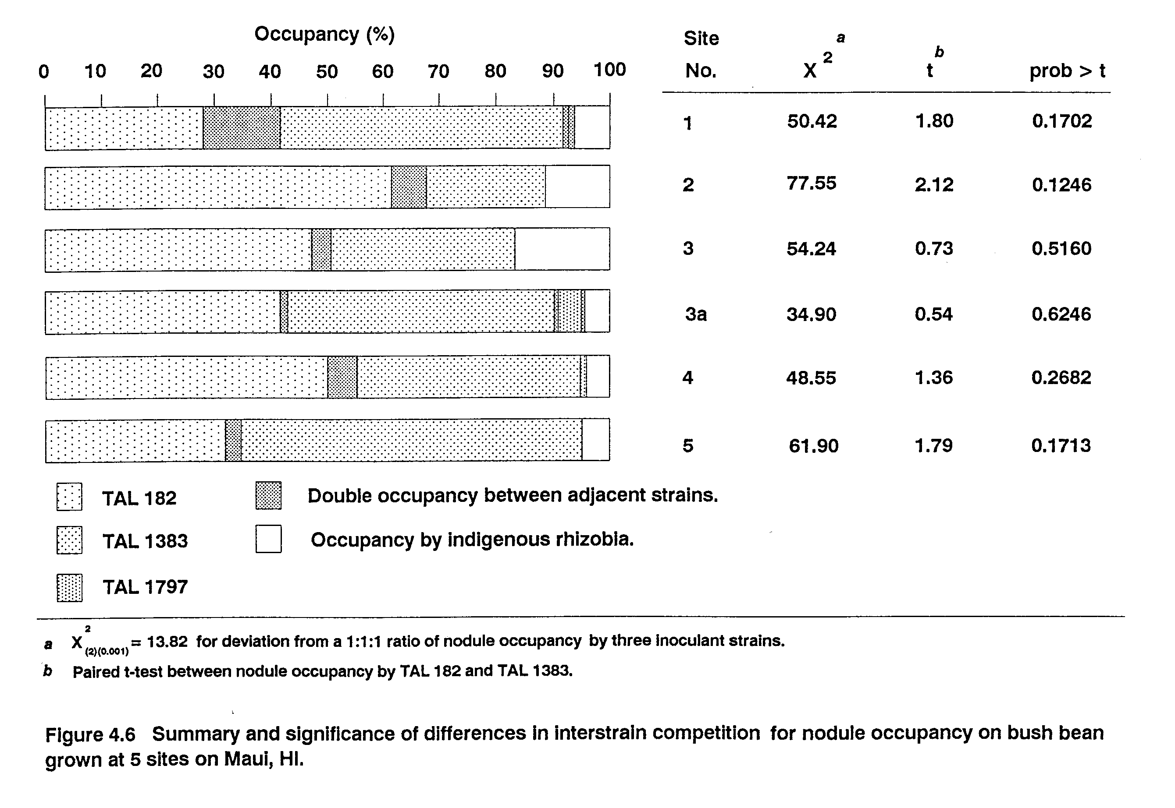

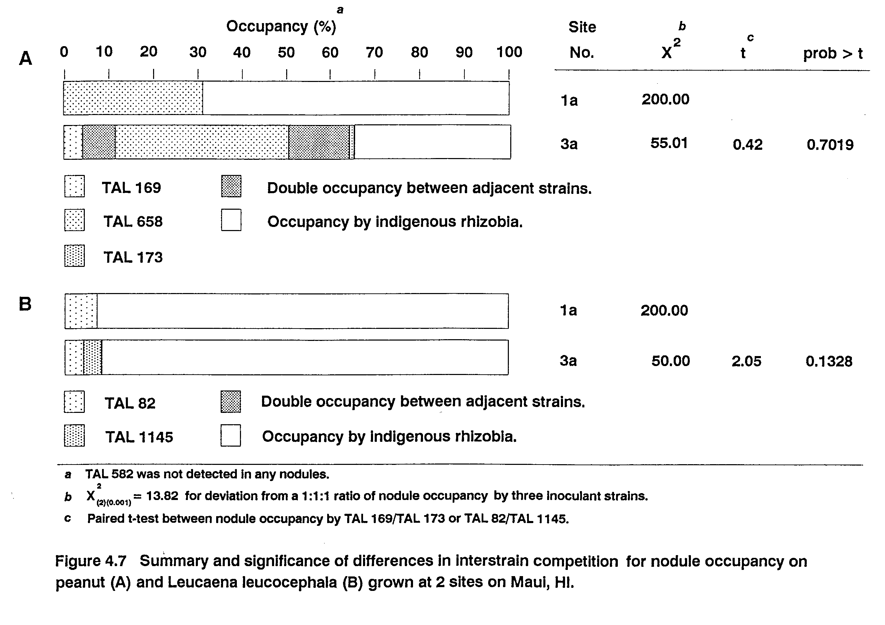

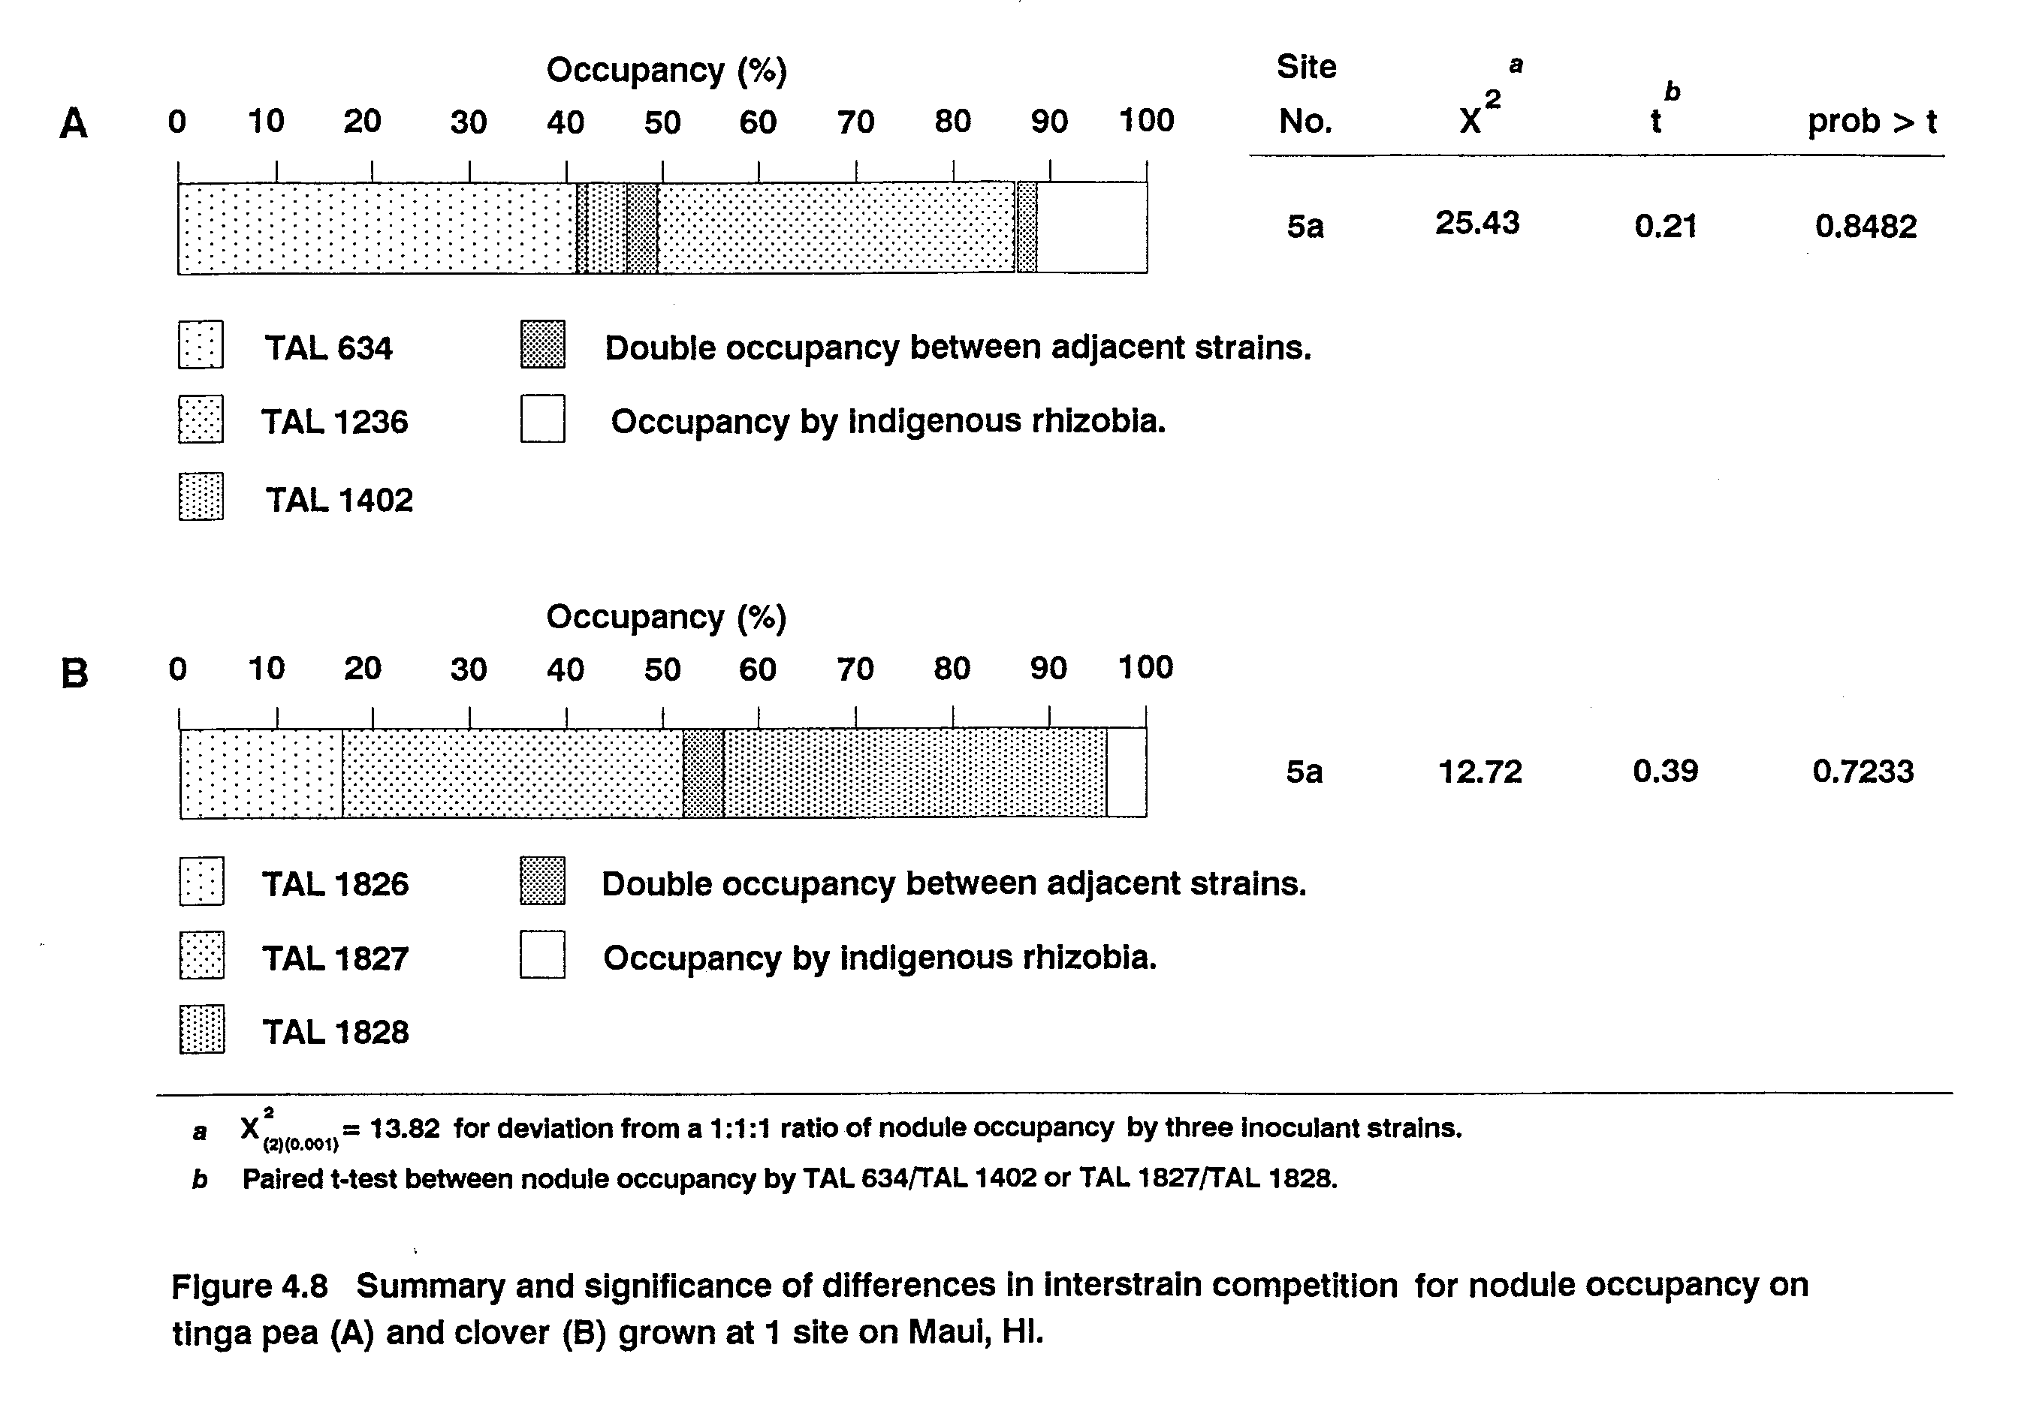
TAL 582 was not recovered from nodules of L. Ieucocephala grown at either site 1a or 3a (Figure 4.7). Failure of this strain to compete successfully for nodule occupancy against TAL 82, TAL 1145, and other Rhizobium sp. strains has been reported previously (Moawad and Bohlool, 1984). There was no significant difference in nodule occupancy by TAL 82 and TAL 1145, both of which failed to compete successfully for nodule occupancy with indigenous rhizobia that were present in excess of 103 g⁻¹ soil at both sites.
Tinga pea (L. tingeatus) and white clover ( T. repens) were grown only at site 5. TAL 1402 proved to be a poor competitor for nodule occupancy on tinga pea (Figure 4.8). While, TAL 634 and TAL 1236 proved to be equally competitive in this trial. Nodule occupancy by the 3 strains used to inoculate clover did not significantly differ.
In summary, factors affecting competition for nodule occupancy were different for the 2 aspects of competition addressed in this study. Competition between inoculant and indigenous rhizobia was most strongly influenced by the size and competitiveness of the indigenous rhizobial population. Whereas, competition between inoculant strains appeared to be more related to soil and climatic factors and host genotype. This result may reflect the influence of environmental factors on differential survival of inoculant strains, or, their possible effect on the activity of inoculant rhizobia. Highly competitive inoculant strains and non-competitive strains were identified for most legume species in all environments.
CHAPTER 5
Effect of Nitrogen Source on the Growth and Phenology of Soybean and Bush Bean

Introduction
Soybean (Glycine max) and bush bean (Phaseolus vulgaris) are twoeconomically important grain legumes that are grown in diverse environments throughout the world. Both are able to form symbiotic relationships with the soil inhabiting, N₂-fixing bacteria, rhizobia, in the groups Bradyrhizobium japonicum and Rhizobium leguminosarum biovar phaseoli, respectively. The symbiosis between these legumes and their homologous rhizobia results in the conversion of atmospheric N₂ to plant protein. The ability of leguminous plants to obtain the N required for their growth and reproduction from both soil and symbiosis sets them apart from other economically valuable crops, such as cereals, that rely solely on soil N assimilation to satisfy their N requirements. Soils are more often deficient in N than in any other element, consequently, N is the most common nutrient limiting plant growth, particularly in the tropics (Atkins, 1986). Increasing yield through application of nitrogenous fertilizers is costly, may have adverse environmental consequences, and is often not a viable option for farmers in developing countries due to its limited availability. The legume-Rhizobium symbiosis has been exploited for many years to try to reduce dependence on N fertilizers without compromising crop yield (Fred et al., 1932). While yield of symbiotic plants may often be comparable to that of N fertilized plants (Summerfield, et al., 1977; Imsande, 1989; Kucey, 1989), it has been shown that plants relying on soil and symbiotic N for growth may achieve only 80-90% of the yield possible through N fertilization (Table 2.7; Silsbury, 1977; Ryle et al., 1979). Bush bean, in particular, is notorious for symbiotic inefficiencies (Graham, 1981; Piha and Munns, 1987). This crop can respond significantly to fertilizer N application in low-N soils in the absence of other limitations to yield, but, yield of symbiotic crops in the same soils frequently falls short of expectations (Figure 2.1 and Appendix 2).
Numerous soybean and a few bush bean models have been developed in recent years to try to predict crop phenology (timing of developmental stages) and yield under varying environmental conditions (Major et al., 1975; Wann and Raper, 1979; Hadley et al., 1984; Hodges and French, 1985; Salado-Navarro et al., 1986a,b; Sinclair et al., 1987; Jones et al., 1989). Few of these models consider N dynamics. The development, calibration, validation, and refinement of models to predict performance of field crops is an immense undertaking requiring information from, and collaboration between, researchers from many scientific disciplines. These models, by their nature, are simplified representations of real cropping systems that are designed to study, understand, and make predictions about the complex interactions that take place between plants and their environment. Because of the complexity of the cropping system and our inability to measure all variables and their interactions, decisions must be made about which processes will be considered in a model, the detail with which each process is described, and level of interaction between processes. These will ultimately be determined by the purpose for which the model is intended (model objectives). SOYGRO V5.42 (Jones et al., 1989) is one such model. The SOYGRO model was originally designed to predict crop yield as a function of irrigation management, hence, weather, crop genetic potential, and soil water relations have been most extensively modeled.
Because N is present in numerous essential compounds, effects of N deficiency on crops are dramatic. In general, N deficiency causes a reduction in growth rate and general chlorosis, often accompanied by early abscission of older leaves (Salisbury and Ross, 1985). Recently, it has been shown that N deficiency hastens crop maturity in soybean (George et al., 1990). Most legume crop models, including SOYGRO, assume that plants have sufficient N for maximum growth. This assumption is not problematic if growth and yield predictions are to be made for crops grown under high N conditions. However, for these models to be of broader applicability and address problems common to crop production in the developing world, the effects of nutrient insufficiencies, particularly N, on crop growth should be addressed.
When modeling the development and yield of legumes, incorporating subroutines to handle N assimilation are complicated by the need to model the symbiotic process. The metabolic cost of N assimilation differs for root uptake and N₂ fixation primarily due to the high energy requirement of the nitrogenase enzyme and cost involved in developing and maintaining nodule tissue (Imsande, 1988; Lynch and Wood, 1988). Increased cost of N₂ fixation in symbiotic plants may result in differences in developmental and growth rates due to diversion of energy to fix N₂ that might otherwise have been used for growth. In N deficient soils, this cost would be amortized by the benefit derived from obtaining fixed N. Developing models that can simulate crop growth under varying sources and supplies of N requires an understanding of the effects of N source on plant development and yield.
This work was undertaken to investigate the effect of N source on growth and yield of soybean and bush bean. The objectives of this study were to ascertain whether: (i) crops relying on soil, symbiotic, or fertilizer N differed in their growth characteristics: (ii) symbiotic plants developed similarly to N fertilized plants; (iii) any effects of N source on crop development were related to final yield; and (iv) the growth simulation model, SOYGRO V5.42, could accurately predict phenology and yield of soybean grown in different environments.
Sites were selected and dates of planting varied in this study to provide differences in both temperature and photoperiod in order to establish whether any differences in development caused by N source were independent of climatic effects. Well characterized sites, equipped with weather stations to record climatic data, were selected from among those in the Maui Soil, Climate, and Land Use Network (MauiNet) (Soil Conservation Service, 1984) on the island of Maui, Hawaii. Weather, site, and soil information were entered into the SOYGRO crop growth simulation model (Jones et al., 1989) and soybean crop growth was simulated. Predictions of the timing of phenological events, duration of growth phases, biomass accumulation, and seed yield were compared with field data. The model was assessed for its ability to simulate growth under non-N limiting conditions. The need to consider N nutrition and symbiotic status of leguminous crops in order to generate realistic predictions of crop growth and development was ascertained.
Materials and Methods
Field inoculation trials. Effect of N source on biomass and N accumulation, phenology, and seed yield of soybean (G. max cv Clark IV, P. Cregan, USDA Nitrogen Fixation Laboratory, Beltsville, MD) and bush bean (P. vulgaris cv Bush Bountiful) was assessed in field trials conducted at sites 1, 3a, 4, and 5 (Table 5.1). General experimental approach, soil amendments, planting density, inoculation procedures, enumeration of indigenous rhizobial populations, and early and final harvest protocols have been described previously (Chapter 2).
In these trials, additional biomass harvests were performed at growth stages V4 (4 nodes on the main stem), R5/R6 (mid pod-fill), and R7 (physiological maturity) (Fehr, et al., 1971) at sites 1, 3a, and 5. For each plot, plants were cut at the soil surface from 3.0 linear m of row (1.8 m²) for the V4 and R5/R6 harvests and from 4.5 linear m of row (2.7 m²) for the R7 harvest. Fresh weight of the sample was determined immediately. A subsample of 10-15 plants was taken to determine moisture content and a 5 plant subsample taken for determination of leaf area and dry weight of component parts. Fresh weight of both subsamples was taken in the field and average number of nodes on the main stem (V stage) recorded. The larger subsamples from all plots were dried, weighed, ground, and analyzed for N content as described previously (Chapter 2). Leaves were removed from plants in the smaller subsamples and leaf area determined with a Licor LI-3100 leaf area meter. Leaves and stems were dried at 70 C to constant weight and weighed separately.
Crop phenology and growth analysis. Crop phenology was recorded every few days in the field from emergence to physiological maturity according to the stage of development descriptions of Fehr et al. (1971). Crop growth rate (CGR) and N assimilation rate (NAR) were calculated by dividing the net increase in biomass or N assimilated by the number of days between harvests. Leaf weight ratio (LWR) equalled leaf dry weight divided by total shoot dry weight. Specific leaf area (SLA) was calculated by dividing leaf area (cm²) of the subsample by its leaf dry weight (g). Total leaf dry weight (Lw) (g nit) was determined by multiplying dry weight of above ground biomass by LWR. Leaf area index (LAI) was calculated by multiplying LW by SLA and dividing by 10,000. Seed fill duration was calculated as days to R7 minus days to R4 (Fehr et al., 1971). Growing degrees days (GDD) were determined by taking the sum from sowing to first flower and from sowing to physiological maturity of the mean daily air temperature minus a base temperature of 7.8 C (Hadley et al., 1984).
Experimental design and data analysis. These trials were incorporated into the larger field inoculation trials described in Chapter 2. Trials were part of a split-plot design with four replications. Legume species were assigned to mainplots and N-source treatments confined to subplots. All crop growth data were analyzed using the analysis of variance procedures of PC-SAS (SAS Institute, 1986). Data were analyzed first by site and LSD values calculated for mean separation. Data were then subjected to combined analysis
Table 5.1 Elevation, planting date, days to first flower (R1), growing degree days and daylength at R1, and average soil and air temperature during crop growth of soybean and bush bean at 4 field sites on Maui, HI.
No. | Site Legume Elevation Planting  Name Species (m) Date | Days to  First  Flower | GDDª  to R1 | Day-  length  at R1 | Temperature C^{b}  Air Soil (10 cm)
1 | Hashimoto Farm G. max 37 4/08/87  P. vuigaris 3/24/87 | 27  33 | 423  463 | 12.7  12.8 | 23.1 29.3
3a | Kula Agric.  Park G. max 366 5/14/87  P. vulgaris | 31  32 | 445  460 | 13.2 | 22.9 27.7
4 | Haleakala  Station G. max 660 6/08/87  P. vuigaris | 36  36 | 472  472 | 13.1 | 21.5 22.5
5 | Tengan Farm^{c} G. max 670 10/20/87  P. vulgaris 10/28/87 | 37  33 | 471  415 | 10.9 | 19.3 21.8
a  b  c | Growing degree days calculated using a base temperature of 7.8 C (Hadley, et al., 1984).  From sowing to physiological maturity of soybean at each site.  From Pulehu Farm (MauiNet) weather station located 0.75 km north.

(McIntosh, 1983) across sites to evaluate main effects of site and associated interactions.
Use of SOYGRO and interpretation of output. Soil, site, and weather data for all trials were entered into SOYGRO V5.42 (Jones et al., 1989). No specific genetic coefficient file was available for the soybean variety Clark IV, therefore, the genetic coefficient file for general maturity group IV soybean was used. Simulations were run for each site under conditions of no water stress as trials were conducted under irrigated conditions. Predicted dates of emergence and first flower were compared with field data. Two adjustments, recommended by J.W. Jones and L.A. Hunt (personal communication), were made to the model input files to adjust simulated flowering dates to match those observed. Minimum temperature for optimum crop growth, TOPT1 in the CROPPARM.SBO file, was changed from 30 C to 25 C. Duration of the photoperiod sensitive phase during vegetative growth, VARTH[4] in the GENETICS.SB9 file, was reduced from 5.88 to 3.00 days. Simulations were then run for each site using the adjusted input files. SOYGRO output was compared with development and yield of plants in the fertilizer N treatment (Chapter 2). Nitrogen fertilized plants were chosen for the comparison as these were most representative of N-sufficient plants. Phenophases of the model output did not correspond exactly to phenophases at each biomass harvest. Therefore, biomass predicted by the model on the date of each biomass harvest of N fertilized plants was used for comparison. Where simulations ran beyond observed crop duration, dates of maximum predicted biomass accumulation and harvest maturity (R8) were plotted.
Use of the BEANGRO model. Phenology and growth analysis data for bush bean were assembled into a database for comparison with output from the BEANGRO model (J.W. Jones and G. Hoogenboom, personal communication). No appropriate genetic coefficients were currently available for bush varieties of P. vulgaris (L.A. Hunt, personal communication), hence, obtaining reliable simulation output was not possible. Comparison between simulated and observed bush bean results awaits development of these genetic coefficients.
Results and Discussion
The effect of N source on phenology and yield of soybean and bush bean was evaluated in 4 different environments. Sites were planted at different times of the year and were located at different elevations. These provided differences in both photoperiod and temperature regimes (Table 5.1). While all growth, development, and yield variables differed significantly between sites (Appendix 7), the effect of changing N source on these variables, in N limited environments, was consistent across sites (Figures 5.1-5.3 and Figures 5.6-5.8).
Effect of N source on crop phenology. Both vegetative and reproductive development were affected by changing N source in the two crops. In general, vegetative growth was accelerated (Figure 5.1) and reproductive development delayed (Figure 5.2 and Appendix 7.1) by N sufficiency. These results agree with those of George, et al. (1990). In the trials reported here, delay in reproductive maturity resulted primarily from an increase in seed fill duration (Figure 5.3) as the time of flowering (R1/R2) was not affected (Figure 5.2). Observed differences in time of flowering between sites were temperature related as critical daylength for the soybean genotype Clark IV was met at all sites (Table 5.1). Similar to the report of George et al. (1990) a strong relationship was observed between time of flowering and growing degree days (GDD).
Differences in vegetative growth between N source treatments in both crops were apparent by full bloom (R2) when the rate of leaf appearance in N fertilized plants was as much as 29% greater than that in uninoculated plants (Figure 5.1). Differences in vegetative development between the N source treatments were not significant for either soybean or bush bean at site 5. Available soil N was shown to be sufficient to meet the N requirement of crops grown at this site (Chapter 2), hence, there was no N source treatment effect. Lack of differences between the treatments at this site, however, indicates that developmental differences observed at the other sites can be primarily attributed to plant N status. For soybean grown at these sites, N fertilized plants had 37-60% greater leaf production by physiological maturity than uninoculated plants (Figure 5.1 A). Leaf production in symbiotic plants was 22-40% greater than that in uninoculated plants, but, 514% lower than that of N fertilized plants. While symbiotic soybeans were more similar in developmental pattern to N fertilized plants, they were not equivalent.
Differences in rate of leaf appearance in bush bean could not be adequately assessed beyond the R4 phase in this study. This was because the vegetative stage of development descriptions used, that were originally developed for soybean (Fehr, et al., 1971), were inappropriate for describing the growth habit of bush bean.
While there were significant differences between sites in days to full-bloom (R2), there was no effect of N source on flowering (R1 and R2) in either legume (Figure 5.2 and Appendix 7.1). Differences in reproductive phase duration due to N source in soybean were evident by R4 at sites 1, 3a, and 4. In general, the duration of each successive phase was slightly extended in N fertilized soybean compared to uninoculated plants. This resulted in significantly extended crop duration in the fertilizer N treatment at all sites. Although there was no effect of N source on vegetative growth at site 5, crop maturity was slightly delayed in N fertilized soybean plants. Delayed reproductive maturity of symbiotic plants was also observed at all sites except site 5, but, differences in phase duration between these and uninoculated plants did not occur until the later phases in reproductive development (generally between R6 and R7).
Differences in phase duration due to N source also occurred during the later reproductive phases in bush bean (Figure 5.2 B). With the exception of site 5, crop duration of N fertilized bush bean was significantly extended over that of both inoculated and uninoculated plants. No significant difference in crop duration between inoculated and uninoculated bush bean was observed at any site. There were, however, indigenous rhizobia capable of nodulating bush bean at all sites. And, at R2, nodule mass on uninoculated plants at sites 3a and 5 was not significantly different from that on inoculated plants (Figure 2.2). Nodule mass was significantly increased by inoculation at sites 1 and 4, but, increased nodulation did not significantly increase N accumulation (Appendix 2). Lack of

any difference in phase duration between these two treatments is, therefore, most likely due to lack of any significant difference in the N status of these plants.
Because the crop growth simulation model SOYGRO V5.42 assumes no N limitation to crop yield, output from SOYGRO simulations was compared with development and yield of plants in the fertilizer N treatment. Comparison between observed phonology of N fertilized soybean and that predicted by SOYGRO is presented in Figure 5.4. Results from the first simulation run (GRO 1) indicated that the model was unable to accurately predict phonology of the soybean genotype used in these experiments with the genetic coefficients developed for a generic maturity group IV soybean. Predicted crop duration was too long at sites 1, 3a, and 4 and too short at site 5 (Figure 5.4 A). Number of nodes on the main stem (V stage) was overpredicted at all sites (Figure 5.4 B). Adjusting model coefficients to achieve a match between observed and predicted flowering dates (GRO 2), resulted in improved prediction of crop duration at sites 1 and 3a, and a poorer fit to observed values at sites 4 and 5. Coefficient adjustment exacerbated the above described problem with V stage predictions.
In general, the SOYGRO model overestimated the rate and extent of leaf appearance in all environments, overestimated one or more of the durations of phases between R4 and R7 (seed filling period) at the warmer sites (sites 1 and 3a), and somewhat underestimated this period at the cooler sites (sites 4 and 5) (Figure 5.5 A). Prior to adjustment of model coefficients, days to flowering (R1) were also overestimated by as much as 12 days at some sites. Simulated values for time between physiological (R7) and harvest maturity (R8) were similar to those observed.
Accurate prediction of time to maturity and crop yield depends on correctly predicting both the rate and extent of leaf appearance and the time to critical developmental stages. If a model cannot predict crop phenology, it cannot produce an accurate estimate of yield. In line with the overestimation of node number and seed fill duration at sites 1 and 3a, the SOYGRO model seriously overpredicted seed yield at these sites (Figure 5.5 B). Although node number was also overestimated at sites 4 and 5, seed yield of N fertilized plants was underpredicted at both sites. These contrasting effects at the warmer (sites 1 and 3a) and cooler sites (sites 4 and 5) (Figure 5.5) may result from insufficient model definitions of the effects of temperature on phase duration and final yield in the soybean genotype Clark IV.
Effect of N source on crop growth and N assimilation rates, biomass accumulation and seed yield. Differences in crop growth rate during different stages of development were observed between N source treatments except at site 5 where rates were maintained at consistently low levels during all reproductive phases for all treatments in both soybean and bush bean (Table 5.2). Crop growth rate was lowest in uninoculated soybean, but, highest rates were observed in this treatment during flowering at all sites. Crop growth rate declined thereafter as growth became N limited. Growth rate of soybean was significantly increased by inoculation and N fertilization at sites 1 and 3a. Highest rates were observed for these treatments

during the early pod-filling phase. Imsande (1989) and George et al. (1990) report similar results with symbiotic soybean. Bush bean crop growth rate was not enhanced by inoculation at these sites. Highest growth rates were observed in uninoculated and inoculated bush bean during flowering at site 1 and during early pod-fill at site 3a. These results were exactly reversed for N fertilized bush bean. Patterns in N assimilation rates were similar to those observed for crop growth rate in both legumes (Table 5.3).
Significant differences between N source treatments in leaf area index (LAI) were observed by the first harvest (V4) (Appendix 7.6). Effects of N source on leaf weight ratio (LWR) were not observed until mid pod-fill (R5/R6) (Appendix 7.5), when, LWR was increased by N sufficiency in soybean, but reduced in bush bean. Little to no effect of N source on specific leaf area (SLA) was observed. In general, N sufficiency resulted in greater leaf area in both legumes. Photosynthetic capacity was, therefore, enhanced in N sufficient plants. Improved C and N nutrition, increased rate of node production (Figure 5.1), and extended seed fill duration (Figure 5.3) resulted in significantly increased biomass and seed yield in N fertilized and symbiotic plants in N limited environments (Figures 5.65.8).
Leaf weight ratio, SLA, and LAI differed significantly between both sites and legume species at the first 3 harvests (Appendix 7.5 and 7.6). For soybean, SLA and LAI were lowest and LWR highest at the coolest site (site 5). These results indicate that soybean produced smaller, thicker leaves, relatively more leaves in relation to stem, but, less total leaf area in response to cooler
Table 5.2 Effect of N source on crop growth rate during vegetative and
Reproductive growth of soybean and bush bean at 3 field sites on Maui, HI.
Species Site N source | Vegetative | Flowering | Pod fill  Early Late |  | Crop  Duration
 | ______________ kg biomass/ha/d ________________
G. max 1 Uninoculated  Inoculated  N Fertilized | 12  17  18 | 63  80  85 | 38  149  180 | 12  18  -45 |  | 24  66  70
3a Uninoculated  Inoculated  N Fertilized | 15  19  22 | 71  82  112 | 70  157  160 | 6  26  88 |  | 34  80  95
5 Uninoculated  Inoculated  N Fertilized | 9  9  8 | 80  73  84 | 52  69  68 | 46  75  80 |  | 37  50  52
P. vulgaris 1 Uninoculated  Inoculated  N Fertilized | 11  10  17 | 38  47  88 | 31  31  162 | -20  -2  -62 |  | 16  19  79
3a Uninoculated  Inoculated  N Fertilized | 20  20  30 | 104  93  171 | 132  137  136 | 77  69  83 |  | 74  73  93
5 Uninoculated  Inoculated  N Fertilized | 18  14  19 | 83  72  90 | 54  70  68 | 88  87  86 |  | 56  57  60
Analysis of Variance  Source df | Pr > F | Pr > F | Pr > F | Pr > F |  | Pr > F
Site (ST) 2 | < 0.001 | 0.008 | < 0.001 | < 0.001 |  | < 0.001
Species (SP) 1 | 0.010 | 0.324 | 0.012 | 0.052 |  | 0.564
N source (N) 2 | < 0.001 | < 0.001 | < 0.001 | < 0.001 |  | <0.001
ST * SP 2 | 0.003 | 0.018 | 0.001 | < 0.001 |  | 0.002
ST * N 4 | < 0.001 | 0.013 | < 0.001 | < 0.001 |  | < 0.001
SP * N 2 | < 0.001 | 0.049 | < 0.001 | < 0.001 |  | < 0.001
ST * SP * N 4 | 0.989 | 0.673 | < 0.001 | 0.002 |  | < 0.001
Vegetative = period from sowing to V4, Flowering = period from V4 to R2, Early pod fill = period from R2 to R5/R6, Late pod fill = period from R5/R6 to R7, Crop duration = sowing to R7.

Table 5.3 Effect of N source on N assimilation rate during vegetative
And reproductive growth of soybean and bush bean at 3 field sites on Maui, HI.
Species Site N source | Vegetative |  | Flowering | Pod fill  Early Late |  |  | Crop  Duration
 | _________________ kg N/ha/d __________________
G. max 1 Uninoculated  Inoculated  N Fertilized | 0.29  0.39  0.56 | 3.00  5.50  6.00 |  |  | 0.44  5.47  5.22 | 0.09  -0.98  -2.04 |  | 0.41  2.04  2.04
3a Uninoculated  Inoculated  N Fertilized | 0.42  0.65  0.85 | 1.45  3.53  3.45 |  |  | 1.18  5.46  4.06 | 0.02  -0.05  3.54 |  | 0.64  2.63  2.80
5 Uninoculated  Inoculated  N Fertilized | 0.37  0.37  0.32 | 2.63  2.34  2.98 |  |  | 1.14  2.30  2.05 | 1.60  2.31  2.66 |  | 1.10  1.54  1.69
P. vulgaris 1 Uninoculated  Inoculated  N Fertilized | 0.25  0.25  0.49 | 1.75  2.48  4.10 |  |  | 0.13  0.15  3.77 | -0.67  -0.67  -5.23 |  | 0.24  0.30  1.82
3a Uninoculated  Inoculated  N Fertilized | 0.59  0.56  1.08 | 2.50  2.25  6.00 |  |  | 2.03  2.19  1.05 | 5.00  1.61  1.07 |  | 1.81  1.44  1.83
5 Uninoculated  Inoculated  N Fertilized | 0.63  0.50  0.75 | 2.96  2.40  1.96 |  |  | 0.85  1.24  1.96 | 2.01  2.06  2.52 |  | 1.37  1.38  1.75
Analysis of Variance  Source df | Pr > F | Pr > F |  |  | Pr > F | Pr > F |  | Pr > F
Site (ST) 2 | < 0.001 | 0.048 |  |  | < 0.001 | < 0.001 |  | < 0.001
Species (SP) 1 | 0.044 | 0.169 |  |  | < 0.001 | 0.024 |  | 0.001
N source (N) 2 | < 0.001 | < 0.001 |  |  | < 0.001 | < 0.001 |  | < 0.001
ST * SP 2 | 0.022 | 0.005 |  |  | < 0.001 | < 0.001 |  | 0.103
ST * N 4 | < 0.001 | < 0.001 |  |  | < 0.001 | < 0.001 |  | < 0.001
SP * N 2 | 0.003 | 0.013 |  |  | < 0.001 | < 0.001 |  | < 0.001
ST * SP * N 4 | 0.248 | 0.005 |  |  | < 0.001 | < 0.001 |  | < 0.001
Vegetative = period from sowing to V4, Flowering = period from V4 to R2, Early pod fill = period from R2 to R5/R6, Late pod fill = period from R5/R6 to R7, Crop duration = sowing to R7.

temperature. Reduced photosynthetic capacity would result, which, could explain the significantly reduced yields observed in all treatments at this site (Figure 5.6 A). Response to lower temperature was quite different in bush bean. Leaf weight ratio, SLA, and LAI were significantly higher at site 5 by the third harvest (Appendix 7.5 and 7.6). This indicates that more leaves in relation to stem, with a greater leaf area were produced. This would enhance photosynthetic capacity, which, coupled with sufficient soil N, would account for the good yield obtained in all treatments at this site (Figure 5.6 B).
Increased biomass in response to N application and inoculation was evident by R2 in most cases and remained consistent throughout the crop cycle (Figures 5.7 and 5.8 and Appendix 7.2). Biomass and yield of symbiotic plants was most similar to that of N fertilized plants, but, symbiotic soybean yielded significantly less than N fertilized plants in the cooler environments (sites 4 and 5) (Figure 5.6 A). Biomass accumulation in N fertilized bush bean was significantly higher than either uninoculated or inoculated plants at the first 4 harvests at site 3a, but, increased biomass did not result in higher yield at this site (Figures 5.6 B and 5.8). This may reflect problems with partitioning of structural biomass to seed in this species. Treatment effects on nitrogen assimilation closely resembled those on biomass accumulation (Appendix 7.3).
There were highly significant differences between sites in all measured growth parameters by the first harvest that were maintained throughout crop growth (Appendix 7.2-7.6). Yield potential of both crops was greatest at site 4 (Figure 5.6). Despite soil N
sufficiency, low temperature limited yield of soybean at site 5, whereas, bush bean yield was not strongly affected.
Biomass accumulation simulated by the SOYGRO model is compared with observed values in Figure 5.7. Model predictions of biomass accumulation at site 5 were remarkably accurate considering model problems in predicting phenology that were outlined above. Model difficulties with predicting duration of phases in the seed filling period at sites 1 and 3a can be seen clearly in Figure 5.7. The simulation ran well beyond observed crop duration and resulted in inflated yield predictions. Rate of biomass accumulation between the 2nd and 3rd harvest dates was underestimated by the model at both sites. However, had the date of physiological maturity (4th harvest) been accurately estimated, final simulated biomass and yield would not have significantly differed from that observed in the N fertilized plants at these sites.
Because of the essential role of N in most biological processes, effects of N deficiency on plant growth are profound. Available soil N was insufficient to achieve the maximum yield potential for soybean and bush bean at 3 of the 4 sites used in this study. At these sites, non symbiotic plants had significantly lower leaf area, decreased photosynthetic capacity, lower growth rate, and lower yield than either symbiotic or N fertilized plants. The period of most rapid growth in N fertilized and symbiotic soybean was during the early reproductive phase, whereas, growth rate was highest for uninoculated plants at flowering. Growth rate of N sufficient bush bean was also accelerated between flowering and mid pod-fill. Source
and supply of N had a significant effect on crop phenology. Nitrogen sufficiency enhanced vegetative development while reproductive development was delayed. Increased crop duration observed in N sufficient plants was attributable to an increase in seed fill duration as time to flowering was not affected. Symbiotic plants were similar, but, in many cases, not equivalent to N fertilized plants in either development or yield. Extended phase duration was observed as early as R4 in N fertilized soybean. Whereas, differences in phase duration observed between inoculated and uninoculated plants did not occur until later reproductive stages (commonly between R5/R6 and R7). Extended growth phase duration in N fertilized bush bean was also not observed until the late reproductive phase. In general, N sufficient plants were larger and had a higher number of nodes on the main stem, and consequently, more leaves, pods, and seeds. This increased sink size extended the time required to remobilize structural biomass and N to seeds, hence, as much as a 10 day increase in seed fill duration was observed in these plants.
Accurate simulation of yield under varying N sources cannot be handled in the current version (V5.42) of the SOYGRO model. However, even for N sufficient plants, problems in simulating soybean development and yield were encountered. The model overpredicted rate and extent of leaf emergence and time of flowering in all environments and overpredicted seed fill duration in the warmer environments. Adjusting model coefficients to match observed and predicted flowering dates exacerbated the problems with leaf emergence and seed fill duration. Genetic coefficients and temperature response functions need adjustment if the SOYGRO model is to accurately simulate phenology and yield of the soybean cultivar Clark IV under non-N-limiting conditions. In N limited environments, the tremendous impact of N source on plant growth, development, and yield demonstrated in these trials indicates the need to address both source and supply of N in future versions of the SOYGRO model.
Complete soybean data sets from these trials and those conducted at sites 2 and 3 (Table 2.1, Chapter 2) have been provided to J.W. Jones of the University of Florida at Gainesville and G. Hoogenboom of the University of Georgia, Georgia Experiment Station, for their use in validation of a recently developed version of the SOYGRO model. The new version contains N subroutines that consider both soil N assimilation and symbiotic N2 fixation as sources of N for soybean crop growth.
SUMMARY AND CONCLUSIONS
Eight field inoculation trials were conducted at 5 well-characterized sites in the MauiNet on the island of Maui, Hawaii. No less than 4 and as many as 7 legumes were planted at each site from among the following: soybean (Glycine max), lima bean (Phaseolus lunatus), cowpea (Vigna unguiculata), bush bean (Phaseolus vulgaris), peanut (Arachis hypogaea), Leucaena leucocephala, tinga pea (Lathyrus tingeatus), alfalfa (Medicago sativa), and clover (Trifolium repens). Crops were either: inoculated at high levels with an equal mixture of three effective strains of rhizobia: fertilized at high rates with urea: or left uninoculated with no N applied. Treatments measured legume inoculation response, crop yield potential, and influence of indigenous rhizobia, when present, respectively. Crops were otherwise grown under high management conditions. Size of indigenous homologous rhizobial populations and indices of soil N availability were measured at each site. Climatic details were recorded for all sites during crop growth.
Major objectives of this study were to identify and quantify the primary environmental factors that determine and can be used to predict the symbiotic success of inoculant rhizobia introduced into tropical soils. Symbiotic success was defined in several ways: (i) ability of inoculation to significantly increase yield over uninoculated crops (inoculation response): (ii) ability of inoculant strains to compete with indigenous rhizobia for nodule occupancy (competitive competence); (iii) ability of inoculant rhizobia to compete among themselves for nodule occupancy in different environments; and (iv) ability of the symbiosis to supply the host with fixed N for maximum yield.
Numbers of indigenous rhizobia and soil N availability in relation to crop N requirement were found to be the primary determinants of inoculation response as long as there were no other serious environmental limitations to yield. Response to inoculation was inversely related to numbers of indigenous rhizobia. As few as 54 rhizobia g⁻¹ soil eliminated inoculation response. When fewer than 10 indigenous rhizobia g⁻¹ soil were present, inoculation significantly increased economic yield 85% of the time. A significant yield increase due to inoculation was obtained in only 6% of the observations where numbers of indigenous rhizobia were greater than 10 cells g⁻¹ soil.
A significant response to N application, indicating an N limitation to maximum yield, did not guarantee a significant inoculation response. Neither did significant increases in nodule parameters. While inoculant strains were very successful in competing with indigenous rhizobia for nodule occupancy, no less than a doubling of nodule mass, and 66% nodule occupancy by inoculant rhizobia were required to significantly increase yield of inoculated over that of uninoculated crops. Lack of an inoculation response was common, however, even when inoculum strains occupied the majority of nodules formed.
The relationship between numbers of indigenous rhizobia and legume inoculation response was best described using a hyperbolic equation. Slope coefficients generated from hyperbolic regressions performed on a site basis were significantly related to indices of soil N availability. Replacing the slope: coefficient in the hyperbolic response regression with equations incorporating indices of soil N availability yielded useful models for describing, quantifying, and predicting legume inoculation response. Nitrogen derived from N₂ fixation in soybean proved to be the best indicator of crop N demand in these trials as it directly measured the crop symbiotic N requirement. The best fit between observed and predicted values was obtained from the equation that contained this N variable. A significant fit of observed to predicted values was also obtained using soil N mineralization values from the different sites to express soil N supply. Using this equation, predictions regarding inoculation response could be made directly from results of soil analyses.
Nodule occupancy by inoculant rhizobia was significantly correlated to the same environmental variables as numbers of indigenous, homologous rhizobia. Correlation coefficients for these two dependent variables were similar in magnitude, but, opposite in sign. This result suggests that environmental factors exert their influence on nodule occupancy by inoculant strains indirectly through their impact on abundance of indigenous rhizobia. And, that number of indigenous rhizobia present at a site is the primary environmental factor controlling nodule occupancy by inoculant strains. Competitive success of inoculant rhizobia was inversely related to numbers of indigenous rhizobia. Models to predict the outcome of competition for nodule occupancy between inoculant and indigenous rhizobia obtained from the literature were evaluated and compared with the best mathematical relationship obtained for observed values. Two equations from the literature were able to provide a significant fit to observed values. At the consistently high inoculant application rates used in these trials, a simplification of the equation proposed by Weaver and Frederick: (1974a) (log-linear) provided the best fit to nodule occupancy by inoculant strains observed in this study.
Strength of the competition barrier presented by indigenous populations of rhizobia was expressed as the percent nodule occupancy by indigenous rhizobia divided by their population size (log₁₀). This index was useful for comparing the relative competitiveness of indigenous rhizobial populations across sites and indicated that the more competitive indigenous populations were observed in the harsher environments.
Effectiveness of indigenous rhizobia belonging to the cowpea miscellany, Bradyrhizobium sp., was determined on 4 legumes belonging to the cowpea 'cross-inoculation' group. Crushates of nodules formed on cowpea following inoculation with soil from 3 field sites were tested for their effectiveness on cowpea, lima bean, peanut, and siratro. Effectiveness of nodule crushates applied to cowpea roots was approximately normally distributed. Presence of rhizobia significantly more effective than inoculant strains was found in each of the 3 soils. Effectiveness and invasiveness of the nodule crushates on siratro was similar to their effectiveness on cowpea, both legumes being very promiscuous. Effectiveness and invasiveness of the crushates varied considerably from that observed on cowpea when applied to lima, bean and peanut. Peanut was more specific for nodulation than any of the other legumes and was more specific for effectiveness than either cowpea or siratro. Whereas, lima bean was more specific for effectiveness, but, showed greater specificity for infection than either cowpea or siratro. The greatest disparity was observed for both infectiveness and effectiveness of nodule crushates between lima bean and peanut. Both legumes shared a larger proportion of crushates in common with cowpea and siratro than with each other. The presence of infective, effective rhizobia capable of nodulating each legume was demonstrated for these sites. Differences in observed infectiveness profiles helped to explain vast differences in the most probable number of indigenous rhizobia counted on these legumes at these sites.
An equal mixture of 3 serologically distinct strains of rhizobia, differing for each of the 8 legumes used in these trials, comprised the inoculant. In competition for nodule occupancy between the 3 inoculant strains of rhizobia, one of strains for each legume species (except clover) was identified as a poor competitor across environments. Competition between the other 2 inoculant strains for each legume species was correlated with environmental factors for some strain/legume combinations, but not for others. Soil minimum temperature and clay content were the 2 environmental variables most frequently correlated with competitive success of one inoculant strain over another. Nodule occupancy by TAL 1383 on bush bean was significantly correlated with soil sodium content. None of the other environmental variables examined were significantly correlated to the competitive success of inoculant strains. In these trials, fields were limed where required and irrigated at all sites. However, extent of differences between environments were still considerable. In this light, it was remarkable that so few variables were found to significantly influence the outcome of competition for nodule occupancy between inoculant strains used. This result suggested that highly competitive inoculant strains can be identified that will perform well across a range of environments. However, failure of at least one of the 3 inoculant strains for each legume species to compete well for nodule occupancy in these trials argues against the use of single strain inoculant, particularly in more stressful environments.
An in-depth analysis of the impact of varying N source on the growth and phenology of soybean and bush bean was conducted at four sites. This portion of the study focused on 3 questions: (i) the ability of inoculation to supply the host with fixed N for maximum yield: (ii) ability of a current process-oriented crop growth simulation model to accurately estimate soybean development and yield in Hawaii under non-N limiting conditions; and (iii) whether N source influenced growth and developmental aspects of leguminous crops sufficiently to warrant the attention of crop modelers. Phenology, rate and extent of leaf emergence (node production), rate of biomass and N accumulation, and yield of non-symbiotic, symbiotic, and N fertilized plants were compared.
Increases in all growth parameters were observed in symbiotic and N fertilized plants in N limited environments. However, N sufficiency delayed time to critical reproductive stages starting as early as beginning pod-fill. Symbiotic plants were found to be similar in phenology and yield to those receiving high rates of N application, but, were not identical. In general, symbiotic plants accumulated less biomass across the crop cycle and yielded less than N fertilized plants, particularly in the cooler environments. Effects of N sufficiency on phenology were also not as pronounced in symbiotic plants.
There was significant disparity between observed phenology and yield and that simulated by the SOYGRO model for N sufficient soybean grown at these sites. Model simulations overestimated rate and extent of leaf emergence at all sites; overestimated crop duration, rate of biomass accumulation, and yield of plants grown in warmer environments; and somewhat underestimated these in the cooler environments. Time of flowering at all sites was also significantly overestimated using the current version (5.42) of the model. Crop temperature response functions and genetic coefficients require adjustment for accurate simulation of the growth and phenology of the soybean genotype Clark IV by the SOYGRO model.
Irrespective of difficulties in simulating the best case scenario in soybean, significant differences in phenology and growth observed between N source treatments in this study indicate that future versions of this soybean crop growth simulation model need to include subroutines that can integrate the effects of both source and supply of N on soybean development and yield.
The primary ecological determinants of the performance of introduced rhizobia in tropical soils were found to be number and competitiveness of indigenous rhizobia and soil N availability in relation to crop N demand. These variables can be incorporated into mathematical models and used to predict inoculation response of legumes and nodule occupancy by inoculant rhizobia. These models should reduce the need to conduct multiple inoculation trials in order to determine the inoculation requirements of legumes grown in diverse environments.
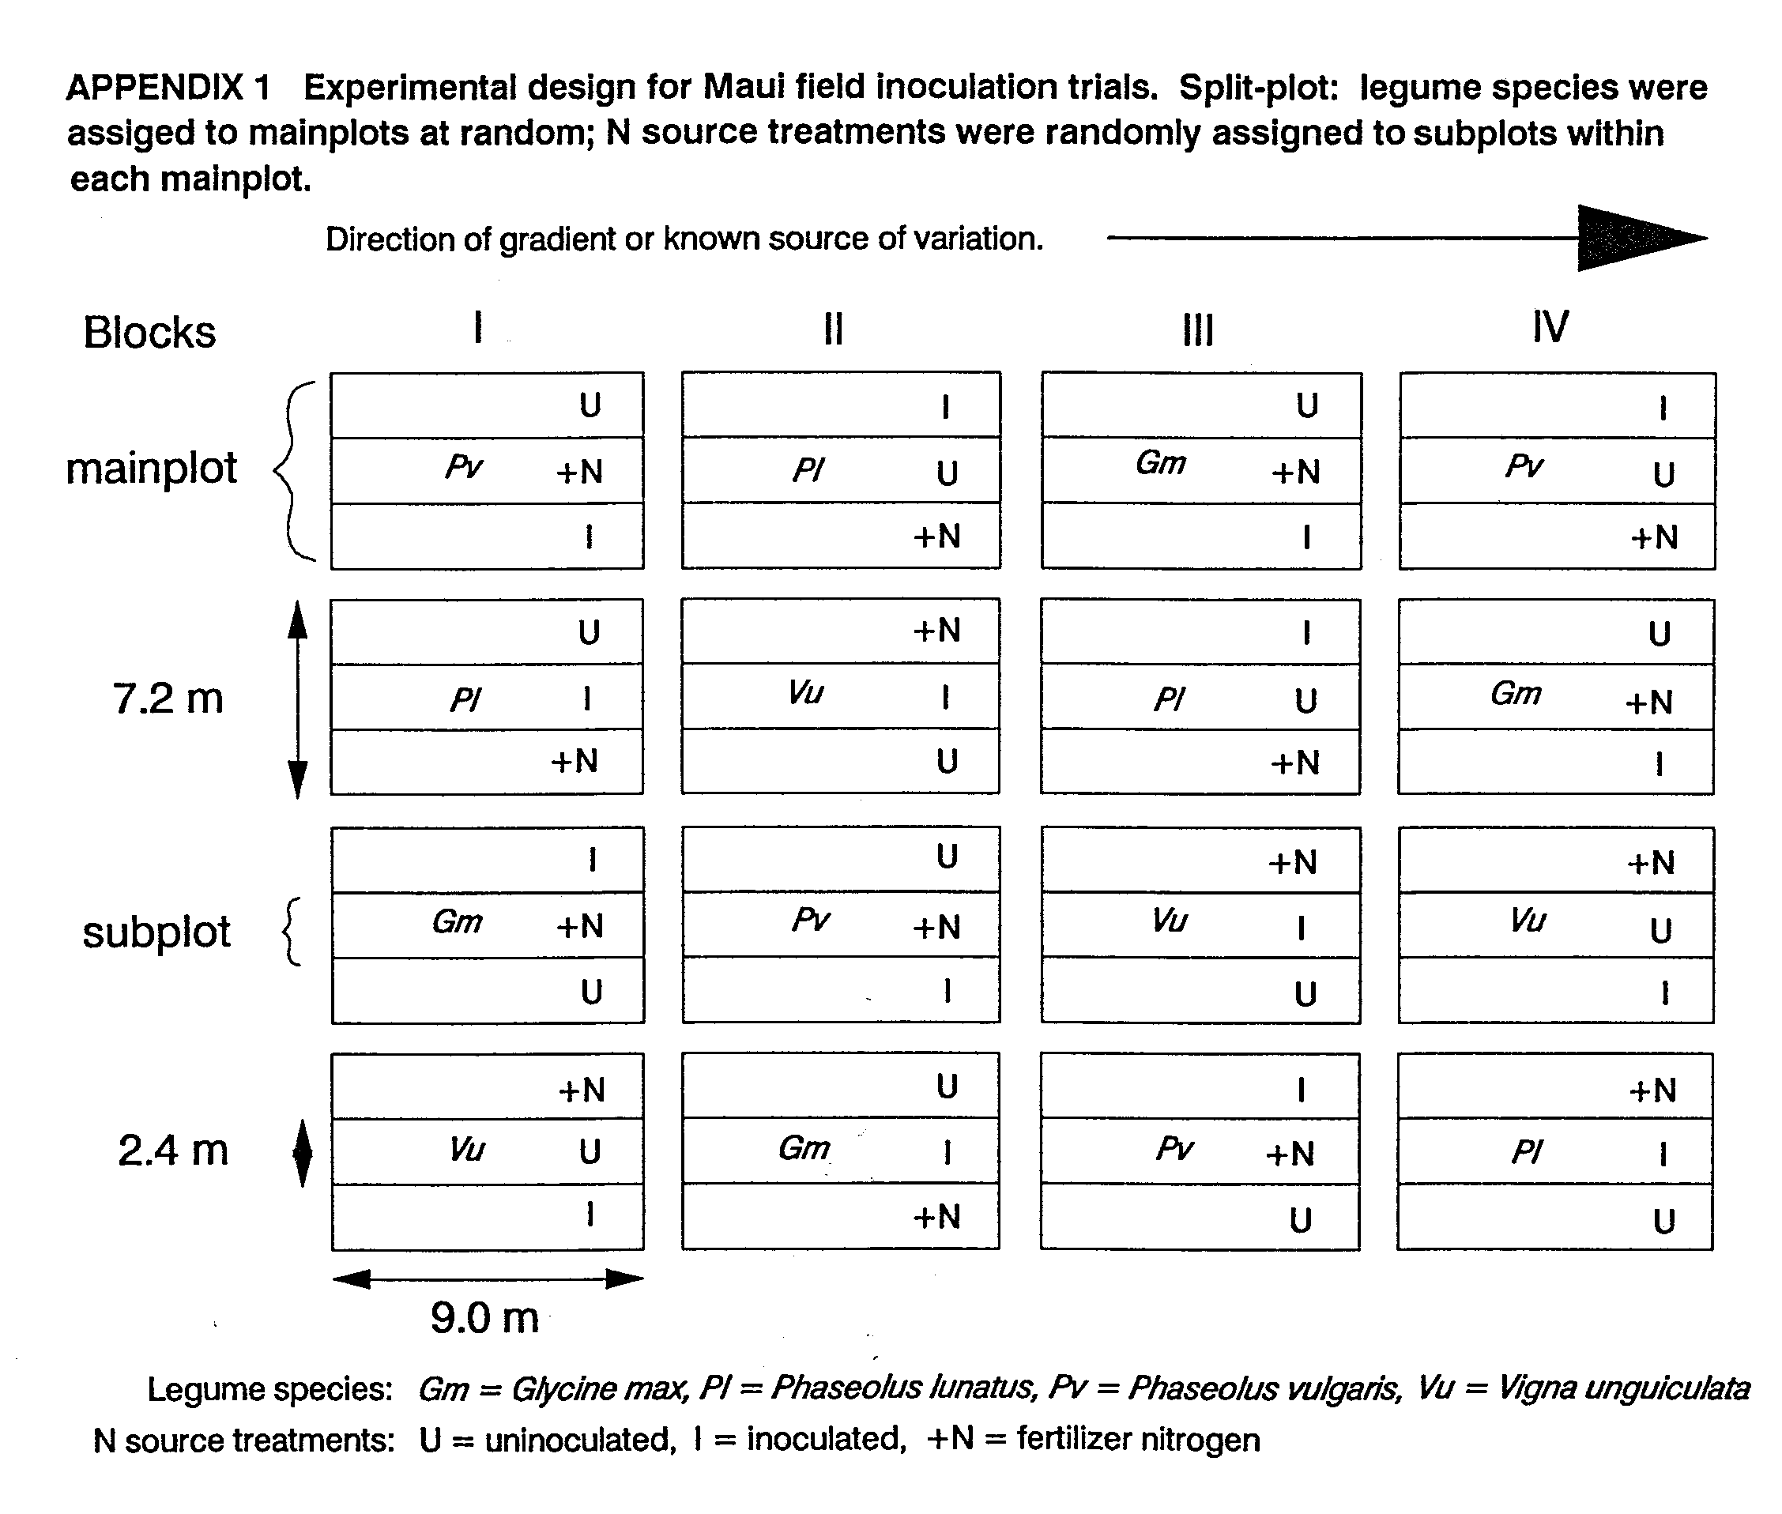
APPENDIX 2.1 | Site 1 (Hashimoto Farm) field harvest data summary - PD 3/24/87 (Gm 4/8/87)
 |  |  | Early Harvest - 35-40 DAP |  |  |  | Late Harvest at Harvest Maturity (R8)
Legume  Species | N  Source  Trmt | Biomass  (kg/ha) | N  Uptake  (kg/ha) | Nodule  Number  (/ha) | Nodule  Mass  (kg/ha) | Total  Biomass  (kg/ha) | Seed  Yield  (kg/ha) | Stover  (kg/ha) | Harvest  Index | Total N  Uptake  (kg/ha) | Seed N  (kg/ha)
G.  max | Uninoc  inoc  + N | 494  714  808 | 15  29  38 | - a  15834686  - | - a  42.4  - | 1624  5078  5571 | 627  3025  3024 | 996  2053  2547 | 0.35  0.59  0.54 | 32  191  180 | 27  177  163
P.  lunatus | Uninoc  Inoc  + N | 1067  1339  2727 | 30  36  113 | 39223  5724750  50497 | 0.6  49.3  0.01 | 4111  6967  10457 | 1379  2531  3970 | 2732  4436  6487 | 0.33  0.36  0.38 | 91  135  297 | 40  77  186
V.  unguiculata | Uninoc  Inoc  + N | 2803  2691  4487 | 74  87  171 | 2609714  8201475  2126937 | 33.3  79.9  6.1 | 5527  5411  7764 | 2179  2113  2839 | 3348  3298  4925 | 0.40  0.40  0.37 | 153  136  197 | 85  100  115
LSD (0.05)(18) |  | 416 | 14 | b | c | 1517 | 705 | 921 | 0.05 | 45 | 30
CV (%) |  | 14.7 | 14.1 |  |  | 17.5 | 19.7 | 18.1 | 8.6 | 19.2 | 18.7
Spp Effect |  | *** | *** |  |  | ** | ns | *** | *** | ns | *
Trmt Effect |  | *** | *** |  |  | *** | *** | *** | *** | *** | ***
Trmt*Spp Inter | action | *** | *** |  |  | ** | *** | ** | *** | *** | ***
P.  vulgaris | Uninoc  Inoc  + N | 576  599  1414 | 20  23  59 | 3774722  37871455  175427 | 1.9  15.9  0.1 | 888  1403  4981 | 400  731  2891 | 489  672  2091 | 0.45  0.52  0.58 | 17  27  128 | 11  20  100
LSD (0.05)(6) |  | 229 | 10 | b | c | 441 | 257 | 201 | 0.03 | 7 | 8
CV (%) |  | 15.1 | 17.2 |  |  | 10.5 | 11.1 | 10.7 | 2.8 | 6.1 | 8.7
Trmt Effect |  | *** | *** |  |  | *** | *** | *** | *** | *** | ***
a Confidence interval does not include zero.
b LSD for P. vulgaris and P. lunatus = 1600000; LSD for V. unguiculata = 5500000.
c LSD for P. vulgaris and P. lunatus = 8.3; LSD for V. unguiculata = 58.1.

APPENDIX 2.2 Site 2 (Kuiaha) field harvest data summary - PD 8/15/86
 |  |  | Early Harvest - 35-40 DAP |  |  |  |  |  |  | Late Harvest at Harvest Maturity (R8)
Legume  Species | N  Source  Trmt | Biomass  (kg/ha) | N  Uptake  (kg/ha) | Nodule  Number  (/ha) | Nodule  Mass  (kg/ha) |  |  |  | Total  Biomass  (kg/ha) | Seed  Yield  (kg/ha) | Stover  (kg/ha) | Harvest  Index | Total N  Uptake  (kg/ha) |  | Seed N  (kg/ha)
G.  max | Uninoc  Inoc  + N | 805  1387  1104 | 16  53  35 | - a  16066167  887167 | - a  76.5  4.7 |  |  |  | 1669  5073  4692 | 840  3120  2962 | 829  1953  1731 | 0.50  0.61  0.63 | 47  206  166 |  | 42  183  152
P.  lunatus | Uninoc  Inoc  + N | 1095  1408  1381 | 37  46  45 | 5285470  10998667  1971083 | 22.7  51.8  10.5 |  |  |  | 6101  6644  6579 | 2819  2698  2743 | 3282  3946  3836 | 0.46  0.41  0.42 | 112  124  135 |  | 69  57  58
P.  vulgaris | Uninoc  Inoc  + N | 986  1085  1663 | 20  29  52 | 2399223  30338667  4635083 | 2.7  36.5  3.3 |  |  |  | 2931  3142  5023 | 1649  1781  2858 | 1282  1361  2264 | 0.57  0.57  0.55 | 69  75  139 |  | 56  60  109
V.  unguiculata | Uninoc  Inoc  + N | 1578  1628  1797 | 54  45  67 | 25788322  27662167  21067494 | 100.6  105.2  53.4 |  |  |  | 4247  5175  5820 | 1443  1738  2082 | 2805  3436  3738 | 0.34  0.34  0.36 | 115  151  159 |  | 61  77  76
LSD (0.05)(24)^{b} |  | 208 | 7.5 | 6691182 | 13.3 |  |  |  | 790 | 399 | 538 | 0.05 | 26 |  | 18
CV (%) |  | 10.7 | 12.4 | 31.1 | 20.8 |  |  |  | 11.4 | 12.3 | 14.5 | 6.6 | 14.3 |  | 14.7
Spp Effect |  | ** | *** | *** | *** |  |  |  | *** | *** | *** | *** | ** |  | ***
Trmt Effect |  | *** | *** | *** | *** |  |  |  | *** | *** | *** | ns | *** |  | ***
Trmt*Spp Interaction |  | *** | *** | *** | *** |  |  |  | *** | "** | ns | *** | *** |  | ***
a Confidence interval does not include zero.
b df for nodulation data = 18

APPENDIX 2.3 Site 3 (Kula Agricultural Park) field harvest data summary - PD 9/12/86
 |  |  | Early Harvest - 35-40 DAP |  |  |  |  |  | Late Harvest at Harvest Maturity (R8)
Legume  Species | N  Source  Trmt | Biomass  (kg/ha) | N  Uptake  (kg/ha) | Nodule  Number  (/ha) |  | Nodule  Mass  (kg/ha) |  | Total  Biomass  (kg/ha) | Seed  Yield  (kg/ha) | Stover  (kg/ha) | Harvest  Index | Total N  Uptake  (kg/ha) | Seed N  (kg/ha)
G.  max | Uninoc  Inoc  + N | 568  1036  1122 | 13  34  27 | - a  16536583  - |  | - a  87.3  - |  | 1002  3318  4413 | 485  2026  2733 | 517  1292  1680 | 0.48  0.61  0.62 | 31  154  199 | 27  141  187
P.  lunatus | Uninoc  Inoc  + N | 652  928  1502 | 14  23  53 | 192409  15551424  92389 |  | 3.1  68.0  2.3 |  | 3644  6680  7424 | 1520  3012  3179 | 2123  3668  4245 | 0.42  0.45  0.43 | 82  155  199 | 49  103  131
P.  vulgaris | Uninoc  Inoc  + N | 697  1147  1998 | 14  31  67 | 2844249  34198583  328603 |  | 7.0  66.1  0.3 |  | 1242  2024  3275 | 669  1228  1853 | 573  797  1422 | 0.54  0.61  0.57 | 23  41  77 | 18  36  61
V.  unguiculata | Uninoc  Inoc  + N | 1062  1243  1714 | 32  33  61 | 4244917  23375322  2143882 |  | 26.7  90.3  4.0 |  | 3749  3886  4898 | 1482  1667  1926 | 2268  2219  2972 | 0.40  0.43  0.40 | 89  93  140 | 53  64  81
LSD b (0.05)(24) |  | 243 | 15 | 2831112 |  | 12.1 |  | 736 | 390 | 408 | 0.04 | 32 | 27.2
CV (%) |  | 14.6 | 30.7 | 20.6 |  | 27.3 |  | 13.3 | 14.7 | 14.1 | 5.3 | 20.3 | 23.6
Spp Effect |  | * | * | *** |  | *** |  | *** | *** | *** | *** | *** | ***
Trmt Effect |  | *** | *** | *** |  | *** |  | *** | *** | *** | *** | *** | ***
Trmt*Spp Interaction |  | ** | ** | *** |  | ns |  | *** | *** | *** | *** | *** | ***
a Confidence interval does not include zero.
b df for nodulation data = 18

APPENDIX 2.4 Site 4 (Haleakala Station) field harvest data summary - PD 6/08187
 |  |  | Early Harvest - 35-40 DAP |  |  |  |  |  | Late Harvest at Harvest Maturity (R8)
Legume  Species | N  Source  Trmt | Biomass  (kg/ha) | N  Uptake  (kg/ha) | Nodule  Number  (/ha) |  |  | Nodule  Mass  (kg/ha) | Total  Biomass  (kg/ha) | Seed  Yield  (kg/ha) | Stover  (kg/ha) | Harvest  Index | Total N  Uptake  (kg/ha) | Seed N  (kg/ha)
G.  max | Uninoc  Inoc  + N | 1132  969  1063 | 35  32  48 | - a  19154223  - |  |  | - a  47.0  - | 4111  6601  9042 | 1711  3686  4596 | 2400  2915  4446 | 0.42  0.56  0.51 | 109  263  354 | 83  221  279
P.  lunatus | Uninoc  Inoc  + N | 2403  2502  2539 | 74  82  98 | 8479012  14383124  3697178 |  |  | 39.8  42.2  3.3 | 10607  10296  11073 | 4117  3838  4165 | 6491  6458  6908 | 0.39  0.37  0.38 | 250  246  293 | 145  138  158
P.  vulgaris | Uninoc  Inoc  + N | 1593  1572  1867 | 47  43  68 | 4625396  41135242  871719 |  |  | 5.5  27.7  0.3 | 5423  6621  7342 | 2622  3489  3868 | 2801  3132  3473 | 0.48  0.53  0.53 | 91  133  161 | 70  101  128
V.  unguiculata | Uninoc  Inoc  + N | 3407  2975  3904 | 116  105  145 | 16576254  16358697  10156952 |  |  | 51.2  68.6  11.5 | 8146  7991  9052 | 2884  2811  2923 | 5262  5180  6128 | 0.35  0.35  0.32 | 195  193  236 | 107  102  110
b  LSD (0.05)(24) |  | 472 | 18 | 9754253 |  |  | 16.8 | 1594 | 793 | 1112 | 0.06 | 50 | 33
CV (%) |  | 15.0 | 16.0 | 50.8 |  |  | 40.6 | 13.6 | 16.0 | 16.4 | 8.9 | 16.4 | 16.5
Spp Effect |  | *** | *** | *** |  |  | *** | *** | * | *** | *** | *** | ***
Trmt Effect |  | * | *** | *** |  |  | *** | *** | *** | ** | * | *** | ***
Trmt* Spp Interaction |  | ns | ns | *** |  |  | * | ** | *** | ns | *** | *** | ***
a Confidence interval does not include zero.
b df for nodulation data = 18

APPENDIX 2.5 Site 5 (Tengan Farm) field harvest data summary- PD 10/20/87 (Gm); 10/28/87 (PI and Pv); 11/18187 (Vu)
 |  |  | Early Harvest - 35-40 DAP |  |  |  |  |  |  |  | Late Harvest at Harvest Maturity (R8)
Legume  Species | N  Source  Trmt | Biomass  (kg/ha) | N  Uptake  (kg/ha) | Nodule  Number  (/ha) | Nodule  Mass  (kg/ha) |  |  |  | Total  Biomass  (kg/ha) |  | Seed  Yield  (kg/ha) | Stover  (kg/ha) | Harvest  Index | Total N  Uptake  (kg/ha) | Seed N  (kg/ha)
G.  max | Uninoc  Inoc  + N | 871  823  877 | 28  23  32 | - a  8395689  - | - b  24.3  - |  |  |  | 3082  3314  4488 |  | 1356  1233  1983 | 1726  2082  2505 | 0.44  0.37  0.44 | 97  116  158 | 73  74  109
P.  lunatus | Uninoc  Inoc  + N | 1241  1249  1472 | 32  31  40 | 4728018  9516899  2181036 | 6.1  13.0  0.8 |  |  |  | 9443  10727  11377 |  | 3793  4135  4627 | 5651  6592  6750 | 0.40  0.39  0.41 | 205  261  319 | 117  135  186
P.  vulgaris | Uninoc  Inoc  + N | 1121  939  1204 | 40  32  35 | 19354439  25552555  8165662 | 6.5  8.2  1.4 |  |  |  | 5123  6375  5644 |  | 2625  3035  2694 | 2498  3341  2950 | 0.50  0.47  0.48 | 106  132  136 | 71  82  81
V.  unguiculata | Uninoc  Inoc  + N | 3300  4855  2991 | 97  142  99 | 8237207  8718849  5167896 | 39.7  36.5  1.9 |  |  |  | 7281  6266  6565 |  | 1910  1801  1746 | 5371  4464  4819 | 0.27  0.29  0.26 | 170  153  178 | 79  76  74
c  LSD (0.05)(24) |  | 807 | 25 | 6435150 | 12.1 |  |  |  | 1726 |  | 848 | 991 | 0.04 | 54 | 34
CV (%) |  | 32.8 | 33.6 | 42.5 | 64.1 |  |  |  | 17.8 |  | 22.5 | 16.7 | 7.8 | 21.8 | 24.0
Spp Effect |  | *** | *** | *** | *** |  |  |  | *** |  | *** | *** | *** | *** | ***
Trmt Effect |  | ns | ns | *** | *** |  |  |  | ns |  | ns | ns | ns | ** | **
Trmt*Spp Interaction |  | * | ns | * | ** |  |  |  | ns |  | ns | ns | ns | ns | ns
a Not significantly different from zero.
b Confidence interval does not include
c df for nodulation data = 18

APPENDIX 2.6 Site 1a (Hashimoto Farm - 2nd planting) field harvest data summary - PD 3/10/88
 |  |  | Early Harvest - 35-40 DAP |  |  | Late Harvest at Harvest Maturity
Legume  Species | N  Source  Trmt | Biomass  (kg/ha) | N  Uptake  (kg/ha) | Nodule  Number  (/ha) | Nodule  Mass  (kg/ha) | Total  Biomass  (kg/ha) | Seed  Yield  (kg/ha) | Total N  Uptake  (kg/ha) | Seed N  (kg/ha)
A.  hypogaea | Uninoc  Inoc  + N | 776  808  892 | 14  16  19 | 23215101  20176153  14163505 | 20.2  22.9  10.3 | 12309  14648  15144 | 5486  6579  6082 | 289  361  367 | 246  312  291
LSD (0.05)(6)  CV (%)  Trmt Effect |  | 123  8.6  ns | 3  11.6  * | 7696136  23.2  ns | 6.8  22.1  ** | 2020  8.3  * | 1206  11.5  ns | 74  12.5  ns | 77  15.8  ns
L.  leucocephala | Uninoc  Inoc  + N | 1121  1236  1812 | 30  27  43 | nd  nd  nd | nd  nd  nd | 24665  21225  26772 |  | 456  339  487
LSD (0.05)(6) |  | 404 | 13 | - | - | 5603 |  | 146
CV (%) |  | 16.8 | 22.7 | - | - | 13.4 |  | 19.8
Trmt Effect |  | * | ns | - | - | ns |  | ns
APPENDIX 2.7 Site 3a (Kula Agricultural Park - 2nd planting) field harvest data summary - PD 5/14187
 |  |  |  | Early Harvest - 35-40 DAP |  |  |  | Late Harvest at Harvest Maturity (R8)
Legume  Species |  | N  Source  Trmt | Biomass  (kg/ha) | N  Uptake  (kg/ha) | Nodule  Number  (/ha) | Nodule  Mass  (kg/ha) | Total  Biomass  (kg/ha) | Seed  Yield  (kg/ha) | Stover  (kg/ha) | Harvest  Index | Total N  Uptake  (kg/ha) | Seed N  (kg/ha)
G.  max |  | Uninoc  Inoc  + N | 709  887  1230 | 18  34  44 | - a  18206824  - | - a  65.8  - | 2150  5629  7114 | 935  2782  3125 | 1215  2848  3989 | 0.42  0.50  0.44 | 50  203  226 | 42  166  179
P.  vulgaris |  | Uninoc  Inoc  + N | 1323  1266  2353 | 35  33  84 | 27285774  66307223  19448056 | 39.5  56.4  6.6 | 4120  4255  4402 | 2198  2316  2130 | 1638  1939  2272 | 0.55  0.54  0.48 | 75  77  101 | 57  60  72
A.  hypogaea |  | Uninoc  Inoc  + N | 536  697  978 | 12  19  26 | 16340950  14224225  18420100 | 11.6  22.7  13.9 | 14347  20487  16859 | 4926  5921  5679 |  | 0.48  0.41  0.51 | 256  332  299 | 217  276  247
b  LSD (0.05)(17) |  |  | 248 | 11 | 9869377 | 11.9 | 1191 | 949 | 1202 | 0.07 | 41 | 41
CV (%) |  |  | 15.2 | 22.4 | 33.3 | 39.0 | 8.8 | 18.5 | 21.1 | 10.6 | 14.8 | 18.3
Spp Effect |  |  | *** | *** | *** | *** | *** | *** | *** | ns | ** | **
Trmt Effect |  |  | *** | *** | *** | *** | *** | *** | *** | ns | *** | ***
Trmt*Spp Interaction |  |  | *** | *** | *** | *** | *** | ns | *** | ns | *** | **
L.  leucocephala | Uninoc  Inoc  + N |  | 551  577  770 | 18  19  30 | 5227259  5234667  2380000 | 13.0  16.1  2.9 | 14682  17502  21998 |  |  |  | 317  323  459
b  LSD (0.05)(5) |  |  | 562 | 24 |  |  | 4470 |  |  |  | 101
CV (%) |  |  | 48.3 | 58.6 |  |  | 13.4 |  |  |  | 14.2
Trmt Effect |  |  | ns | ns |  |  | * |  |  |  | *
a Confidence interval does not include zero.
b P. vulgaris and L. leucocephala each had one missing replication; df for nodulation data = 22(includes
Leucaena).

APPENDIX 2.8 Site 5a (Tengan Farm - 2nd planting) forage legumes field harvest data summary - PD 1/7/88
 |  | Early Harvest - 71-74 DAP |  |  |  | Late Harvest - 112-117 DAP
Legume  Species | N  Source  Trmt | Biomass  (kg/ha) | N  Uptake  (kg/ha) | Nodule  Number  (/ha) | Nodule  Mass  (kg/ha) | Total  Biomass  (kg/ha) | Total N  Uptake  (kg/ha)
M.  sativa | Uninoc  Inoc  + N | 4130  3683  4774 | 156  112  196 | 2.7E+08  1.9E+08  81651639 | 93.8  65.0  23.6 | 4640  5129  5320 | 107  119  131
T.  repens | Uninoc  Inoc  + N | 3596  4847  4202 | 125  186  188 | 16083332  48333332  5300000 | 14.3  12.1  1.1 | 3562  3778  4078 | 97  104  133
L.  tingeatus | Uninoc  Inoc  + N | 4776  3678  4806 | 201  156  227 | 13582575  25805700  12640500 | 75.1  98.7  29.5 | 2946  3598  3050 | 91  111  108
LSD (0.05)(18) |  | 665 | 32 | 68613494 | 17.0 | 906 | 23
CV (%) |  | 10.5 | 12.1 | 62.9 | 24.9 | 15.2 | 13.8
Spp Effect |  | ns | ** | *** | *** | ** | ns
Trmt Effect |  | * | *** | ** | *** | ns | **
Trmt*Spp Interaction |  | *** | * | ** | ** | ns | ns

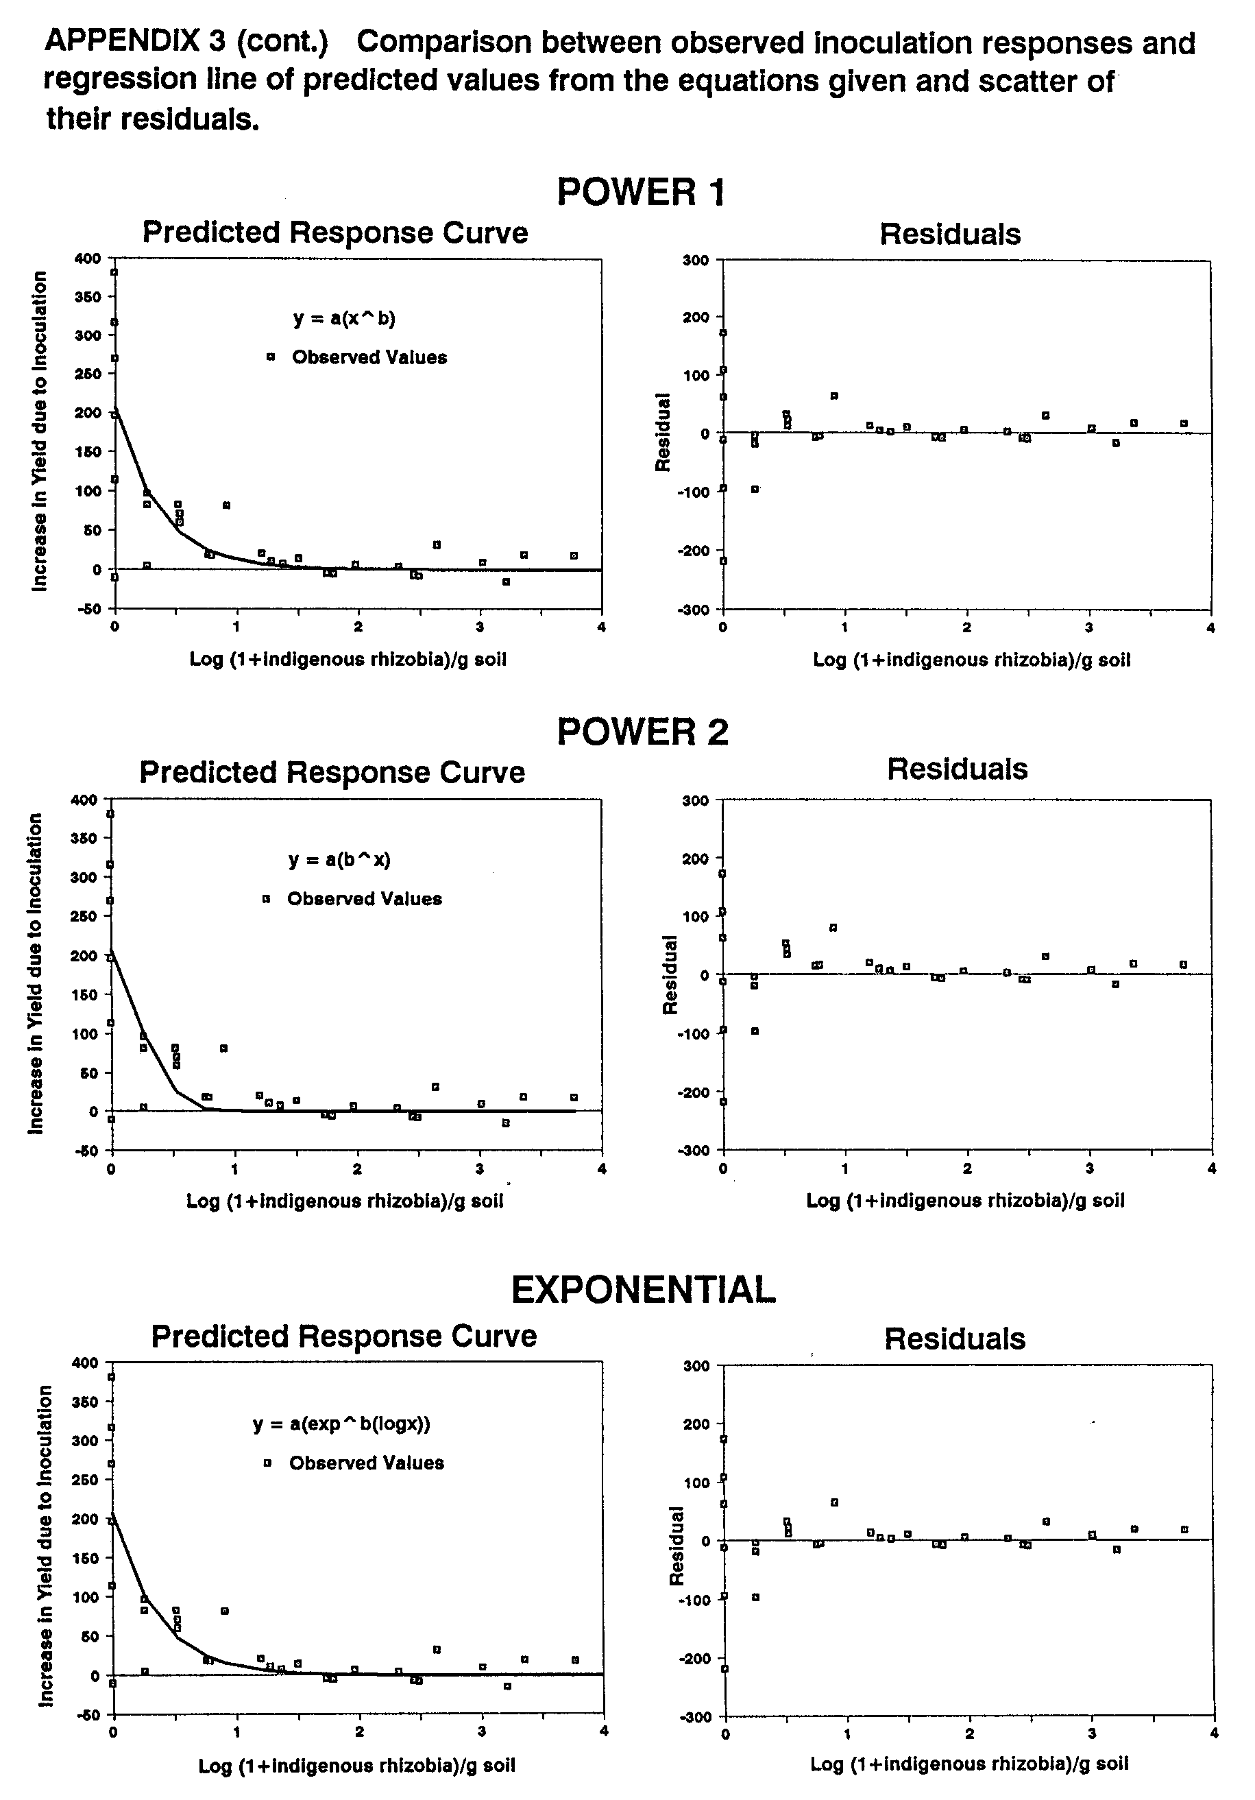
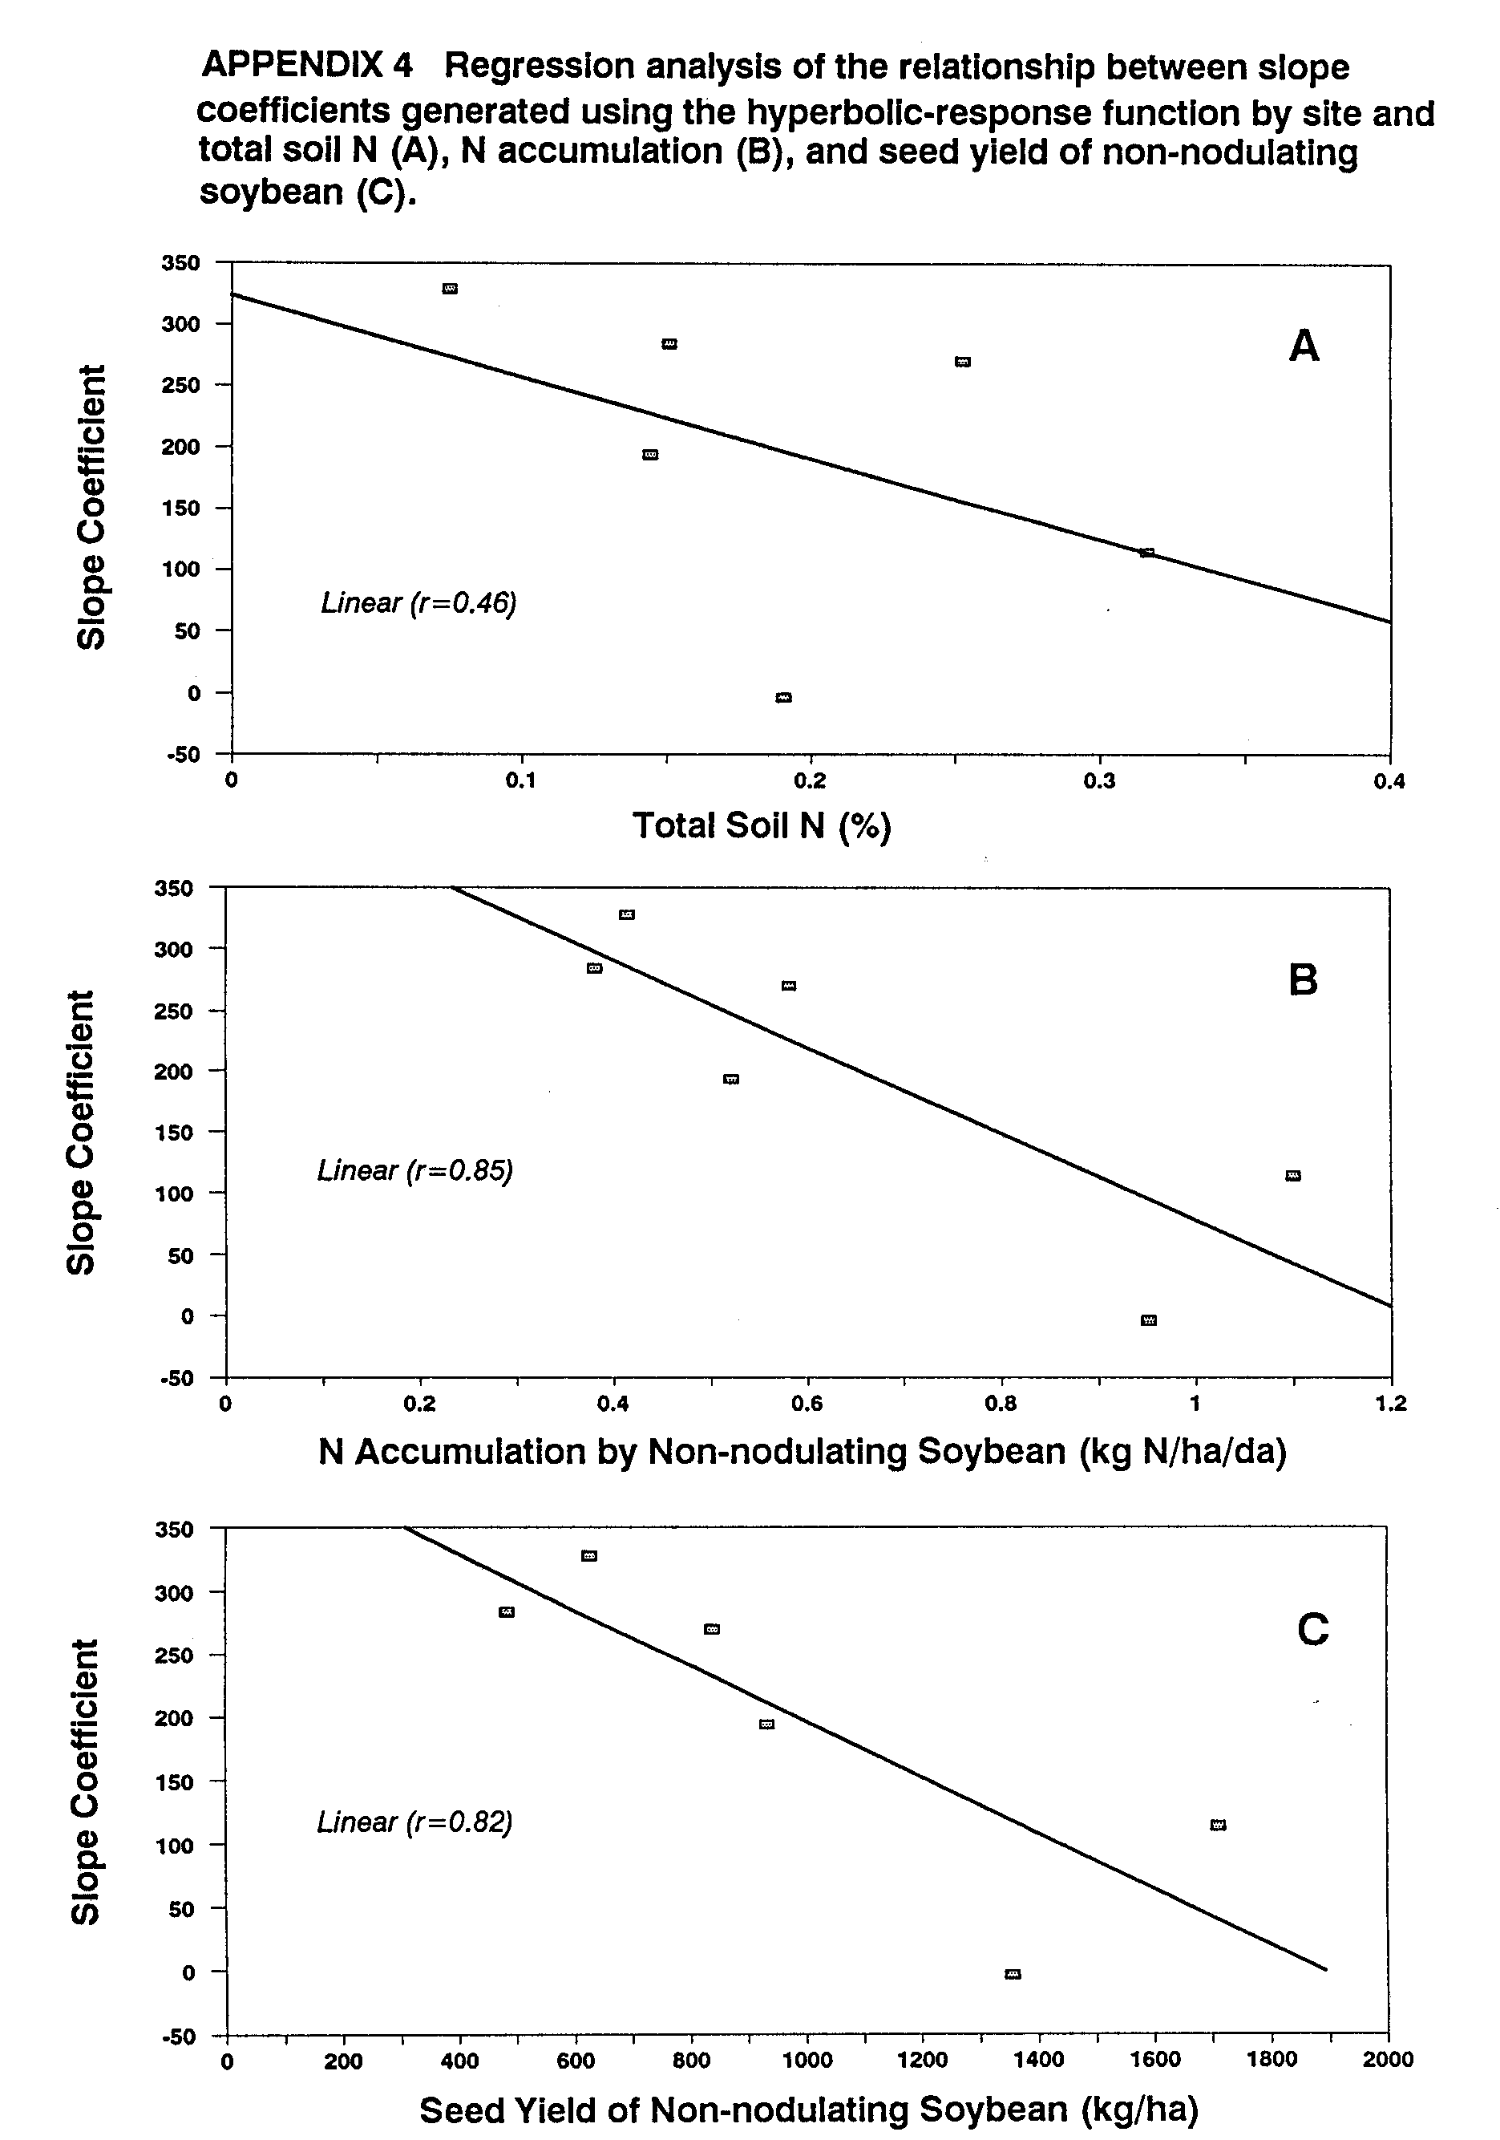
APPENDIX 6 Rate of N accumulation in legumes grown in 8 inoculation trials conducted
at 5 sites on Maui, HI.
Legume  Species | N Source  Trmt |  | Site number  1 2 3 4 5 1a 3a 5a
a
____________________ kg N/ha/d_____________________
G. max | Uninoc  Inoc  +N |  | 0.44  2.59  2.41 | 0.58  2.45  1.83 | 0.38  1.90  2.19 | 1.10  2.63  3.36 | 0.95  1.12  1.50 | - 0.52  - 2.12  - 2.30 | -  -  -
P.lunatus | Uninoc  Inoc  +N |  | 0.92  1.37  3.00 | 1.32  1.46  1.59 | 0.90  1.53  1.99 | 2.05  2.02  2.40 | 1.32  1.69  2.06 | - -  - -  - - | -  -  -
P. vulgaris | Uninoc  Inoc  +N |  | 0.25  0.48  1.96 | 1.10  1.18  2.21 | 0.33  0.60  1.11 | 1.21  1.65  3.00 | 1.12  1.36  1.43 | - 1.01  - 1.03  - 1.70 | -  -  -
V.  unguiculata | Uninoc  Inoc  +N |  | 1.54  1.37  1.99 | 1.26  1.66  1.75 | 0.94  0.98  1.47 | 1.70  1.68  2.05 | 1.14  1.03  1.20 | - -  - -  - - | -  -  -
A. hypogaea | Uninoc  Inoc  +N |  | -  -  - | -  -  - | -  -  - | -  -  - | -  -  - | 2.09 1.92  2.64 2.49  2.68 2.25 | -  -  -
L.  leucocephala | Uninoc  Inoc  +N |  | -  -  - | -  -  - | -  -  - | -  -  - | -  -  - | 2.75 2.18  2.04 2.08  2.94 2.88 | -  -  -
M. sativa | Uninoc  Inoc  +N |  | -  -  - | -  -  - | -  -  - | -  -  - | -  -  - | - -  - -  - - | 0.93  1.04  1.15
T. repens | Uninoc  Inoc  +N |  | -  -  - | -  -  - | -  -  - | -  -  - | -  -  - | - -  - -  - - | 0.85  0.91  1.17
L, tingeatus | Uninoc  Inoc  +N |  | -  -  - | -  -  - | -  -  - | -  -  - | -  -  - | - -  - -  - - | 0.80  0.97  0.95
LSD (0.05) |  |  | 0.40 | 0.30 | 0.35 | 0.43 | 0.42 | 0.66 0.40 | 0.20
CV (%) |  |  | 18.8 | 13.3 | 20.4 | 14.3 | 21.4 | 16.9 14.8 | 13.8
Spp Effect |  |  | *** | ns | *** | ** | ** | ns ** | ns
Trmt Effect |  |  | *** | *** | *** | *** | ** | ns *** | **
Spp * Trmt Interaction |  |  | *** | *** | *** | *** | ns | * *** | ns
a Calculated by dividing N accumulation (kg/ha) at harvest maturity (R8) by total
crop duration in days.

APPENDIX 7.1 Average days to critical phenological stages in soybean and bush bean grown at 4 sites on Maui, HI.

No. | Site  Name | Legume  Species | N  Source  Trmt | Phenological Stage  V4 R2 R6 R7 R8 |  |  |  |  | a  Seed fill  Duration
 |  |  |  | _________________days _____________
1 | Hashimoto  Farm | G. max  P. vulgaris | Uninoc  Inoc  FertN  Uninoc  Inoc  FertN | 28  27  26  28  29  24 | 30  30  30  35  35  35 | 58  58  62  56  56  63 | 70  80  82  63  64  69 | 84  90  90  69  69  73 | 27  37  37  24  25  29
3a | Kula  Agric.  Park | G. max  P, vulgaris | Uninoc  Inoc  FertN  Uninoc  Inoc  FertN | 31  30  29  26  25  24 | 34  34  34  34  34  34 | 60  67  67  53  53  53 | 75  81  84  56  59  65 | 92  96  99  72  74  78 | 33  37  38  16  19  19
4 | Haleakala  Station | G. max  P. vulgaris | Uninoc  Inoc  FertN  Uninoc  Inoc  FertN | 31  31  30  30  30  30 | 38  38  38  38  38  38 | 74  74  82  53  53  53 | 89  93  99  65  68  70 | 106  108  113  83  85  90 | 41  46  46  22  26  27
5 | Tengan  Farm | G, max  P. vulgaris | Uninoc  Inoc  FertN  Uninoc  Inoc  FertN | 34  34  34  28  28  28 | 41  41  41  35  35  35 | 81  86  85  59  59  59 | 93  94  99  82  82  82 | 109  109  113  97  99  98 | 46  47  52  43  44  43
a | Period from R4 to R7.

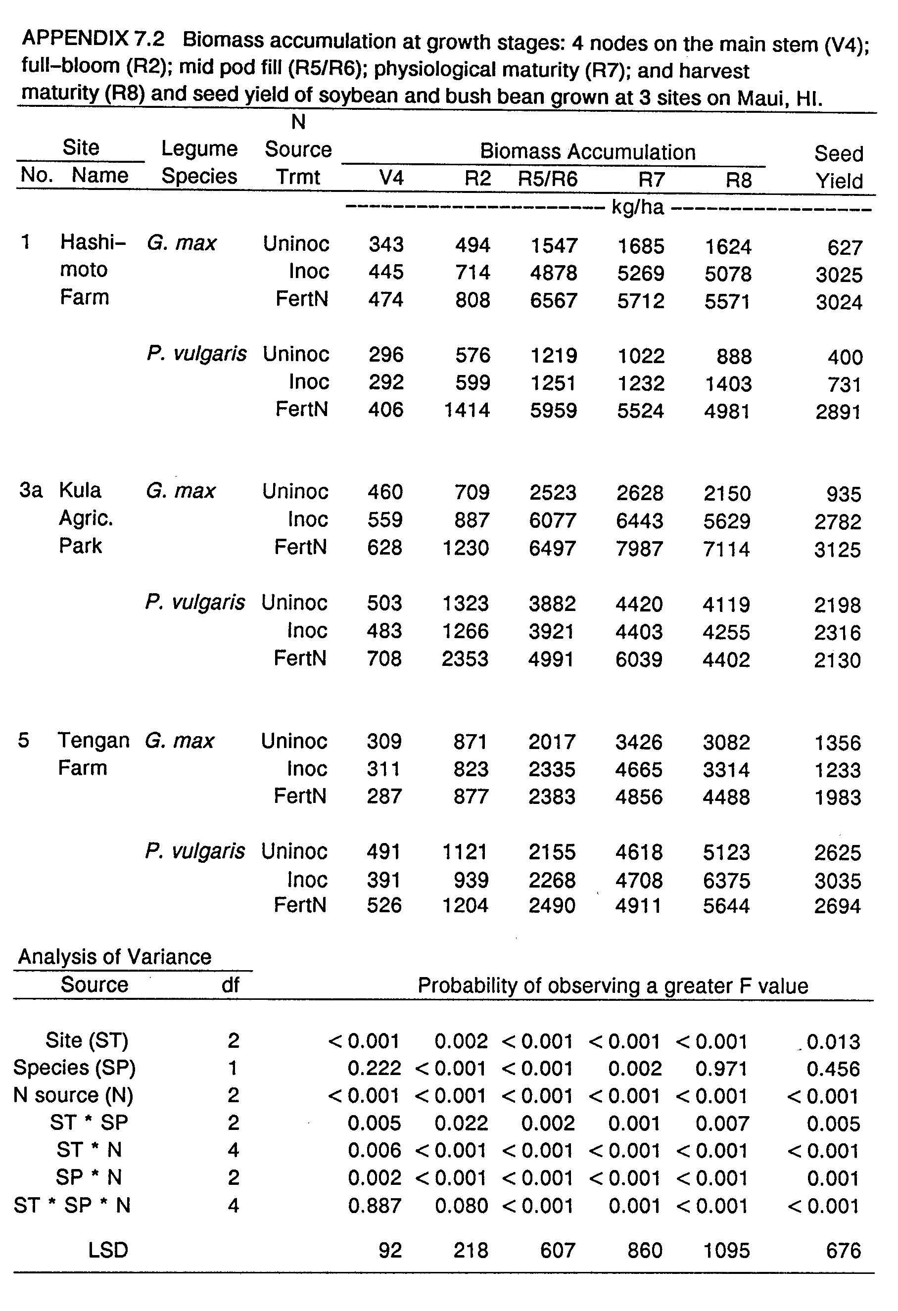
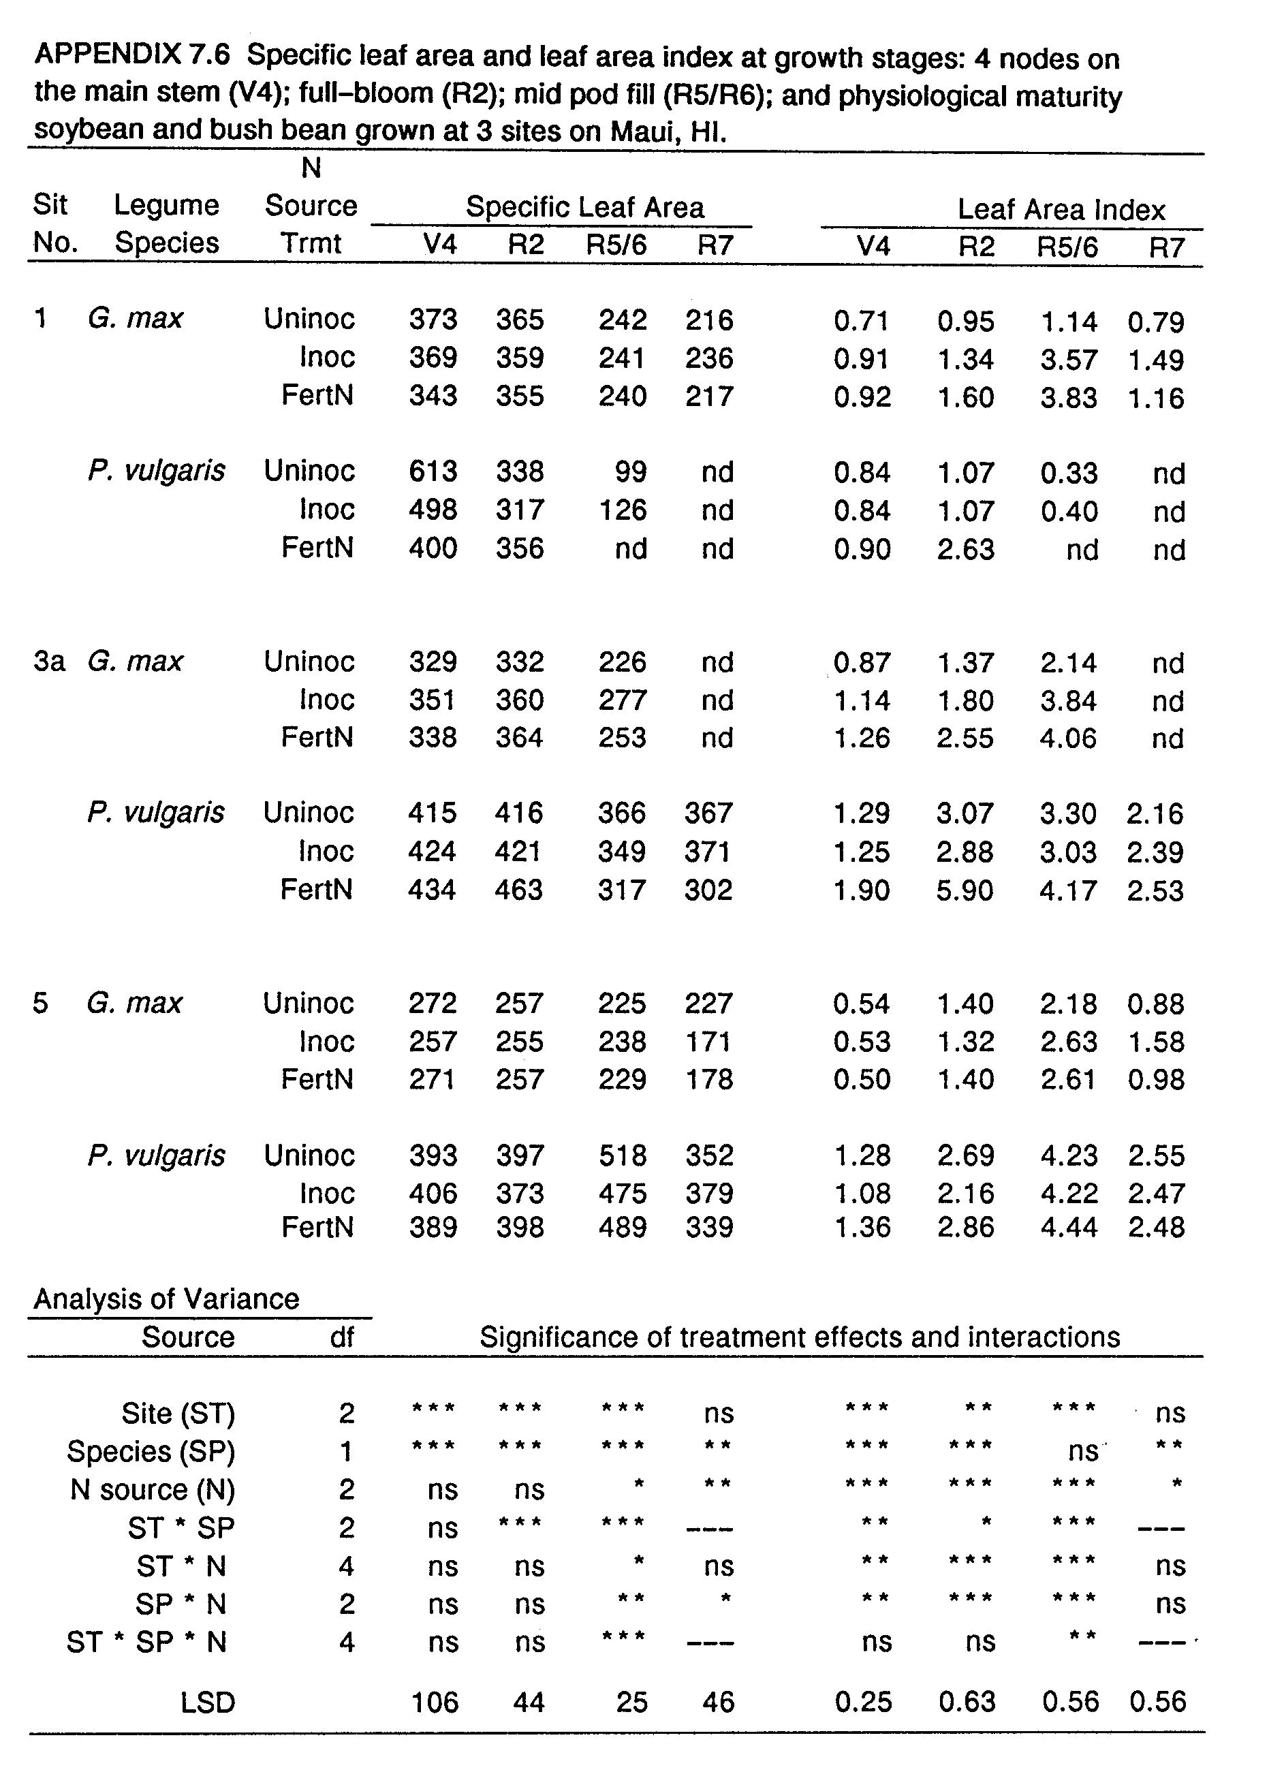
LITERATURE CITED

Abaidoo, R.C., T. George, B.B. Bohlool, and P.W. Singleton. 1990. Influence of elevation and applied nitrogen on rhizosphere colonization and competition for nodule occupancy by different rhizobial strains on field-grown soybean and common bean. Appl. Environ. Microbiol. In press.

Amarger, N. 1984. Evaluation of competition in Rhizobium spp. p. 300-305. In: M.J. Klug and C.A. Reddy (ed.) Current Perspectives in Microbial Ecology. Amer. Soc. Microbiol., Washington, D.C.

Amarger, N., and J.P. Lobreau. 1982. Quantitative study of nodulation competitiveness in Rhizobium strains. Appl. Environ. Microbiol. 44:583-588.

Atkins, C.A. 1986. The legume/Rhizobium symbiosis: Limitations to maximizing nitrogen fixation. Outlook on Agric. 15:128-134.

Bauer, W.D. 1981. Infection of legumes by rhizobia. Ann. Rev. Plant Physiol. 32:407-449.

Beattie, G.A., M.K. Clayton, and J. Handelsman. 1989. Quantitiative comparison of the laboratory and field competitiveness of Rhizobium leguminosarum biovar phaseoli. Appl. Environ. Microbiol. 55:2755-2761

Berg, R.K. Jr., T.E. Loynachan, R.M. Zablotowicz, and M.T. Lieberman. 1988. Nodule occupancy by introduced Bradyrhizobium japonicum in Iowa soils. Agron. J. 80:876-881.

Bergersen, F.J. 1970. Some Australian studies relating to long term effects of the inoculation of legume seed. Plant Soil. 32:727-736.

Bohlool, B.B., and E.L. Schmidt. 1973. Persistence and competition aspects of Rhizobium japonicum observed in soil by immunofluorescence microscopy. Soil Sci. Soc. Amer. Proc. 37:561-564.

Boonkerd, N., D.F. Weber, and D.F. Bezdicek. 1978. Influence of Rhizobium japonicum strains and inoculation methods on soybean grown in rhizobia-populated soils. Agron. J. 70:547-549.

Boonkerd, N., and R.W. Weaver. 1982. Survival of cowpea rhizobia in soil as affected by soil temperature and moisture. Appl. Environ. Microbiol. 43:585-589.

Bremner, J.M., and C.S. Mulvaney. 1982. Nitrogen-total. In A.L. Page, R.H. Miller, and D.R. Keeney (ed.) Methods of Soil Analysis. Part 2. Agronomy 9:595-624.

Brockwell, J., R.R. Gault, M. Zorin, and M.J. Roberts. 1982. Effects of environmental variables on the competition between inoculum strains and naturalized populations of Rhizobium trifolii for nodulation of Trifolium subterraneum L. and on rhizobia persistence in the soil. Aust. J. Agric. Res. 33:803-815.

Brockwell, J., R.J. Roughly, and D.F. Herridge. 1987. Population dynamics of Rhizobium japonicum strains used to inoculate three successive crops of soybean. Aust. J. Agric. Res. 38:61-74.

Caldwell, B.E. 1969. Initial competition of root-nodule bacteria on soybeans in a field environment. Agron J. 61:813-815.

Caldwell, B.E., and G. Vest. 1968. Nodulation interaction between soybean genotypes and serogroups of Rhizobium japonicum. Crop Sci. 8:680-682.

Caldwell, B.E., and D.F. Weber. 1970. Distribution of Rhizobium japonicum serogroups in soybean nodules as affected by planting dates. Agron. J. 62:12-14.

Damirgi, S.M., L.R. Frederick, and I.C. Anderson. 1967. Serogroups of Rhizobium japonicum in soybean nodules as affected by soil types. Agron. J. 59:10-12.

Dart, P. 1977. Infection and development of leguminous nodules. p. 367-472. In R.W.F. Hardy and W.S. Silver (ed.) A Treatise on Dinitrogen Fixation, Section III. Biology. Wiley, New York.

Department of Land and Natural Resources. 1982. Median rainfall. Circular C88, Department of Natural Resources, Division of Water and Land Development, Honolulu, HI.

Diatloff, A., and S. Langford. 1975. Effective natural nodulation of peanuts in Queensland. Queensl. J. Agric. Anim. Sci. 32:95-100.

Diatloff, A., and J. Brockwell. 1976. Ecological studies of root-nodule bacteria introduced into field environments: 4. Symbiotic properties of Rhizobium japonicum and competitive success in nodulation of two Glycine max cultivars by effective and ineffective strains. Aust. J. Exp. Agric. Anim. Husb. 16:514-521.

Doku, E.V. 1969. Host specificity among five species in the cowpea cross-inoculation group. Plant Soil 30:126-128.

Dowling, D.N., and W.J. Broughton. 1986. Competition for nodulation in legumes. Ann. Rev. Microbiol. 40:131-157.

Dughri, M.H., and P.J. Bottomley. 1983. Effect of acidity on the composition of an indigenous soil population of Rhizobium trifolii found in nodules of Trifolium subterraneum L. Appl. Environ. Microbiol. 46:1207-1213.

Dughri, M.H., and P.J. Bottomley. 1984. Soil acidity and the composition of an indigenous population of Rhizobium trifolii in nodules of different cultivars of Trifolium subterraneum L. Soil Biol. Biochem. 16:405-411.

Elkins, D.M., G. Hamilton, C.K.Y. Chan, M.A. Briskovich, and J.W. Vandeventer. 1976. Effect of cropping history on soybean growth and nodulation and soil rhizobia. Agron. J. 68:513-517.

FAO. 1984. Legume Inoculants and Their Use. Food and Agriculture Organization of the United Nations, Rome, Italy.

Fehr, W.R., C.E. Caviness, D.T. Burmood, and J.S. Pennington. 1971. Stage of development descriptions for soybeans, Glycine max (L.) Merrill. Crop Sci. 11:929-931.

Fred, E.B., 1.L. Baldwin, and E. McCoy. 1932. Root Nodule Bacteria and Leguminous Plants. University of Wisconsin Studies in Science, No. 5, Madison, WI

George, T., B.B. Bohlool, and P.W. Singleton. 1987. Bradyrhizobium j aponicum-environment interactions: Nodulation and interstrain competition in soils along an elevational transect. Appl. Environ. Microbiol. 53:11131117.

George, T., D.P. Bartholomew, and P.W. Singleton. 1990. Effect of temperature and maturity group on phenology of field grown nodulating and nonnodulating soybean isolines. In press.

Gibson, A.H., and J.E. Harper. 1985. Nitrate effect on nodulation of soybean by Bradyrhizobium japonicum. Crop Sci. 25:497-501.

Graham, P.H. 1981. Some problems of nodulation and symbiotic nitrogen fixation in Phaseolus vulgaris L.: A review. Field Crops Res. 4:93-112.

Hadley, P., E.H. Roberts, R.J. Summerfield, and F.R. Minchin. 1984. Effects of temperature and photoperiod on flowering in soya bean [Glycine max (L.) Merrill]: A quantitative model. Ann. Bot. 53:669-681.

Ham, G.E. 1980. Inoculation of legumes with Rhizobium in competition with naturalized strains, p. 131-138. In W.E. Newton and W.H. Orme-Johnson (ed.) Nitrogen Fixation, Vol. II, University Park Press, Baltimore.

Ham,G.E., and V.B. Cardwell, and H.W. Johnson. 1971. Evaluation of Rhizobium japonicum inoculants in soils containing naturalized populations of rhizobia. Agron. J. 63:301-303.

Ham, G.E., L.R. Frederick, and I.C. Anderson. 1971. Serogroups of Rhizobium japonicum in soybean nodules sampled in Iowa. Agron. J. 63:69-72.

Harris, S.C. 1979. Planning an international network of legume inoculation trials. NifTAL Project and U.S. Agency for International Development, Paia, Hawaii.

Hodges, T., and V. French. 1985. Soyphen: Soybean growth stages modeled from temperature, daylength, and water availability. Agron J. 77:500-505.

Holding, A.J., and J.F. Lowe. 1971. Some effects of acidity and heavy metals on the Rhizobium-leguminous plant association. Plant Soil, Spec. Vol. 153-166.

Hunter, W.J., and C.J. Fahring. 1980. Movement by Rhizobium and nodulation of legumes. Soil Biol. Biochem. 12:537-542.

Imsande, J. 1988. Interrelationship between plant developmental stage, plant growth rate, nitrate utilization and nitrogen fixation in hydroponically grown soybean. J. Exp. Bot. 39:775-785.

Imsande, J. 1989. Rapid dinitrogen fixation during soybean pod fill enhances net photosynthetic output and seed yield: A new perspective. Agron. J. 81:549-556.

Ireland, J.A., and J.M. Vincent. 1968. A quantitative study of competition for nodule formation. p. 85-93. In Transactions of the 9th International Congress on Soil Science, Adelaide, Vol. 2. International Society of Soil Science and Angus and Robertson, Sydney, Australia.

Jensen, E.S. 1987. Inoculation of pea by application of Rhizobium in the planting furrow. Plant Soil 97:63-70.

Johnson, H.W., U.M. Means, and C.R. Weber. 1965. Competition for nodule sites between strains of Rhizobium japonicum. Agron. J. 57:179-185.

Jones, J.W., K.J. Boote, G. Hoogenboom, S.S. Jagtap, and G. G. Wilkerson. 1989. SOYGRO v. 5.42: Soybean crop growth simulation model. User's Guide. Florida Agricultural Experiment Station Journal No. 8304, Gainesville, FL.

Keeney, D.R. 1982. Nitrogen-availability indices. In A.L. Page, R.H. Miller, and D.R. Keeney (ed.) Methods of Soil Analysis. Part 2. Agronomy 9:711-733.

Keeney, D.R., and D.W. Nelson. 1982. Nitrogen-inorganic forms. In A.L. Page, R.H. Miller, and D.R. Keeney (ed.) Methods of Soil Analysis. Part 2. Agronomy 9:643-698.

Keyser, H.H., D.N. Munns, and J.S. Hohenberg. 1979. Acid tolerance of rhizobia in culture and in symbiosis with cowpea. Soil Sci. Soc. Am. J. 43:719-722.

Keyser, H.H., and P.B. Cregan. 1987. Nodulation and competition for nodulation of selected soybean genotypes among Bradyrhizobium japonicum serogroup 123 isolates. Appl. Environ. Microbiol. 53:2631-2635.

Kishinevsky, B., R. Lobel, and Y. Friedman. 1984. Symbiotic performance and efficiency evaluation of different peanut Rhizobium strains under field conditions. Oleagineux 39:417-421.

Klubek, B.P., L.L. Hendrickson, R.M. Zablotowicz, J.E. Skwara, E.C. Varsa, S. Smith, T.G. Islieb, J. Maya, M. Valdes, F.B. Dazzo, R.L. Todd, and D.D. Walgenback. 1988. Competitiveness of selected Bradyrhizobium japonicum strains in midwestern USA soils. Soil Sci. Soc. Am. J. 52:662-666.

Kluson, R.A., W.J. Kenworthy, and D.F. Weber. 1986. Soil temperature effects on competitiveness and growth of Rhizobium japonicum and on rhizobium-induced chlorosis of soybeans. Plant Soil 95:201-207.

Kosslak, R.M., and B.B. Bohlool. 1985. Influence of environmental factors on interstrain competition in Rhizobium japonicum. Appl. Environ. Microbiol. 49:1128-1133.

Kucey, R.M.N. 1989. The influence of rate and time of mineral N application on yield and N₂ fixation by field bean. Can. J. Plant Sci. 69:427-436.

Kvien, C.S., G.E. Ham, and J.W. Lambert. 1981. Recovery of introduced Rhizobium japonicum strains by soybean genotypes. Agron. J. 73:900-905.

Kvien, C.S., and G.E. Ham. 1985. Effect of soil temperature and inoculum rate on the recovery of three introduced strains of Rhizobium japonicum. Agron. J. 77:484-489.

Lowendorf, H.S. 1980. Factors affecting survival of Rhizobium in soil. p. 87-123. In M. Alexander (ed.) Advances in Microbial Ecology, Vol. 4. Plenum Publishing Corp., New York.

Lynch, J.M., and M. Wood. 1988. Interactions between plant roots and micro-organisms. p. 526-563. In A. Wild (ed.) Russell's Soil Conditions and Plant Growth. 11th ed. Longman Scientific & Technical, Essex, England.

Major, D.J., D.R. Johnson, and V.D. Luedders. 1975. Evaluation of eleven thermal unit methods for predicting soybean development. Crop Sci. 15:172-174.

Materon, L.A., and J.M. Vincent. 1980. Host specificity and interstrain competition with soybean rhizobia. Field Crops Res. 3:215-224.

McIntosh, M.S. 1983. Analysis of combined experiments. Agron. J. 75:153-155.

McMiel, D.L. 1982. Variations in ability of Rhizobium japonicum strains to nodulate soybeans and maintain fixation in the presence of nitrate. Appl. Environ. Microbiol. 44:647-652.

Meade, J., P. Higgins, and F. O'Gara. 1985. Studies on the inoculation and competitiveness of a Rhizobium leguminosarum strain in soils containing indigenous rhizobia. Appl. Environ. Microbiol. 49:899-903.

Mirza, N.A., B.B. Bohlool, and P. Somasegaran. 1990. Nondestructive chlorophyll assay for screeening of strains of Bradyrhizobium japonicum. Soil Biol. Biochem. 22:203-207.

Moawad, H., and B.B. Bohlool. 1984. Competition among Rhizobium spp. for nodulation of Leucaena leucocephala in two tropical soils. Appl. Environ. Microbiol. 48:5-9.

Moawad, H., W.R. Ellis, and E.L. Schmidt. 1984. Rhizosphere response as a factor in competition among three serogroups of indigenous Rhizobium japonicum for nodulation of fieldgrown soybeans. Appl. Environ. Microbiol. 47:607-612.

Munns, D.N., H.H Keyser, V.W. Fogle, J.S Hohenberg, T.L. Righetti, D.L. Lauter, M.G. Zaroug, K.L. Clarkin, and K.W. Whitacre. 1979. Tolerance of soil acidity in symbioses of mung bean with rhizobia. Agron. J. 71:256-260.

Odum, E.P. 1971. Fundamentals of Ecology, 3rd ed.. W.B. Saunders Co., Philadelphia, PA.

Parkinson, M.S., and S.E. Allen. 1975. A wet oxidation procedure suitable for the determination of nitrogen and mineral nutrients in biological material. Commun. Soil Sci. Plant Anal. 6:1-11.

Peoples, M.B., A.W. Faizah, B. Rerkasem, and D.F. Herridge. 1989. Methods for Evaluating Nitrogen Fixation by Nodulated Legumes in the Field. ACIAR, Monograph No. il, Canberra, A.C.T.

Piha, M. I., and D.N. Munns. 1987. Nitrogen fixation capacity of field-grown bean compared to other grain legumes. Agron. J. 79:690-696.

Read, M.P. 1953. The establishment of serologically identifiable strains of Rhizobium trifolii in field soils in competition with the native microflora. J. Gen. Microbiol. 9:1-14.

Roughley, R.J., W.M. Blowes, and D.F. Herridge. 1976. Nodulation of Prifolium subterraneum by introduced rhizobia in competition with naturalized strains. Soil Biol. Biochem. 8:403-407.
Ryle, G.J.A., C.E. Powell, and A.J. Gordon. 1979. The respiratory costs of nitrogen fixation in soyabean, cowpea, and white clover. II. Comparisons of the cost of nitrogen fixation and the utilization of combined nitrogen. J. Exp. Bot. 30:145-153.

Salado-Navarro, L.R., T.R. Sinclair, and K. Hinson. 1986a. Yield and reproductive growth of simulated and field-grown soybean. I. Seed-filling duration. Crop Sci. 26:966-970.

Salado-Navarro, L.R., T.R. Sinclair, and K. Hinson. 1986b. Yield and reproductive growth of simulated and field-grown soybean. II. Dry matter allocation and seed growth rates. Crop Sci. 26:971-975.

Salisbury, F.B., and C.W. Ross. 1985. Plant Physiology. 3rd ed. Wadsworth Publishing Co, Inc., Belmont, CA.

SAS Institute. 1986. SAS user's guide: Statistics. SAS Institute Inc., Cary, NC.

Schwinghamer, E.A., and J. Brockwell. 1978. Competitive advantage of bacteriocin- and phage-producing strains of Rhizobium trifolii in mixed culture. Soil Biol. Biochem. 10:383-387.

Silsbury, J.H. 1977. Energy requirement for symbiotic nitrogen fixation. Nature 267:149-150.

Sinclair, T.R., R.C. Muchow, M.M. Ludlow, G.J. Leach, R.J. Lawn, and M.A. Foale. 1987. Field and model analysis of the effect of water deficits on carbon and nitrogen accumulation by soybean, cowpea, and black gram. Field Crops Res. 17:121140.

Singleton, P.W. 1983. A split-root growth system for evaluating components of the soybean-Rhizobium japonicum symbiosis. Crop Sci. 23:259-262.

Singleton, P.W., H.M. AbdelMagid, and J.W. Tavares. 1985. Effect of phosphorus on the effectiveness of strains of Rhizobium japonicum. Soil Sci. Soc. Am. J. 49:613-616.

Singleton, P.W., and B.B. Bohlool. 1983. The effect of salinity on the functional components of the soybean-Rhizobium japonicum symbiosis. Crop Sci. 23:815-818.

Singleton, P.W., and K.R. Stockinger. 1983. Compensation against ineffective nodulation in soybean. Crop Sci. 23:69-72.

Singleton, P.W., and J.W. Tavares. 1986. Inoculation response of legumes in relation to the number and effectiveness of indigenous rhizobium populations. Appl. Environ. Microbiol. 51:1013-1018.

Soil Conservation Service. 1972. Soil survey of the islands of Kauai, Oahu, Maui, Molokai, and Lanai; State of Hawaii. Soil Conservation Service, U.S. Department of Agriculture, Washington, D.C.

Soil Conservation Service. 1984. Soil survey, laboratory data, and descriptions for some soils of MauiNet. Soil Conservation Service, U.S. Department of Agriculture, Washington D.C.

Somasegaran, P., and H. Hoben. 1985. Methods in legume Rhizobium technology. University of Hawaii NifTAL Project, Paia, HI.

Sparrow, S.D., and G.E. Ham. 1983. Nodulation, N₂ fixation, and seed yield of navy beans as influenced by inoculant rate and inoculant carrier. Agron. J. 75:20-24.

Summerfield, R.J., P.J. Dart, P.A. Huxley, A.R.J. Eaglesham, F.R. Minchin, and J.M. Day. 1977. Nitrogen nutrition of cowpea (Vigna unguiculata). I. Effects of applied nitrogen and symbiotic nitrogen fixation on growth and seed yield. Expl. Agric. 13:129-142.

Sutton, W.D. 1983. Nodule development and senescence. p. 144-212. In W.J. Broughton (ed.) Nitrogen Fixation Vol. 3: Legumes. Oxford Univ. Press, New York.

Torres, R.O., R.A. Morris, and D. Pasaribu. 1987. Inoculation methods and nitrogen fertilizer effects on soybean in the Philippines: I. nodulation and nitrogen yields. Trop. Agric. (Trinidad) 65:219-225.

Triplett, E.W., and T.M. Barta. 1987. Trifolitoxin production and nodulation are necessary for the expression of superior nodulation competitiveness by Rhizobium leguminosarum bv. trifolii strain T24 on clover. Plant Physiol. 85:335-342.

Vincent, J.M. 1970. A Manual for the Practical Study of Root Nodule Bacteria. Blackwell Scientific Publications, Oxford.

Wadisirisuk, P., S.K.A. Danso, G. Hardarson, and G.D. Bowen. 1989. Influence of Bradyrhizobium japonicum location and movement on nodulation and nitrogen fixation in soybeans. Appl. Environ. Microbiol. 55:1711-1716.

Wann, M., and C.D. Raper, Jr. 1979. A dynamic model for plant growth: Adaptation for vegetative growth of soybeans. Crop Sci. 19:461-467.

Weaver, R. W., and L.R. Frederick. 1974a. Effect of inoculum rate on competitive nodulation of Glycine max L. Merrill. I. Greenhouse studies. Agron. J. 66:229-232.

Weaver, R.W., and L.R. Frederick. 1974b. Effect of inoculum rate on competitive nodulation of Glycine max L. Merrill. II. Field studies. Agron. J. 66:233-236.

Weber, D.F., and V.L. Miller. 1972. Effect of soil temperature on Rhizobium japonicum serogroup distribution in soybean nodules. Agron. J. 64:796-798.

Wilkinson, L. 1988. SYSTAT: The System for Statistics. SYSTAT, Inc., Evanston, IL

Woomer, P., P.W. Singleton, and B.B. Bohlool. 1988. Ecological indicators of native rhizobia in tropical soils. App1. Environ. Microbiol. 54:1112-1116.

Woomer, P., J. Bennet, and R.S. Yost. 1990. Overcoming the inflexibility in most-probable-number procedures. Agron. J. 82:349-353.

